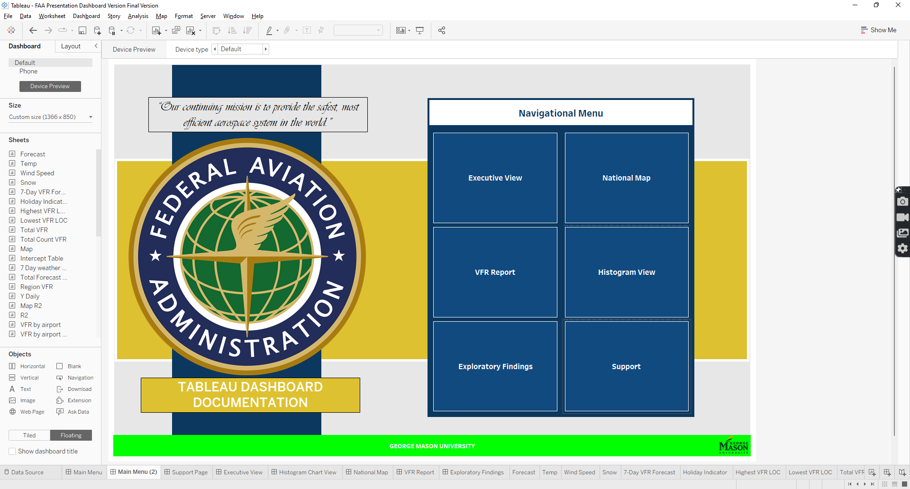

# Support Information

**Table of Contents**

Support Information 2

Introduction 6

Main Menu 6

Support Page 7

Executive Summary View 7

Filters 8

KPI Card 9

Airport Details KPI 9

Holiday Indicator KPI 49

Weather Forecast KPI 50

Max Temperature 51

Wind Speed 52

Model Type KPI 53

Model Expression 53

Tables 54

7 – Day Weather Forecast 54

Sunrise and Sunset Table 55

Daily Intercept and Log Table 56

Charts 57

7 – Day Predicted Forecast 57

Pseudo R-Squared By Airport 58

Current VFR Forecast 59

Average Pseudo R-Squared and Total VFR By Region 60

Histogram Chart View 61

Charts 61

All Airports Pseudo R-Squared Histogram 62

All Airports Intercept Histogram 62

Table 63

Total Airports Pseudo R-Squared and Intercept Coefficient Tables 63

National Map View 64

Filters 64

Variables Used 65

Calculated Fields 65

Map R2 Bar Chart 66

VFR Report 66

Filters 67

Tables 67

Total VFR By Airport 68

VFR Statistical Analysis Report 68

Exploratory Findings 69

KPI 69

Highest VFR Airport 69

Lowest VFR Airport 70

Total VFR 71

Total Distinct VFR Count 71

Table 71

Total VFR by Weekday 72

Charts 72

VFR By Forecast 72

Top 5 Regions by Total VFR 73

Bottom 5 Regions by Total VFR 74

Top 10 Airports by Total VFR 74

Bottom 10 Airports by Total VFR 74

Top 10 State by Total VFR 75

Bottom 10 State by Total VFR 75

Top 10 Cities by Total VFR 75

Bottom 10 Cities by Total VFR 76

VFR By LOC Chart 76

VFR Histogram 77

Tables of Figures and Tables 78

Table of Tables 78

Table of Figures 78

# Introduction

This document will provide information pertaining to the Federal Aviation Administration Dashboard visualizations and calculated fields developed. There are 7 pages in total: Main Menu, Support Page, Executive View, Histogram Chart View, National Map, VFR Report and Exploratory Findings. The documentation will focus on 5 of the pages, as Main Menu and Support Page do not contain any calculations aside from navigation buttons. The document will focus on the pages, filters, charts created, calculations and additional information that is relevant in understanding the process created and using the dashboard appropriately.

# Main Menu

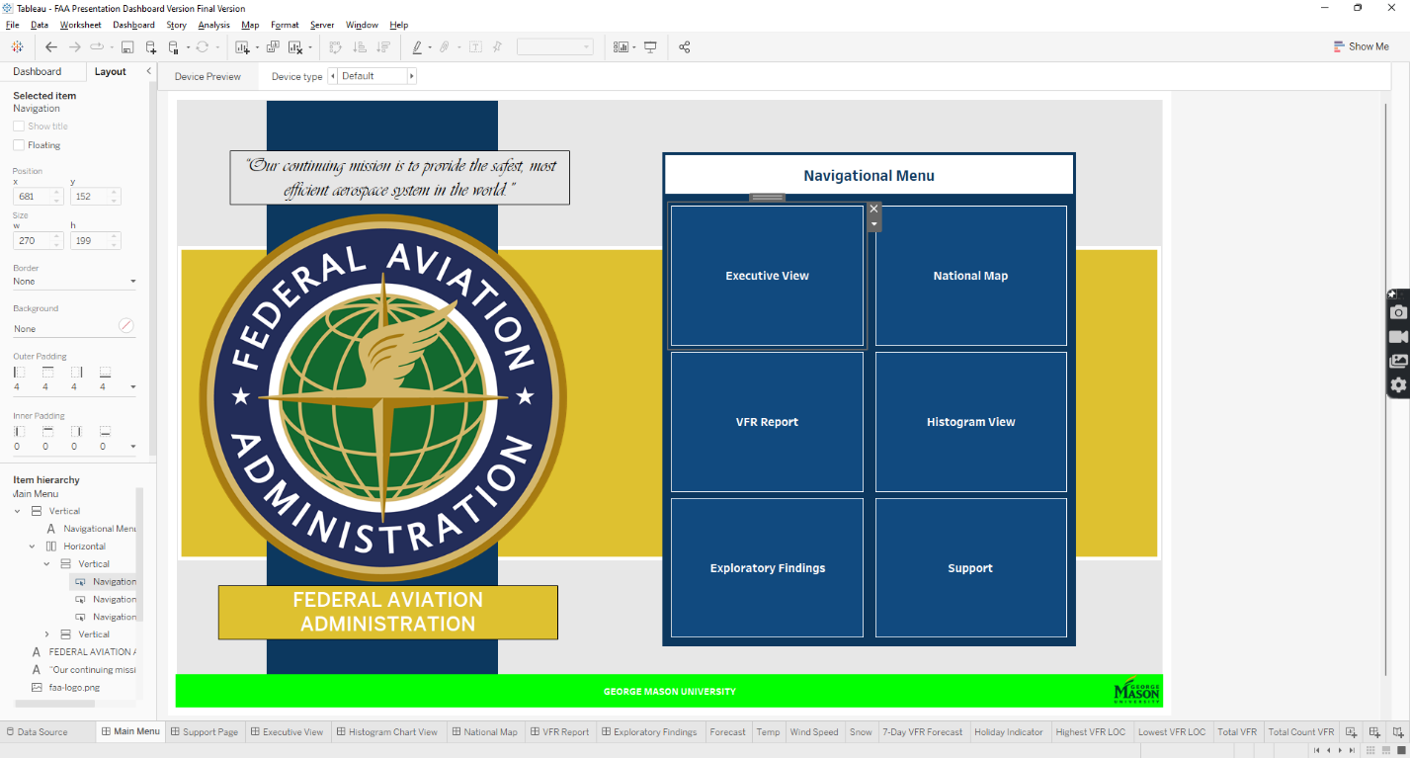Main Menu is the landing page when you first use the dashboard. It provides all the navigational buttons to access the pages in the dashboard. There are no calculations.

Figure 1 Main Menu Page

# Support Page

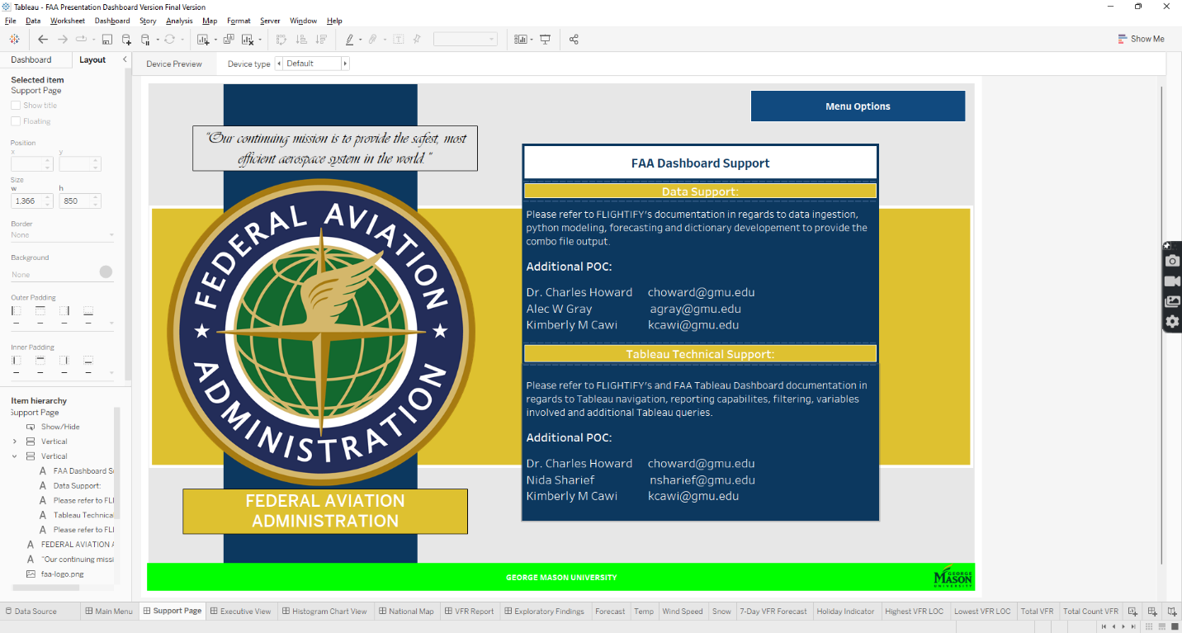The Support page provides information if issues arise. The section is broken out into two areas: Data Support and Tableau Support. Data pertains to the python files created to develop the output that is ingested into the Tableau dashboard. The Tableau support pertains to the dashboard itself and if problems arise in regards to syncing, navigating, calculations invaliding and other areas. Point of contacts emails are provided to be used to reach out to.

Figure 2 Support Page View

# Executive Summary View

There are several KPIs and cards that leverage both created calculations and variables from the original datafile. In this section, we will go through each KPI, applied filters and formulas created. In addition, we will also discuss additional features that were implemented for functionality within the Executive Summary View. There are 2 parts to the Executive summary, first is the main page and second is the hidden page that can be found using the VFR Details button. Below are the screens:

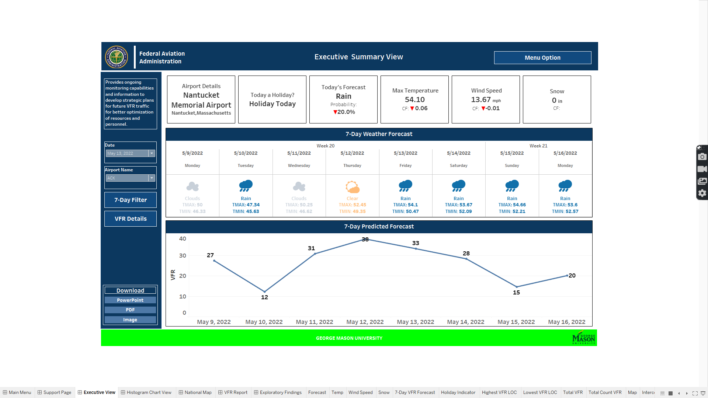

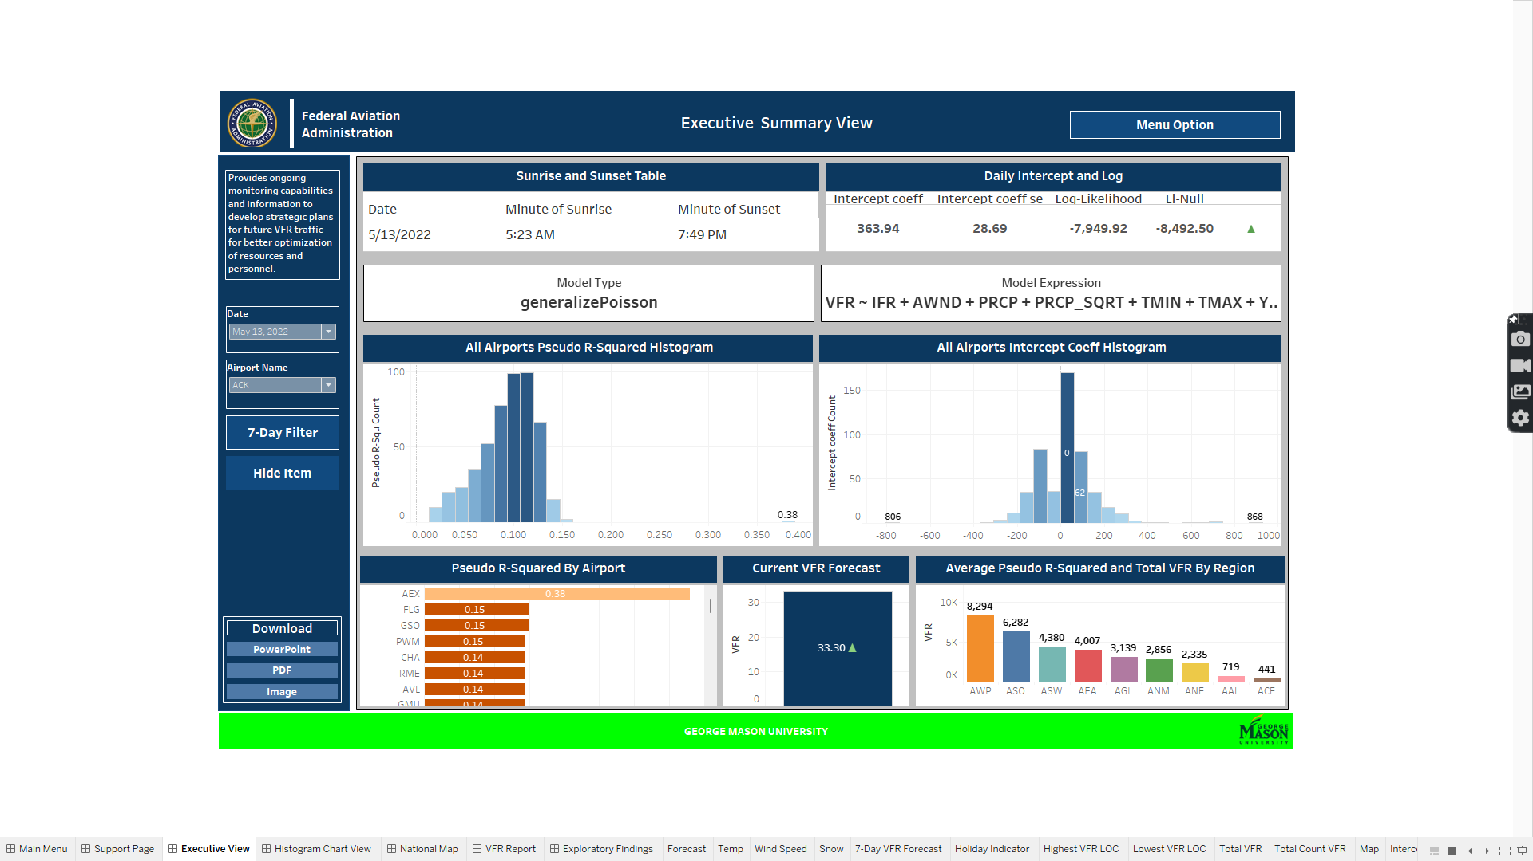Figure 3 Executive Summary View page

Figure 4 VFR Details Content

## Filters

There are 2 main filters applied on the Executive sheet and to other pages in the dashboard: Date and Airport Name which is alias for the LOC variables. The Date can be formatted in the MDY format, (Month -Day-Year). The filters contain only as much as the data file being used has, so the date is limited to only what is available.

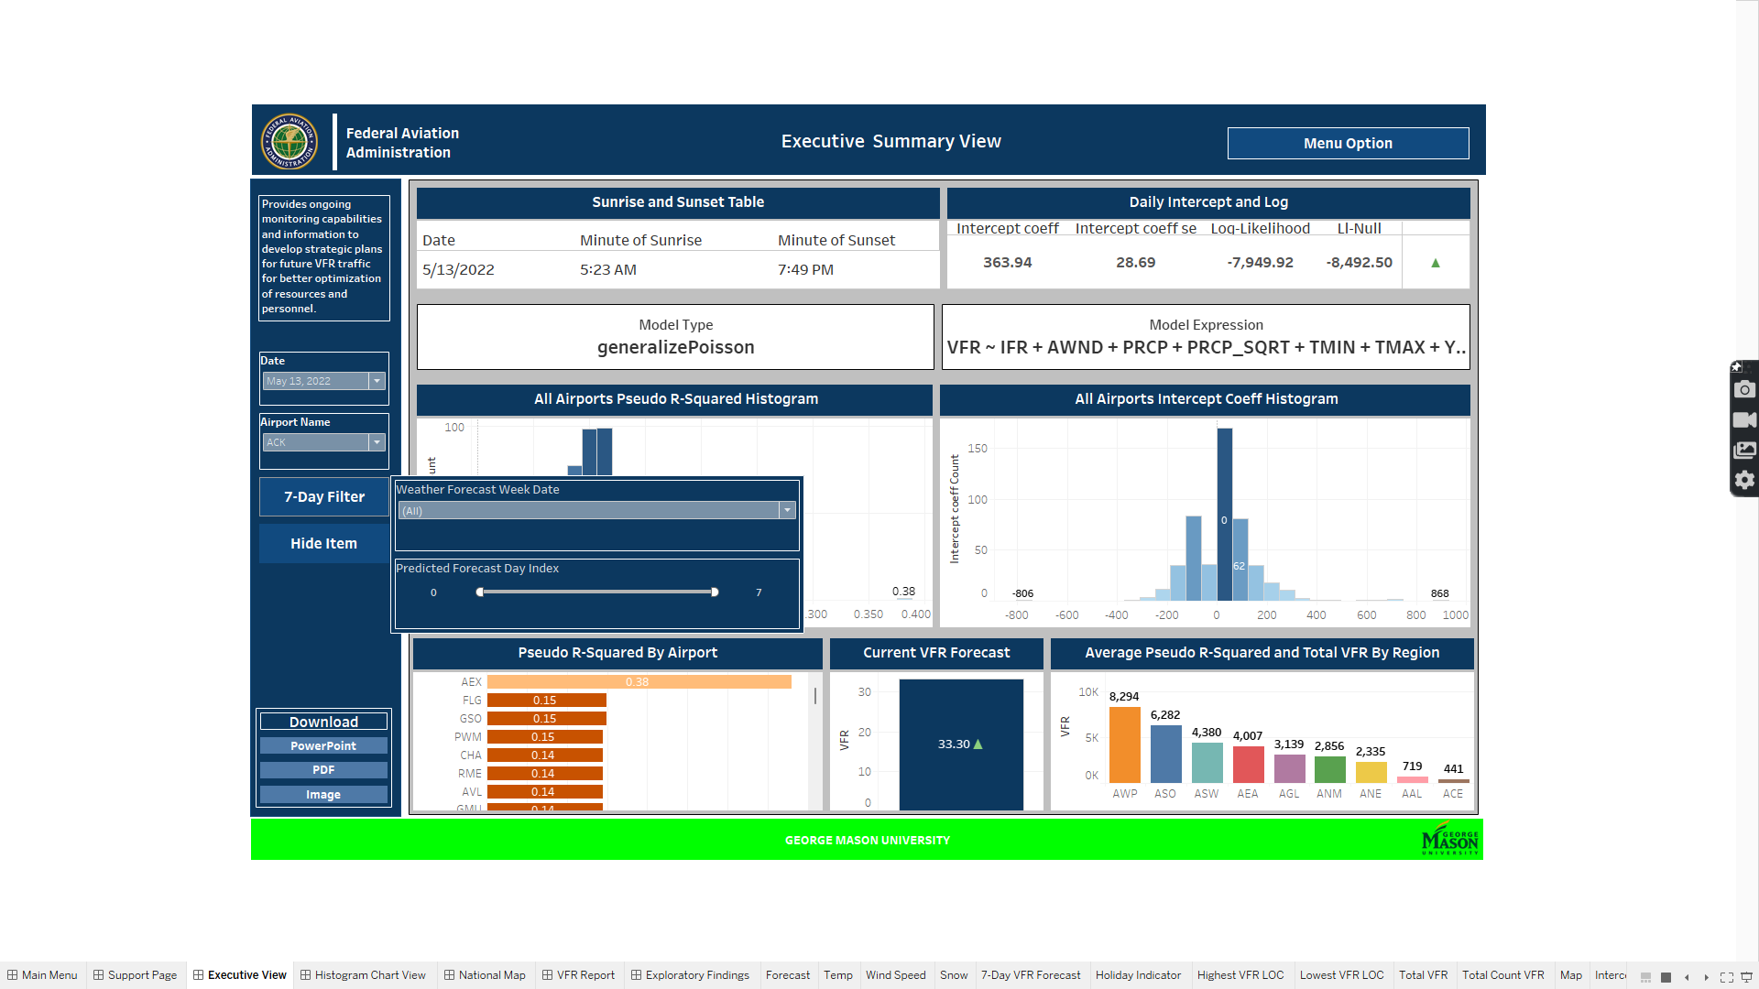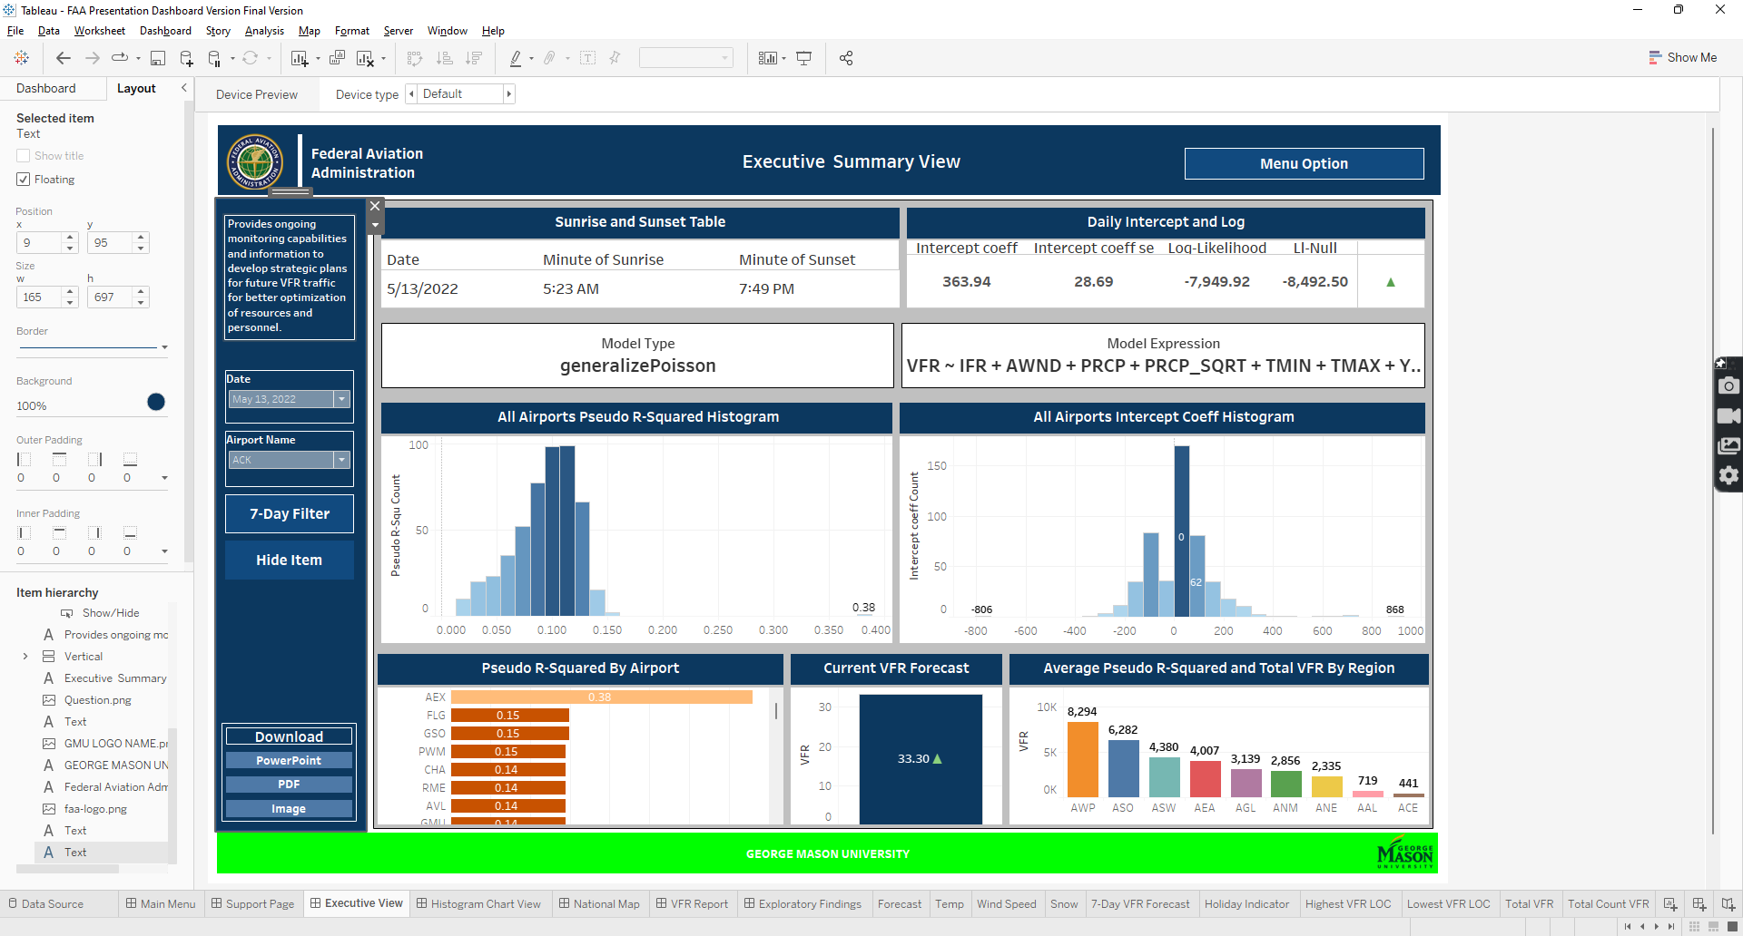There are 2 other filters but they pertain to only to the chart they are specified for. The 7- Day Forecast has a Week Number filter and the 7-Day Predicted Forecast graph has a Day Index filter that can be found in the 7- Day filter button. Further details will be provided in the next sections.

Figure 5 7-Day Filter Button

Figure 6 Executive View Filter

## KPI Card

Within the Executive Summary, there are KPI cards that provide information in regards to the selected filters. The cards provide a daily account for specific conditions that pertain to weather, climate and other factors that will be discussed. The next sections will go over the variables, purpose and calculated fields created to develop the KPI cards.

### Airport Details KPI

Airport details is a KPI card that provides information in regards to the Airports full name, their location, in the city, state format, and region. The tooltip also relays the same information using color and bolding along with LOC variable.

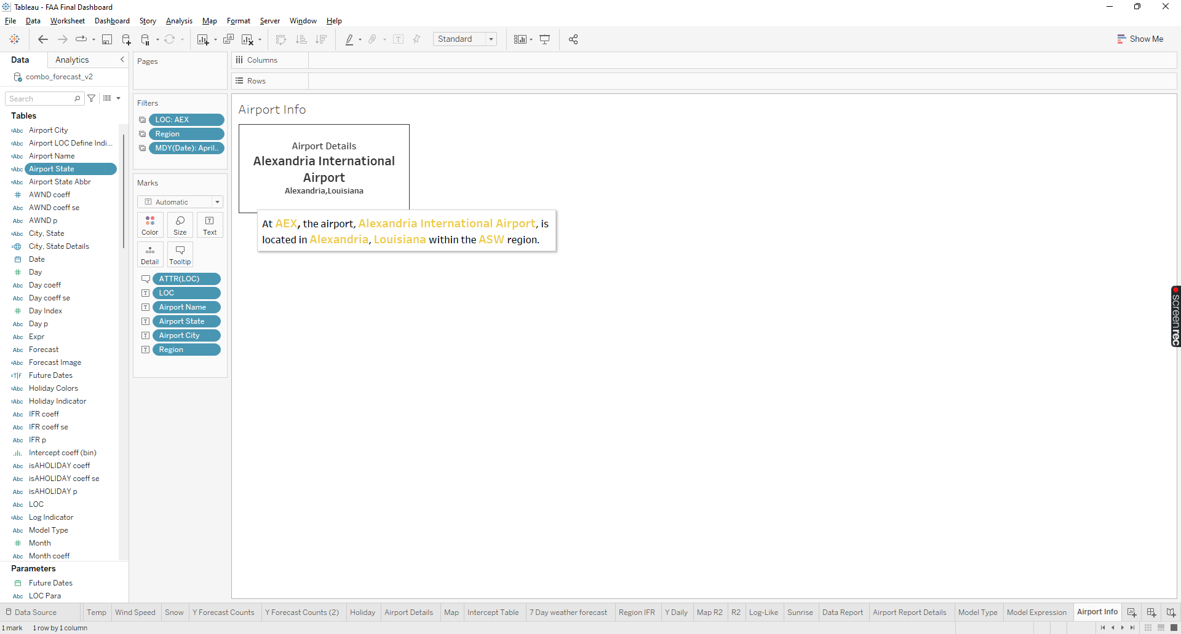

Figure 7 Airport Details KPI card

#### Variables Used

Variables used to create the text are the following: Airport Name, Airport State and Airport City. For the filter LOC, Region, and Date modified in the MDY format, are used. The tooltip uses Region, Airport Name, Airport State, Airport City and Region. The following table summarizes how are the variables are used:

Table 1 Airport KPI Variables Usage.

|  |  |  |  |
| --- | --- | --- | --- |
| **Variable Name** | **Filter** | **Text** | **Tooltip** |
| LOC | Yes |  | Yes |
| Region | Yes |  | Yes |
| Date | Yes |  |  |
| Airport Name |  | Yes | Yes |
| Airport State |  | Yes | Yes |
| Airport City |  | Yes | Yes |

#### Created Calculated Fields

There are several variables mentioned previously that were created to provide the current values present, specifically, Airport Name, Airport State and Airport City. The text values were obtained using Google maps to confirm the LOC, State and City associated with the Airport. The values were compiled in the Excel workbook that automated the concatenate text so the Else/IF statements can be bulk imported into Tableau. The following table displays the full code used:

Table 2 Airport Location formula.

|  |  |  |
| --- | --- | --- |
| **Calculated Field** | **Variables**  **Used** | **Formula** |
| Airport Name | LOC | IF [LOC] = "JFK" THEN "John F. Kennedy International Airport"  ELSEIF [LOC] = "EWR" THEN "Newwark Liberty International Airport"  ELSEIF [LOC] = "LGA" THEN "LaGuardia Airport"  ELSEIF [LOC] = "TEB" THEN "Teterboro Airport"  ELSEIF [LOC] = "VNY" THEN "Van Nuys Airport"  ELSEIF [LOC] = "ACY" THEN "Atlantic City International Airport"  ELSEIF [LOC] = "GFK" THEN "Grand Forks International Airport"  ELSEIF [LOC] = "DVT" THEN "Phoenix Deer Valley Airport"  ELSEIF [LOC] = "PRC" THEN "Prescott Regional Airport"  ELSEIF [LOC] = "CVG" THEN "Cincinnati/Northern Kentucky International Airport"  ELSEIF [LOC] = "ABE" THEN "Lehigh Valley International Airport"  ELSEIF [LOC] = "ABI" THEN "Abilene Regional Airport"  ELSEIF [LOC] = "ABQ" THEN "Albuquerque International Sunport"  ELSEIF [LOC] = "ABY" THEN "Southwest Georgia Regional Airport"  ELSEIF [LOC] = "ACK" THEN "Nantucket Memorial Airport"  ELSEIF [LOC] = "ACT" THEN "Waco Regional Airport"  ELSEIF [LOC] = "ADS" THEN "Addison Airport"  ELSEIF [LOC] = "AEX" THEN "Alexandria International Airport"  ELSEIF [LOC] = "AFW" THEN "Fort Worth Alliance Airport"  ELSEIF [LOC] = "AGC" THEN "Allegheny County Airport"  ELSEIF [LOC] = "AGS" THEN "Augusta Regional Airport (Bush Field)"  ELSEIF [LOC] = "AHN" THEN "Athens-Ben Epps Airport"  ELSEIF [LOC] = "AKN" THEN "King Salmon Airport"  ELSEIF [LOC] = "ALB" THEN "Albany International Airport"  ELSEIF [LOC] = "ALN" THEN "St. Louis Regional Airport"  ELSEIF [LOC] = "ALW" THEN "Walla Walla Regional Airport"  ELSEIF [LOC] = "AMA" THEN "Rick Husband Amarillo International Airport"  ELSEIF [LOC] = "ANC" THEN "Ted Stevens Anchorage International Airport"  ELSEIF [LOC] = "ANE" THEN "Anoka County-Blaine Airport"  ELSEIF [LOC] = "APA" THEN "Centennial Airport"  ELSEIF [LOC] = "APC" THEN "Napa County Airport"  ELSEIF [LOC] = "APF" THEN "Naples Airport"  ELSEIF [LOC] = "ARB" THEN "Ann Arbor Municipal Airport"  ELSEIF [LOC] = "ARR" THEN "Aurora Municipal Airport"  ELSEIF [LOC] = "ASE" THEN "Aspen/Pitkin County Airport (Sardy Field)"  ELSEIF [LOC] = "ASG" THEN "Springdale Municipal Airport"  ELSEIF [LOC] = "ASH" THEN "Nashua Airport"  ELSEIF [LOC] = "ATL" THEN "Hartsfield–Jackson Atlanta International Airport"  ELSEIF [LOC] = "ATW" THEN "Appleton International Airport"  ELSEIF [LOC] = "AUS" THEN "Austin–Bergstrom International Airport"  ELSEIF [LOC] = "AVL" THEN "Asheville Regional Airport"  ELSEIF [LOC] = "AVP" THEN "Wilkes-Barre/Scranton International Airport"  ELSEIF [LOC] = "AZO" THEN "Kalamazoo/Battle Creek International Airport"  ELSEIF [LOC] = "BAF" THEN "Westfield-Barnes Regional Airport"  ELSEIF [LOC] = "BAK" THEN "Columbus Municipal Airport"  ELSEIF [LOC] = "BAZ" THEN "New Braunfels Regional Airport"  ELSEIF [LOC] = "BBG" THEN "Branson Airport"  ELSEIF [LOC] = "BCT" THEN "Boca Raton Airport"  ELSEIF [LOC] = "BDL" THEN "Bradley International Airport"  ELSEIF [LOC] = "BDR" THEN "Sikorsky Memorial Airport"  ELSEIF [LOC] = "BED" THEN "Hanscom Field / Hanscom Air Force Base"  ELSEIF [LOC] = "BET" THEN "Bethel Airport (also see Bethel Seaplane Base)"  ELSEIF [LOC] = "BFI" THEN "King County International Airport (Boeing Field)"  ELSEIF [LOC] = "BFL" THEN "Meadows Field"  ELSEIF [LOC] = "BFM" THEN "Mobile Downtown Airport"  ELSEIF [LOC] = "BGR" THEN "Bangor International Airport"  ELSEIF [LOC] = "BHM" THEN "Birmingham–Shuttlesworth International Airport"  ELSEIF [LOC] = "BIL" THEN "Billings Logan International Airport"  ELSEIF [LOC] = "BIS" THEN "Bismarck Municipal Airport"  ELSEIF [LOC] = "BJC" THEN "Rocky Mountain Metropolitan Airport"  ELSEIF [LOC] = "BKL" THEN "Cleveland Burke Lakefront Airport"  ELSEIF [LOC] = "BKV" THEN "Brooksville-Tampa Bay Regional Airport"  ELSEIF [LOC] = "BLI" THEN "Bellingham International Airport"  ELSEIF [LOC] = "BMG" THEN "Monroe County Airport"  ELSEIF [LOC] = "BMI" THEN "Central Illinois Regional Airport at Bloomington-Normal"  ELSEIF [LOC] = "BNA" THEN "Nashville International Airport (Berry Field)"  ELSEIF [LOC] = "BOI" THEN "Boise Airport (Boise Air Terminal) (Gowen Field)"  ELSEIF [LOC] = "BOS" THEN "Gen. Edward Lawrence Logan International Airport"  ELSEIF [LOC] = "BPT" THEN "Jack Brooks Regional Airport (was Southeast Texas Regional)"  ELSEIF [LOC] = "BRO" THEN "Brownsville/South Padre Island International Airport"  ELSEIF [LOC] = "BTL" THEN "Battle Creek Executive Airport at Kellogg Field"  ELSEIF [LOC] = "BTR" THEN "Baton Rouge Metropolitan Airport (Ryan Field)"  ELSEIF [LOC] = "BTV" THEN "Burlington International Airport"  ELSEIF [LOC] = "BUF" THEN "Buffalo Niagara International Airport"  ELSEIF [LOC] = "BUR" THEN "Hollywood Burbank Airport (was Bob Hope Airport)"  ELSEIF [LOC] = "BVY" THEN "Beverly Regional Airport"  ELSEIF [LOC] = "BWI" THEN "Baltimore/Washington International Airport"  ELSEIF [LOC] = "BZN" THEN "Bozeman Yellowstone International Airport (was Gallatin Field)"  ELSEIF [LOC] = "CAE" THEN "Columbia Metropolitan Airport"  ELSEIF [LOC] = "CAK" THEN "Akron-Canton Regional Airport"  ELSEIF [LOC] = "CCR" THEN "Buchanan Field Airport"  ELSEIF [LOC] = "CDW" THEN "Essex County Airport"  ELSEIF [LOC] = "CFO" THEN "Colorado Air and Space Port"  ELSEIF [LOC] = "CGF" THEN "Aeropuerto Internacional Jaime González"  ELSEIF [LOC] = "CHA" THEN "Chattanooga Metropolitan Airport (Lovell Field)"  ELSEIF [LOC] = "CHD" THEN "Chandler Municipal Airport"  ELSEIF [LOC] = "CHO" THEN "Charlottesville–Albemarle Airport"  ELSEIF [LOC] = "CHS" THEN "Charleston International Airport / Charleston AFB"  ELSEIF [LOC] = "CID" THEN "The Eastern Iowa Airport"  ELSEIF [LOC] = "CKB" THEN "North Central West Virginia Airport (was Harrison-Marion Regional)"  ELSEIF [LOC] = "CLE" THEN "Cleveland Hopkins International Airport"  ELSEIF [LOC] = "CLL" THEN "Easterwood Airport (Easterwood Field)"  ELSEIF [LOC] = "CLT" THEN "Charlotte Douglas International Airport"  ELSEIF [LOC] = "CMA" THEN "Camarillo Airport"  ELSEIF [LOC] = "CMH" THEN "John Glenn Columbus International Airport"  ELSEIF [LOC] = "CMI" THEN "University of Illinois - Willard Airport"  ELSEIF [LOC] = "CNO" THEN "Chino Airport"  ELSEIF [LOC] = "COS" THEN "City of Colorado Springs Municipal Airport"  ELSEIF [LOC] = "COU" THEN "Columbia Regional Airport"  ELSEIF [LOC] = "CPR" THEN "Casper–Natrona County International Airport"  ELSEIF [LOC] = "CPS" THEN "St. Louis Downtown Airport"  ELSEIF [LOC] = "CRE" THEN "Grand Strand Airport"  ELSEIF [LOC] = "CRG" THEN "Jacksonville Executive at Craig Airport (JAXEX)"  ELSEIF [LOC] = "CRP" THEN "Corpus Christi International Airport"  ELSEIF [LOC] = "CRQ" THEN "McClellan-Palomar Airport"  ELSEIF [LOC] = "CRW" THEN "Yeager Airport"  ELSEIF [LOC] = "CSG" THEN "Columbus Airport"  ELSEIF [LOC] = "CWA" THEN "Central Wisconsin Airport"  ELSEIF [LOC] = "CWF" THEN "Chennault International Airport"  ELSEIF [LOC] = "CXO" THEN "Conroe-North Houston Regional Airport"  ELSEIF [LOC] = "CXY" THEN "Capital City Airport"  ELSEIF [LOC] = "CYS" THEN "Cheyenne Regional Airport"  ELSEIF [LOC] = "DAB" THEN "Daytona Beach International Airport"  ELSEIF [LOC] = "DAL" THEN "Dallas Love Field"  ELSEIF [LOC] = "DAY" THEN "James M. Cox Dayton International Airport"  ELSEIF [LOC] = "DBQ" THEN "Dubuque Regional Airport"  ELSEIF [LOC] = "DCA" THEN "Ronald Reagan Washington National Airport"  ELSEIF [LOC] = "DEC" THEN "Decatur Airport"  ELSEIF [LOC] = "DEN" THEN "Denver International Airport"  ELSEIF [LOC] = "DET" THEN "Detroit Metropolitan Wayne County Airport"  ELSEIF [LOC] = "DFW" THEN "Dallas/Fort Worth International Airport"  ELSEIF [LOC] = "DHN" THEN "Dothan Regional Airport"  ELSEIF [LOC] = "DLH" THEN "Duluth International Airport"  ELSEIF [LOC] = "DPA" THEN "DuPage Airport"  ELSEIF [LOC] = "DSM" THEN "Des Moines International Airport"  ELSEIF [LOC] = "DTN" THEN "Shreveport Downtown Arprt"  ELSEIF [LOC] = "DTO" THEN "Denton Enterprise Airport"  ELSEIF [LOC] = "DTS" THEN "Destin Executive Airport"  ELSEIF [LOC] = "DTW" THEN "Detroit Metro Wayne County Airport"  ELSEIF [LOC] = "DWH" THEN "David Wayne Hooks Memorial Airport"  ELSEIF [LOC] = "DXR" THEN "Danbury Municipal Airport"  ELSEIF [LOC] = "EAU" THEN "Chippewa Valley Regional Airport"  ELSEIF [LOC] = "ECP" THEN "Northwest Florida Beaches International Airport"  ELSEIF [LOC] = "EGE" THEN "Eagle County Regional Airport"  ELSEIF [LOC] = "ELM" THEN "Elmira/Corning Regional Airport"  ELSEIF [LOC] = "ELP" THEN "El Paso International Airport"  ELSEIF [LOC] = "EMT" THEN "San Gabriel Valley Airport"  ELSEIF [LOC] = "ENA" THEN "Kenai Municipal Airport"  ELSEIF [LOC] = "ENW" THEN "Kenosha Regional Airport"  ELSEIF [LOC] = "ERI" THEN "Erie International Airport (Tom Ridge Field)"  ELSEIF [LOC] = "ESN" THEN "Easton Airport"  ELSEIF [LOC] = "EUG" THEN "Eugene Airport (Mahlon Sweet Field)"  ELSEIF [LOC] = "EVB" THEN "New Smyrna Beach Municipal Airport"  ELSEIF [LOC] = "EVV" THEN "Evansville Regional Airport"  ELSEIF [LOC] = "EWB" THEN "New Bedford Regional Airport"  ELSEIF [LOC] = "EWN" THEN "Coastal Carolina Regional Airport (was Craven County Regional)"  ELSEIF [LOC] = "EYW" THEN "Key West International Airport"  ELSEIF [LOC] = "FAI" THEN "Fairbanks International Airport"  ELSEIF [LOC] = "FAR" THEN "Hector International Airport"  ELSEIF [LOC] = "FAT" THEN "Fresno Yosemite International Airport"  ELSEIF [LOC] = "FAY" THEN "Fayetteville Regional Airport (Grannis Field)"  ELSEIF [LOC] = "FCM" THEN "Flying Cloud Airport"  ELSEIF [LOC] = "FDK" THEN "Frederick Municipal Airport"  ELSEIF [LOC] = "FFZ" THEN "Falcon Field Airport"  ELSEIF [LOC] = "FIN" THEN "Flagler Executive Airport"  ELSEIF [LOC] = "FLG" THEN "Flagstaff Pulliam Airport"  ELSEIF [LOC] = "FLL" THEN "Fort Lauderdale–Hollywood International Airport"  ELSEIF [LOC] = "FLO" THEN "Florence Regional Airport"  ELSEIF [LOC] = "FMN" THEN "Four Corners Regional Airport"  ELSEIF [LOC] = "FMY" THEN "Page Field"  ELSEIF [LOC] = "FNT" THEN "Bishop International Airport"  ELSEIF [LOC] = "FOE" THEN "Topeka Regional Airport"  ELSEIF [LOC] = "FOK" THEN "Francis S Gabreski Airport"  ELSEIF [LOC] = "FPR" THEN "Treasure Coast International Airport and Business Park"  ELSEIF [LOC] = "FRG" THEN "Republic Airport"  ELSEIF [LOC] = "FSD" THEN "Sioux Falls Regional Airport (Joe Foss Field)"  ELSEIF [LOC] = "FSM" THEN "Fort Smith Regional Airport"  ELSEIF [LOC] = "FTW" THEN "Fort Worth Meacham International Airport"  ELSEIF [LOC] = "FTY" THEN "Fulton County Airport"  ELSEIF [LOC] = "FWA" THEN "Fort Wayne International Airport"  ELSEIF [LOC] = "FWS" THEN "Spinks Airport"  ELSEIF [LOC] = "FXE" THEN "Fort Lauderdale Executive Airport"  ELSEIF [LOC] = "FYV" THEN "Drake Field"  ELSEIF [LOC] = "GCK" THEN "Garden City Regional Airport"  ELSEIF [LOC] = "GCN" THEN "Grand Canyon National Park Airport"  ELSEIF [LOC] = "GEG" THEN "Spokane International Airport (Geiger Field)"  ELSEIF [LOC] = "GEU" THEN "Glendale Municipal Airport"  ELSEIF [LOC] = "GGG" THEN "East Texas Regional Airport"  ELSEIF [LOC] = "GJT" THEN "Grand Junction Regional Airport (Walker Field)"  ELSEIF [LOC] = "GKY" THEN "Arlington Municipal Airport"  ELSEIF [LOC] = "GLS" THEN "Scholes International Airport"  ELSEIF [LOC] = "GMU" THEN "Greenville Downtown Airport"  ELSEIF [LOC] = "GNV" THEN "Gainesville Regional Airport"  ELSEIF [LOC] = "GON" THEN "Groton - New London Airport"  ELSEIF [LOC] = "GPI" THEN "Glacier Park International Airport"  ELSEIF [LOC] = "GPT" THEN "Gulfport–Biloxi International Airport"  ELSEIF [LOC] = "GRB" THEN "Green Bay–Austin Straubel International Airport"  ELSEIF [LOC] = "GRI" THEN "Central Nebraska Regional Airport"  ELSEIF [LOC] = "GRR" THEN "Gerald R. Ford International Airport"  ELSEIF [LOC] = "GSN" THEN "Saipan International Airport (Francisco C. Ada)"  ELSEIF [LOC] = "GSO" THEN "Piedmont Triad International Airport"  ELSEIF [LOC] = "GSP" THEN "Greenville–Spartanburg International Airport (Roger Milliken Field)"  ELSEIF [LOC] = "GTF" THEN "Great Falls International Airport"  ELSEIF [LOC] = "GTR" THEN "Golden Triangle Regional Airport"  ELSEIF [LOC] = "GTU" THEN "Georgetown Municipal Airport"  ELSEIF [LOC] = "GUM" THEN "Antonio B. Won Pat International Airport"  ELSEIF [LOC] = "GYH" THEN "Donaldson Center Airport"  ELSEIF [LOC] = "GYI" THEN "North Texas Regional Airport"  ELSEIF [LOC] = "GYR" THEN "Phoenix-Goodyear Airport"  ELSEIF [LOC] = "GYY" THEN "Gary/Chicago International Airport"  ELSEIF [LOC] = "HEF" THEN "Manassas Regional Airport"  ELSEIF [LOC] = "HFD" THEN "Hartford–Brainard Airport"  ELSEIF [LOC] = "HGR" THEN "Hagerstown Regional Airport (Richard A. Henson Field)"  ELSEIF [LOC] = "HHR" THEN "Hawthorne Municipal Airport"  ELSEIF [LOC] = "HIO" THEN "Hillsboro Airport"  ELSEIF [LOC] = "HKS" THEN "Hawkins Field Airport"  ELSEIF [LOC] = "HKY" THEN "Hickory Regional Airport"  ELSEIF [LOC] = "HLG" THEN "Wheeling Ohio County Airport"  ELSEIF [LOC] = "HLN" THEN "Helena Regional Airport"  ELSEIF [LOC] = "HND" THEN "Haneda Airport"  ELSEIF [LOC] = "HNL" THEN "Daniel K. Inouye International Airport"  ELSEIF [LOC] = "HOB" THEN "Lea County Regional Airport"  ELSEIF [LOC] = "HOU" THEN "William P. Hobby Airport"  ELSEIF [LOC] = "HPN" THEN "Westchester County Airport"  ELSEIF [LOC] = "HQZ" THEN "Mesquite Metro Airport"  ELSEIF [LOC] = "HRL" THEN "Valley International Airport"  ELSEIF [LOC] = "HSV" THEN "Huntsville International Airport (Carl T. Jones Field)"  ELSEIF [LOC] = "HTS" THEN "Tri-State Airport (Milton J. Ferguson Field)"  ELSEIF [LOC] = "HUF" THEN "Terre Haute Regional Airport"  ELSEIF [LOC] = "HUM" THEN "Houma–Terrebonne Airport"  ELSEIF [LOC] = "HUT" THEN "Hutchinson Regional Airport"  ELSEIF [LOC] = "HVN" THEN "Tweed-New Haven Airport"  ELSEIF [LOC] = "HWD" THEN "Hayward Executive Airport"  ELSEIF [LOC] = "HWO" THEN "North Perry Airport"  ELSEIF [LOC] = "HXD" THEN "Hilton Head Airport"  ELSEIF [LOC] = "HYA" THEN "Cape Cod Gateway Airport (Boardman/Polando Field)"  ELSEIF [LOC] = "HYI" THEN "San Marcos Regional Airport"  ELSEIF [LOC] = "IAD" THEN "Washington Dulles International Airport"  ELSEIF [LOC] = "IAG" THEN "Niagara Falls International Airport"  ELSEIF [LOC] = "IAH" THEN "George Bush Intercontinental Airport"  ELSEIF [LOC] = "ICT" THEN "Wichita Dwight D. Eisenhower National Airport (was Wichita Mid-Continent Airport)"  ELSEIF [LOC] = "IDA" THEN "Idaho Falls Regional Airport (Fanning Field)"  ELSEIF [LOC] = "ILG" THEN "Wilmington Airport"  ELSEIF [LOC] = "ILM" THEN "Wilmington International Airport"  ELSEIF [LOC] = "IND" THEN "Indianapolis International Airport"  ELSEIF [LOC] = "INT" THEN "Smith Reynolds Airport"  ELSEIF [LOC] = "IPT" THEN "Williamsport Regional Airport"  ELSEIF [LOC] = "ISM" THEN "Kissimmee Gateway Airport"  ELSEIF [LOC] = "ISO" THEN "Kinston Regional Jetport"  ELSEIF [LOC] = "ISP" THEN "Long Island MacArthur Airport"  ELSEIF [LOC] = "ITH" THEN "Ithaca Tompkins International Airport"  ELSEIF [LOC] = "ITO" THEN "Hilo International Airport"  ELSEIF [LOC] = "IWA" THEN "Phoenix–Mesa Gateway Airport (formerly Williams AFB)"  ELSEIF [LOC] = "IXD" THEN "New Century AirCenter"  ELSEIF [LOC] = "JAC" THEN "Jackson Hole Airport"  ELSEIF [LOC] = "JAN" THEN "Jackson–Medgar Wiley Evers International Airport"  ELSEIF [LOC] = "JAX" THEN "Jacksonville International Airport"  ELSEIF [LOC] = "JEF" THEN "Jefferson City Airport"  ELSEIF [LOC] = "JKA" THEN "Jack Edwards Airport"  ELSEIF [LOC] = "JLN" THEN "Joplin Regional Airport"  ELSEIF [LOC] = "JNU" THEN "Juneau International Airport"  ELSEIF [LOC] = "JQF" THEN "Concord-Padgett Regional Airport"  ELSEIF [LOC] = "JRF" THEN "Kalaeloa Airport"  ELSEIF [LOC] = "JVL" THEN "Southern Wisconsin Regional Airport"  ELSEIF [LOC] = "JWN" THEN "John C Tune Airport"  ELSEIF [LOC] = "JXN" THEN "Jackson County Airport"  ELSEIF [LOC] = "KOA" THEN "Ellison Onizuka Kona International Airport at Keahole"  ELSEIF [LOC] = "LAF" THEN "Purdue University Airport"  ELSEIF [LOC] = "LAL" THEN "Lakeland Linder International Airport"  ELSEIF [LOC] = "LAN" THEN "Capital Region International Airport (was Lansing Capital City)"  ELSEIF [LOC] = "LAS" THEN "Harry Reid International Airport"  ELSEIF [LOC] = "LAW" THEN "Lawton–Fort Sill Regional Airport"  ELSEIF [LOC] = "LAX" THEN "Los Angeles International Airport"  ELSEIF [LOC] = "LBB" THEN "Lubbock Preston Smith International Airport"  ELSEIF [LOC] = "LBE" THEN "Arnold Palmer Regional Airport"  ELSEIF [LOC] = "LCH" THEN "Lake Charles Regional Airport"  ELSEIF [LOC] = "LEB" THEN "Lebanon Municipal Airport"  ELSEIF [LOC] = "LEE" THEN "Leesburg International Airport"  ELSEIF [LOC] = "LEX" THEN "Blue Grass Airport"  ELSEIF [LOC] = "LFT" THEN "Lafayette Regional Airport (Paul Fournet Field)"  ELSEIF [LOC] = "LGB" THEN "Long Beach Airport (Daugherty Field)"  ELSEIF [LOC] = "LIH" THEN "Lihue Airport"  ELSEIF [LOC] = "LIT" THEN "Clinton National Airport (Adams Field) (was Little Rock National)"  ELSEIF [LOC] = "LMT" THEN "Crater Lake - Klamath Regional Airport"  ELSEIF [LOC] = "LNK" THEN "Lincoln Airport (was Lincoln Municipal)"  ELSEIF [LOC] = "LNS" THEN "Lancaster Airport"  ELSEIF [LOC] = "LOU" THEN "Bowman Field"  ELSEIF [LOC] = "LRD" THEN "Laredo International Airport"  ELSEIF [LOC] = "LSE" THEN "La Crosse Regional Airport"  ELSEIF [LOC] = "LUK" THEN "Cincinnati Municipal Lunken Airport"  ELSEIF [LOC] = "LVK" THEN "Livermore Municipal Airport"  ELSEIF [LOC] = "LWB" THEN "Greenbrier Valley Airport"  ELSEIF [LOC] = "LWM" THEN "Lawrence Municipal Airport"  ELSEIF [LOC] = "LWS" THEN "Lewiston–Nez Perce County Airport"  ELSEIF [LOC] = "LYH" THEN "Lynchburg Regional Airport (Preston Glenn Field)"  ELSEIF [LOC] = "LZU" THEN "Gwinnett County Airport"  ELSEIF [LOC] = "MAF" THEN "Midland International Air and Space Port"  ELSEIF [LOC] = "MBS" THEN "MBS International Airport"  ELSEIF [LOC] = "MCI" THEN "Kansas City International Airport (was Mid-Continent International)"  ELSEIF [LOC] = "MCN" THEN "Middle Georgia Regional Airport"  ELSEIF [LOC] = "MCO" THEN "Orlando International Airport"  ELSEIF [LOC] = "MDH" THEN "Southern Illinois Airport"  ELSEIF [LOC] = "MDT" THEN "Harrisburg International Airport"  ELSEIF [LOC] = "MDW" THEN "Chicago Midway International Airport"  ELSEIF [LOC] = "MEI" THEN "Key Field"  ELSEIF [LOC] = "MEM" THEN "Memphis International Airport"  ELSEIF [LOC] = "MFD" THEN "Mansfield Lahm Regional Airport"  ELSEIF [LOC] = "MFE" THEN "McAllen Miller International Airport"  ELSEIF [LOC] = "MFR" THEN "Rogue Valley International–Medford Airport"  ELSEIF [LOC] = "MGM" THEN "Montgomery Regional Airport (Dannelly Field)"  ELSEIF [LOC] = "MGW" THEN "Morgantown Municipal Airport"  ELSEIF [LOC] = "MHK" THEN "Manhattan Regional Airport"  ELSEIF [LOC] = "MHR" THEN "Mather Airport"  ELSEIF [LOC] = "MHT" THEN "Manchester–Boston Regional Airport"  ELSEIF [LOC] = "MIA" THEN "Miami International Airport"  ELSEIF [LOC] = "MIE" THEN "Delaware County Airport"  ELSEIF [LOC] = "MKC" THEN "Charles B. Wheeler Downtown Airport"  ELSEIF [LOC] = "MKE" THEN "Milwaukee Mitchell International Airport"  ELSEIF [LOC] = "MKG" THEN "Muskegon County Airport"  ELSEIF [LOC] = "MKK" THEN "Molokai Airport (Hoolehua Airport)"  ELSEIF [LOC] = "MKL" THEN "McKellar-Sipes Regional Airport"  ELSEIF [LOC] = "MLB" THEN "Melbourne Orlando International Airport"  ELSEIF [LOC] = "MLI" THEN "Quad City International Airport"  ELSEIF [LOC] = "MLU" THEN "Monroe Regional Airport"  ELSEIF [LOC] = "MMU" THEN "Morristown Municipal Airport"  ELSEIF [LOC] = "MOB" THEN "Mobile Regional Airport"  ELSEIF [LOC] = "MOD" THEN "Modesto City–County Airport"  ELSEIF [LOC] = "MOT" THEN "Minot International Airport"  ELSEIF [LOC] = "MQY" THEN "Smyrna/Rutherford County Airport Authority"  ELSEIF [LOC] = "MRY" THEN "Monterey Regional Airport (was Monterey Peninsula Airport)"  ELSEIF [LOC] = "MSN" THEN "Dane County Regional Airport (Truax Field)"  ELSEIF [LOC] = "MSO" THEN "Missoula Montana Airport (was Missoula International Airport)"  ELSEIF [LOC] = "MSP" THEN "Minneapolis–St. Paul International/Wold-Chamberlain Airport"  ELSEIF [LOC] = "MSY" THEN "Louis Armstrong New Orleans International Airport"  ELSEIF [LOC] = "MTN" THEN "Martin State Airport"  ELSEIF [LOC] = "MVY" THEN "Martha's Vineyard Airport"  ELSEIF [LOC] = "MWA" THEN "Veterans Airport of Southern Illinois (Williamson County Regional Airport)"  ELSEIF [LOC] = "MWC" THEN "Timmerman Airport"  ELSEIF [LOC] = "MWH" THEN "Grant County International Airport"  ELSEIF [LOC] = "MYF" THEN "Montgomery-Gibbs Executive Airport"  ELSEIF [LOC] = "MYR" THEN "Myrtle Beach International Airport"  ELSEIF [LOC] = "NEW" THEN "New Orleans Lakefront Airport"  ELSEIF [LOC] = "NQA" THEN "Millington-Memphis Airport"  ELSEIF [LOC] = "OAJ" THEN "Albert J. Ellis Airport"  ELSEIF [LOC] = "OAK" THEN "Oakland International Airport"  ELSEIF [LOC] = "OCF" THEN "Ocala International Airport"  ELSEIF [LOC] = "OGD" THEN "Ogden-Hinckley Airport"  ELSEIF [LOC] = "OGG" THEN "Kahului Airport"  ELSEIF [LOC] = "OJC" THEN "Johnson County Executive Airport"  ELSEIF [LOC] = "OKC" THEN "Will Rogers World Airport"  ELSEIF [LOC] = "OLM" THEN "Olympia Regional Airport"  ELSEIF [LOC] = "OLV" THEN "Olive Branch Airport"  ELSEIF [LOC] = "OMA" THEN "Eppley Airfield"  ELSEIF [LOC] = "ONT" THEN "Ontario International Airport"  ELSEIF [LOC] = "OPF" THEN "Miami-Opa Locka Executive Airport"  ELSEIF [LOC] = "ORD" THEN "Chicago O'Hare International Airport"  ELSEIF [LOC] = "ORF" THEN "Norfolk International Airport"  ELSEIF [LOC] = "ORH" THEN "Worcester Regional Airport"  ELSEIF [LOC] = "ORL" THEN "Orlando Executive Airport"  ELSEIF [LOC] = "OSH" THEN "Wittman Regional Airport"  ELSEIF [LOC] = "OSU" THEN "Ohio State University Airport"  ELSEIF [LOC] = "OTH" THEN "Southwest Oregon Regional Airport (was North Bend Municipal)"  ELSEIF [LOC] = "OUN" THEN "Max Westheimer Airport"  ELSEIF [LOC] = "OWB" THEN "Owensboro–Daviess County Regional Airport"  ELSEIF [LOC] = "OWD" THEN "Norwood Regional Airport"  ELSEIF [LOC] = "OXC" THEN "Waterbury-Oxford Airport"  ELSEIF [LOC] = "OXR" THEN "Oxnard Airport"  ELSEIF [LOC] = "PAE" THEN "Paine Field"  ELSEIF [LOC] = "PAH" THEN "Barkley Regional Airport"  ELSEIF [LOC] = "PAO" THEN "Palo Alto Airport"  ELSEIF [LOC] = "PBI" THEN "Palm Beach International Airport"  ELSEIF [LOC] = "PDK" THEN "DeKalb-Peachtree Airport"  ELSEIF [LOC] = "PDT" THEN "Pendleton Airport"  ELSEIF [LOC] = "PDX" THEN "Portland International Airport"  ELSEIF [LOC] = "PGD" THEN "Punta Gorda Airport"  ELSEIF [LOC] = "PHF" THEN "Newport News/Williamsburg International Airport (Patrick Henry Field)"  ELSEIF [LOC] = "PHL" THEN "Philadelphia International Airport"  ELSEIF [LOC] = "PHX" THEN "Phoenix Sky Harbor International Airport"  ELSEIF [LOC] = "PIA" THEN "General Downing-Peoria International Airport"  ELSEIF [LOC] = "PIE" THEN "St. Pete–Clearwater International Airport"  ELSEIF [LOC] = "PIH" THEN "Pocatello Regional Airport"  ELSEIF [LOC] = "PIT" THEN "Pittsburgh International Airport"  ELSEIF [LOC] = "PKB" THEN "Mid-Ohio Valley Regional Airport"  ELSEIF [LOC] = "PMD" THEN "Palmdale Regional Airport"  ELSEIF [LOC] = "PMP" THEN "Pompano Beach Airpark"  ELSEIF [LOC] = "PNE" THEN "Northeast Philadelphia Airport"  ELSEIF [LOC] = "PNS" THEN "Pensacola International Airport"  ELSEIF [LOC] = "POC" THEN "Brackett Field Airport"  ELSEIF [LOC] = "POU" THEN "Hudson Valley Regional Airport"  ELSEIF [LOC] = "PSC" THEN "Tri-Cities Airport"  ELSEIF [LOC] = "PSP" THEN "Palm Springs International Airport"  ELSEIF [LOC] = "PTK" THEN "Oakland County International Airport"  ELSEIF [LOC] = "PUB" THEN "Pueblo Memorial Airport"  ELSEIF [LOC] = "PVD" THEN "Rhode Island T. F. Green International Airport"  ELSEIF [LOC] = "PVU" THEN "Provo Municipal Airport"  ELSEIF [LOC] = "PWA" THEN "Wiley Post Airport"  ELSEIF [LOC] = "PWK" THEN "Chicago Executive Airport"  ELSEIF [LOC] = "PWM" THEN "Portland International Jetport"  ELSEIF [LOC] = "RAL" THEN "Riverside Municipal Airport"  ELSEIF [LOC] = "RAP" THEN "Rapid City Regional Airport"  ELSEIF [LOC] = "RBD" THEN "Dallas Executive Airport"  ELSEIF [LOC] = "RDD" THEN "Redding Municipal Airport"  ELSEIF [LOC] = "RDG" THEN "Reading Regional Airport"  ELSEIF [LOC] = "RDM" THEN "Redmond Municipal Airport (Roberts Field)"  ELSEIF [LOC] = "RDU" THEN "Raleigh–Durham International Airport"  ELSEIF [LOC] = "RFD" THEN "Chicago Rockford International Airport (was Northwest Chicagoland Regional Airport at Rockford)"  ELSEIF [LOC] = "RIC" THEN "Richmond International Airport (Byrd Field)"  ELSEIF [LOC] = "RME" THEN "Griffiss International Airport"  ELSEIF [LOC] = "RNO" THEN "Reno/Tahoe International Airport"  ELSEIF [LOC] = "RNT" THEN "Renton Municipal Airport"  ELSEIF [LOC] = "ROA" THEN "Roanoke–Blacksburg Regional Airport (Woodrum Field)"  ELSEIF [LOC] = "ROC" THEN "Frederick Douglass/Greater Rochester International Airport"  ELSEIF [LOC] = "ROG" THEN "Rogers Municipal Airport"  ELSEIF [LOC] = "ROW" THEN "Roswell Air Center"  ELSEIF [LOC] = "RST" THEN "Rochester International Airport"  ELSEIF [LOC] = "RSW" THEN "Southwest Florida International Airport"  ELSEIF [LOC] = "RVS" THEN "Tulsa Riverside Airport"  ELSEIF [LOC] = "RYN" THEN "Ryan Airfield"  ELSEIF [LOC] = "RYY" THEN "Cobb County International Airport"  ELSEIF [LOC] = "SAC" THEN "Sacramento International Airport"  ELSEIF [LOC] = "SAF" THEN "Santa Fe Municipal Airport"  ELSEIF [LOC] = "SAN" THEN "San Diego International Airport (Lindbergh Field)"  ELSEIF [LOC] = "SAT" THEN "San Antonio International Airport"  ELSEIF [LOC] = "SAV" THEN "Savannah/Hilton Head International Airport"  ELSEIF [LOC] = "SAW" THEN "Sawyer International Airport"  ELSEIF [LOC] = "SBA" THEN "Santa Barbara Municipal Airport (Santa Barbara Airport)"  ELSEIF [LOC] = "SBD" THEN "San Bernardino International Airport"  ELSEIF [LOC] = "SBN" THEN "South Bend International Airport"  ELSEIF [LOC] = "SBP" THEN "San Luis Obispo County Regional Airport (McChesney Field)"  ELSEIF [LOC] = "SBY" THEN "Salisbury–Ocean City–Wicomico Regional Airport"  ELSEIF [LOC] = "SCK" THEN "Stockton Metropolitan Airport"  ELSEIF [LOC] = "SDF" THEN "Louisville International Airport (Standiford Field)"  ELSEIF [LOC] = "SDL" THEN "Scottsdale Airport"  ELSEIF [LOC] = "SDM" THEN "Brown Field Municipal Airport"  ELSEIF [LOC] = "SEA" THEN "Seattle–Tacoma International Airport"  ELSEIF [LOC] = "SEE" THEN "Gillespie Field"  ELSEIF [LOC] = "SFB" THEN "Orlando Sanford International Airport"  ELSEIF [LOC] = "SFF" THEN "Felts Field"  ELSEIF [LOC] = "SFO" THEN "San Francisco International Airport"  ELSEIF [LOC] = "SGF" THEN "Springfield–Branson National Airport"  ELSEIF [LOC] = "SGJ" THEN "Northeast Florida Regional Airport"  ELSEIF [LOC] = "SGR" THEN "Sugar Land Regional Airport"  ELSEIF [LOC] = "SHV" THEN "Shreveport Regional Airport"  ELSEIF [LOC] = "SIG" THEN "Fernando Luis Ribas Dominicci Airport (Isla Grande Airport)"  ELSEIF [LOC] = "SJC" THEN "Norman Y. Mineta San José International Airport"  ELSEIF [LOC] = "SJT" THEN "San Angelo Regional Airport (Mathis Field)"  ELSEIF [LOC] = "SJU" THEN "Luis Muñoz Marín International Airport"  ELSEIF [LOC] = "SLC" THEN "Salt Lake City International Airport"  ELSEIF [LOC] = "SLE" THEN "Salem Municipal Airport"  ELSEIF [LOC] = "SLN" THEN "Salina Regional Airport"  ELSEIF [LOC] = "SMF" THEN "Sacramento International Airport"  ELSEIF [LOC] = "SMO" THEN "Santa Monica Airport"  ELSEIF [LOC] = "SMX" THEN "Santa Maria Public Airport (Capt G. Allan Hancock Field)"  ELSEIF [LOC] = "SNA" THEN "John Wayne Airport (was Orange County Airport)"  ELSEIF [LOC] = "SNS" THEN "Salinas Municipal Airport"  ELSEIF [LOC] = "SPG" THEN "Albert Whitted Airport"  ELSEIF [LOC] = "SPI" THEN "Abraham Lincoln Capital Airport"  ELSEIF [LOC] = "SQL" THEN "San Carlos Airport"  ELSEIF [LOC] = "SRQ" THEN "Sarasota–Bradenton International Airport"  ELSEIF [LOC] = "SSF" THEN "Stinson Municipal Airport"  ELSEIF [LOC] = "STC" THEN "St. Cloud Regional Airport"  ELSEIF [LOC] = "STJ" THEN "Rosecrans Memorial Airport"  ELSEIF [LOC] = "STL" THEN "St. Louis Lambert International Airport"  ELSEIF [LOC] = "STP" THEN "St. Paul Downtown Airport"  ELSEIF [LOC] = "STS" THEN "Charles M. Schulz–Sonoma County Airport"  ELSEIF [LOC] = "STT" THEN "Cyril E. King Airport"  ELSEIF [LOC] = "STX" THEN "Henry E. Rohlsen Airport"  ELSEIF [LOC] = "SUA" THEN "Witham Field"  ELSEIF [LOC] = "SUN" THEN "Friedman Memorial Airport"  ELSEIF [LOC] = "SUS" THEN "Spirit of St Louis Airport"  ELSEIF [LOC] = "SUX" THEN "Sioux Gateway Airport (Brig. General Bud Day Field)"  ELSEIF [LOC] = "SWF" THEN "New York Stewart International Airport"  ELSEIF [LOC] = "SWO" THEN "Stillwater Regional Airport"  ELSEIF [LOC] = "SYR" THEN "Syracuse Hancock International Airport"  ELSEIF [LOC] = "TCL" THEN "Tuscaloosa National Airport"  ELSEIF [LOC] = "TIW" THEN "Tacoma Narrows Airport"  ELSEIF [LOC] = "TIX" THEN "Space Coast Regional Airport"  ELSEIF [LOC] = "TKI" THEN "McKinney National Airport"  ELSEIF [LOC] = "TLH" THEN "Tallahassee International Airport"  ELSEIF [LOC] = "TMB" THEN "Miami Executive Airport"  ELSEIF [LOC] = "TOA" THEN "Zamperini Field"  ELSEIF [LOC] = "TOL" THEN "Toledo Express Airport"  ELSEIF [LOC] = "TOP" THEN "Philip Billard Airport"  ELSEIF [LOC] = "TPA" THEN "Tampa International Airport"  ELSEIF [LOC] = "TRI" THEN "Tri-Cities Regional Airport (Tri-Cities Regional TN/VA)"  ELSEIF [LOC] = "TTN" THEN "Trenton Mercer Airport"  ELSEIF [LOC] = "TUL" THEN "Tulsa International Airport"  ELSEIF [LOC] = "TUP" THEN "Tupelo Regional Airport (C.D. Lemons Field)"  ELSEIF [LOC] = "TUS" THEN "Tucson International Airport"  ELSEIF [LOC] = "TVC" THEN "Cherry Capital Airport (was Cherry County Airpark)"  ELSEIF [LOC] = "TWF" THEN "Magic Valley Regional Airport (Joslin Field)"  ELSEIF [LOC] = "TXK" THEN "Texarkana Regional Airport (Webb Field)"  ELSEIF [LOC] = "TYR" THEN "Tyler Pounds Regional Airport"  ELSEIF [LOC] = "TYS" THEN "McGhee Tyson Airport"  ELSEIF [LOC] = "UAO" THEN "Aurora State Airport"  ELSEIF [LOC] = "UES" THEN "Waukesha County Airport"  ELSEIF [LOC] = "UGN" THEN "Waukegan National Airport"  ELSEIF [LOC] = "UNV" THEN "University Park Airport"  ELSEIF [LOC] = "VCT" THEN "Victoria Regional Airport"  ELSEIF [LOC] = "VCV" THEN "Southern California Logistics Airport"  ELSEIF [LOC] = "VGT" THEN "North Las Vegas Airport"  ELSEIF [LOC] = "VQQ" THEN "Cecil Airport"  ELSEIF [LOC] = "VRB" THEN "Vero Beach Regional Airport"  ELSEIF [LOC] = "WDG" THEN "Enid-Woodring Airport"  ELSEIF [LOC] = "WJF" THEN "General William J. Fox Airfield"  ELSEIF [LOC] = "XNA" THEN "Northwest Arkansas National Airport"  ELSEIF [LOC] = "YIP" THEN "Willow Run Airport"  ELSEIF [LOC] = "YKM" THEN "Yakima Air Terminal (McAllister Field)"  ELSEIF [LOC] = "YNG" THEN "Youngstown-Warren Regional Airport"  END |
| Airport State | LOC | IF [LOC] = "JFK" THEN "New York"  ELSEIF [LOC] = "EWR" THEN "New Jersey"  ELSEIF [LOC] = "LGA" THEN "New York"  ELSEIF [LOC] = "TEB" THEN "New Jersey"  ELSEIF [LOC] = "VNY" THEN "California"  ELSEIF [LOC] = "ACY" THEN "New Jersey"  ELSEIF [LOC] = "GFK" THEN "North Dakota"  ELSEIF [LOC] = "DVT" THEN "Arizona"  ELSEIF [LOC] = "PRC" THEN "Arizona"  ELSEIF [LOC] = "CVG" THEN "Kentucky"  ELSEIF [LOC] = "ABE" THEN "Pennsylvania"  ELSEIF [LOC] = "ABI" THEN "Texas"  ELSEIF [LOC] = "ABQ" THEN "New Mexico"  ELSEIF [LOC] = "ABY" THEN "Georgia"  ELSEIF [LOC] = "ACK" THEN "Massachusetts"  ELSEIF [LOC] = "ACT" THEN "Texas"  ELSEIF [LOC] = "ADS" THEN "Texas"  ELSEIF [LOC] = "AEX" THEN "Louisiana"  ELSEIF [LOC] = "AFW" THEN "Texas"  ELSEIF [LOC] = "AGC" THEN "Pennsylvania"  ELSEIF [LOC] = "AGS" THEN "Georgia"  ELSEIF [LOC] = "AHN" THEN "Georgia"  ELSEIF [LOC] = "AKN" THEN "Alaska"  ELSEIF [LOC] = "ALB" THEN "Georgia"  ELSEIF [LOC] = "ALN" THEN "Illinois"  ELSEIF [LOC] = "ALW" THEN "Washington"  ELSEIF [LOC] = "AMA" THEN "Texas"  ELSEIF [LOC] = "ANC" THEN "Alaska"  ELSEIF [LOC] = "ANE" THEN "Minnesota"  ELSEIF [LOC] = "APA" THEN "Colorado"  ELSEIF [LOC] = "APC" THEN "California"  ELSEIF [LOC] = "APF" THEN "Florida"  ELSEIF [LOC] = "ARB" THEN "Michigan"  ELSEIF [LOC] = "ARR" THEN "Illinois"  ELSEIF [LOC] = "ASE" THEN "Colorado"  ELSEIF [LOC] = "ASG" THEN "Arkansas"  ELSEIF [LOC] = "ASH" THEN "New Hampshire"  ELSEIF [LOC] = "ATL" THEN "Georgia"  ELSEIF [LOC] = "ATW" THEN "Wisconsin"  ELSEIF [LOC] = "AUS" THEN "Texas"  ELSEIF [LOC] = "AVL" THEN "North Carolina"  ELSEIF [LOC] = "AVP" THEN "Pennsylvania"  ELSEIF [LOC] = "AZO" THEN "Michigan"  ELSEIF [LOC] = "BAF" THEN "Massachusetts"  ELSEIF [LOC] = "BAK" THEN "Indiana"  ELSEIF [LOC] = "BAZ" THEN "Texas"  ELSEIF [LOC] = "BBG" THEN "Missouri"  ELSEIF [LOC] = "BCT" THEN "Florida"  ELSEIF [LOC] = "BDL" THEN "Connecticut"  ELSEIF [LOC] = "BDR" THEN "Connecticut"  ELSEIF [LOC] = "BED" THEN "Massachusetts"  ELSEIF [LOC] = "BET" THEN "Alaska"  ELSEIF [LOC] = "BFI" THEN "Washington"  ELSEIF [LOC] = "BFL" THEN "California"  ELSEIF [LOC] = "BFM" THEN "Alabama"  ELSEIF [LOC] = "BGR" THEN "Maine"  ELSEIF [LOC] = "BHM" THEN "Alabama"  ELSEIF [LOC] = "BIL" THEN "Montana"  ELSEIF [LOC] = "BIS" THEN "North Dakota"  ELSEIF [LOC] = "BJC" THEN "Colorado"  ELSEIF [LOC] = "BKL" THEN "Ohio"  ELSEIF [LOC] = "BKV" THEN "Florida"  ELSEIF [LOC] = "BLI" THEN "Washington"  ELSEIF [LOC] = "BMG" THEN "Indiana"  ELSEIF [LOC] = "BMI" THEN "Illinois"  ELSEIF [LOC] = "BNA" THEN "Tennessee"  ELSEIF [LOC] = "BOI" THEN "Idaho"  ELSEIF [LOC] = "BOS" THEN "Massachusetts"  ELSEIF [LOC] = "BPT" THEN "Texas"  ELSEIF [LOC] = "BRO" THEN "Texas"  ELSEIF [LOC] = "BTL" THEN "Michigan"  ELSEIF [LOC] = "BTR" THEN "Louisiana"  ELSEIF [LOC] = "BTV" THEN "Vermont"  ELSEIF [LOC] = "BUF" THEN "New York"  ELSEIF [LOC] = "BUR" THEN "California"  ELSEIF [LOC] = "BVY" THEN "Massachusetts"  ELSEIF [LOC] = "BWI" THEN "Maryland"  ELSEIF [LOC] = "BZN" THEN "Montana"  ELSEIF [LOC] = "CAE" THEN "Missouri"  ELSEIF [LOC] = "CAK" THEN "Ohio"  ELSEIF [LOC] = "CCR" THEN "California"  ELSEIF [LOC] = "CDW" THEN "New Jersey"  ELSEIF [LOC] = "CFO" THEN "Colorado"  ELSEIF [LOC] = "CGF" THEN "Cuba"  ELSEIF [LOC] = "CHA" THEN "Tennessee"  ELSEIF [LOC] = "CHD" THEN "Arizona"  ELSEIF [LOC] = "CHO" THEN "Virginia"  ELSEIF [LOC] = "CHS" THEN "South Carolina"  ELSEIF [LOC] = "CID" THEN "Iowa"  ELSEIF [LOC] = "CKB" THEN "West Virginia"  ELSEIF [LOC] = "CLE" THEN "Ohio"  ELSEIF [LOC] = "CLL" THEN "Texas"  ELSEIF [LOC] = "CLT" THEN "North Carolina"  ELSEIF [LOC] = "CMA" THEN "California"  ELSEIF [LOC] = "CMH" THEN "Georgia"  ELSEIF [LOC] = "CMI" THEN "Illinois"  ELSEIF [LOC] = "CNO" THEN "California"  ELSEIF [LOC] = "COS" THEN "Colorado"  ELSEIF [LOC] = "COU" THEN "Missouri"  ELSEIF [LOC] = "CPR" THEN "Wyoming"  ELSEIF [LOC] = "CPS" THEN "Illinois"  ELSEIF [LOC] = "CRE" THEN "South Carolina"  ELSEIF [LOC] = "CRG" THEN "Florida"  ELSEIF [LOC] = "CRP" THEN "Texas"  ELSEIF [LOC] = "CRQ" THEN "California"  ELSEIF [LOC] = "CRW" THEN "South Carolina"  ELSEIF [LOC] = "CSG" THEN "Georgia"  ELSEIF [LOC] = "CWA" THEN "Wisconsin"  ELSEIF [LOC] = "CWF" THEN "Louisiana"  ELSEIF [LOC] = "CXO" THEN "Texas"  ELSEIF [LOC] = "CXY" THEN "Pennsylvania"  ELSEIF [LOC] = "CYS" THEN "Wyoming"  ELSEIF [LOC] = "DAB" THEN "Florida"  ELSEIF [LOC] = "DAL" THEN "Texas"  ELSEIF [LOC] = "DAY" THEN "Ohio"  ELSEIF [LOC] = "DBQ" THEN "Iowa"  ELSEIF [LOC] = "DCA" THEN "Virginia"  ELSEIF [LOC] = "DEC" THEN "Illinois"  ELSEIF [LOC] = "DEN" THEN "Colorado"  ELSEIF [LOC] = "DET" THEN "Michigan"  ELSEIF [LOC] = "DFW" THEN "Texas"  ELSEIF [LOC] = "DHN" THEN "Alabama"  ELSEIF [LOC] = "DLH" THEN "Minnesota"  ELSEIF [LOC] = "DPA" THEN "Illinois"  ELSEIF [LOC] = "DSM" THEN "Iowa"  ELSEIF [LOC] = "DTN" THEN "Louisiana"  ELSEIF [LOC] = "DTO" THEN "Texas"  ELSEIF [LOC] = "DTS" THEN "Florida"  ELSEIF [LOC] = "DTW" THEN "Michigan"  ELSEIF [LOC] = "DWH" THEN "Texas"  ELSEIF [LOC] = "DXR" THEN "Connecticut"  ELSEIF [LOC] = "EAU" THEN "Wisconsin"  ELSEIF [LOC] = "ECP" THEN "Florida"  ELSEIF [LOC] = "EGE" THEN "Colorado"  ELSEIF [LOC] = "ELM" THEN "New York"  ELSEIF [LOC] = "ELP" THEN "Texas"  ELSEIF [LOC] = "EMT" THEN "California"  ELSEIF [LOC] = "ENA" THEN "Alaska"  ELSEIF [LOC] = "ENW" THEN "Wisconsin"  ELSEIF [LOC] = "ERI" THEN "Pennsylvania"  ELSEIF [LOC] = "ESN" THEN "Maryland"  ELSEIF [LOC] = "EUG" THEN "Oregon"  ELSEIF [LOC] = "EVB" THEN "Florida"  ELSEIF [LOC] = "EVV" THEN "Indiana"  ELSEIF [LOC] = "EWB" THEN "Massachusetts"  ELSEIF [LOC] = "EWN" THEN "North Carolina"  ELSEIF [LOC] = "EYW" THEN "Florida"  ELSEIF [LOC] = "FAI" THEN "Alaska"  ELSEIF [LOC] = "FAR" THEN "North Dakota"  ELSEIF [LOC] = "FAT" THEN "California"  ELSEIF [LOC] = "FAY" THEN "Arkansas"  ELSEIF [LOC] = "FCM" THEN "Minnesota"  ELSEIF [LOC] = "FDK" THEN "Maryland"  ELSEIF [LOC] = "FFZ" THEN "Arizona"  ELSEIF [LOC] = "FIN" THEN "Florida"  ELSEIF [LOC] = "FLG" THEN "Arizona"  ELSEIF [LOC] = "FLL" THEN "Florida"  ELSEIF [LOC] = "FLO" THEN "South Carolina"  ELSEIF [LOC] = "FMN" THEN "New Mexico"  ELSEIF [LOC] = "FMY" THEN "Florida"  ELSEIF [LOC] = "FNT" THEN "Michigan"  ELSEIF [LOC] = "FOE" THEN "Kansas"  ELSEIF [LOC] = "FOK" THEN "New York"  ELSEIF [LOC] = "FPR" THEN "Florida"  ELSEIF [LOC] = "FRG" THEN "New York"  ELSEIF [LOC] = "FSD" THEN "South Dakota"  ELSEIF [LOC] = "FSM" THEN "Arkansas"  ELSEIF [LOC] = "FTW" THEN "Texas"  ELSEIF [LOC] = "FTY" THEN "Georgia"  ELSEIF [LOC] = "FWA" THEN "Indiana"  ELSEIF [LOC] = "FWS" THEN "Texas"  ELSEIF [LOC] = "FXE" THEN "Florida"  ELSEIF [LOC] = "FYV" THEN "Arkansas"  ELSEIF [LOC] = "GCK" THEN "Kansas"  ELSEIF [LOC] = "GCN" THEN "Arizona"  ELSEIF [LOC] = "GEG" THEN "Washington"  ELSEIF [LOC] = "GEU" THEN "Arizona"  ELSEIF [LOC] = "GGG" THEN "Texas"  ELSEIF [LOC] = "GJT" THEN "Colorado"  ELSEIF [LOC] = "GKY" THEN "Texas"  ELSEIF [LOC] = "GLS" THEN "Texas"  ELSEIF [LOC] = "GMU" THEN "South Carolina"  ELSEIF [LOC] = "GNV" THEN "Florida"  ELSEIF [LOC] = "GON" THEN "Connecticut"  ELSEIF [LOC] = "GPI" THEN "Montana"  ELSEIF [LOC] = "GPT" THEN "Mississippi"  ELSEIF [LOC] = "GRB" THEN "Wisconsin"  ELSEIF [LOC] = "GRI" THEN "Nebraska"  ELSEIF [LOC] = "GRR" THEN "Michigan"  ELSEIF [LOC] = "GSN" THEN "Guam"  ELSEIF [LOC] = "GSO" THEN "North Carolina"  ELSEIF [LOC] = "GSP" THEN "North Carolina"  ELSEIF [LOC] = "GTF" THEN "Montana"  ELSEIF [LOC] = "GTR" THEN "Georgia"  ELSEIF [LOC] = "GTU" THEN "Texas"  ELSEIF [LOC] = "GUM" THEN "Guam"  ELSEIF [LOC] = "GYH" THEN "South Carolina"  ELSEIF [LOC] = "GYI" THEN "Texas"  ELSEIF [LOC] = "GYR" THEN "Arizona"  ELSEIF [LOC] = "GYY" THEN "Indiana"  ELSEIF [LOC] = "HEF" THEN "Virginia"  ELSEIF [LOC] = "HFD" THEN "Connecticut"  ELSEIF [LOC] = "HGR" THEN "Maryland"  ELSEIF [LOC] = "HHR" THEN "California"  ELSEIF [LOC] = "HIO" THEN "Oregon"  ELSEIF [LOC] = "HKS" THEN "Mississippi"  ELSEIF [LOC] = "HKY" THEN "North Carolina"  ELSEIF [LOC] = "HLG" THEN "West Virginia"  ELSEIF [LOC] = "HLN" THEN "Montana"  ELSEIF [LOC] = "HND" THEN "Tokyo"  ELSEIF [LOC] = "HNL" THEN "Hawaii"  ELSEIF [LOC] = "HOB" THEN "New Mexico"  ELSEIF [LOC] = "HOU" THEN "Texas"  ELSEIF [LOC] = "HPN" THEN "New York"  ELSEIF [LOC] = "HQZ" THEN "Texas"  ELSEIF [LOC] = "HRL" THEN "Texas"  ELSEIF [LOC] = "HSV" THEN "Alabama"  ELSEIF [LOC] = "HTS" THEN "West Virginia"  ELSEIF [LOC] = "HUF" THEN "Indiana"  ELSEIF [LOC] = "HUM" THEN "Louisiana"  ELSEIF [LOC] = "HUT" THEN "Kansas"  ELSEIF [LOC] = "HVN" THEN "Connecticut"  ELSEIF [LOC] = "HWD" THEN "California"  ELSEIF [LOC] = "HWO" THEN "Florida"  ELSEIF [LOC] = "HXD" THEN "South Carolina"  ELSEIF [LOC] = "HYA" THEN "Massachusetts"  ELSEIF [LOC] = "HYI" THEN "Texas"  ELSEIF [LOC] = "IAD" THEN "Virginia"  ELSEIF [LOC] = "IAG" THEN "New York"  ELSEIF [LOC] = "IAH" THEN "Texas"  ELSEIF [LOC] = "ICT" THEN "Kansas"  ELSEIF [LOC] = "IDA" THEN "Idaho"  ELSEIF [LOC] = "ILG" THEN "Delaware"  ELSEIF [LOC] = "ILM" THEN "North Carolina"  ELSEIF [LOC] = "IND" THEN "Indiana"  ELSEIF [LOC] = "INT" THEN "North Carolina"  ELSEIF [LOC] = "IPT" THEN "Pennsylvania"  ELSEIF [LOC] = "ISM" THEN "Florida"  ELSEIF [LOC] = "ISO" THEN "North Carolina"  ELSEIF [LOC] = "ISP" THEN "New York"  ELSEIF [LOC] = "ITH" THEN "New York"  ELSEIF [LOC] = "ITO" THEN "Hawaii"  ELSEIF [LOC] = "IWA" THEN "Arizona"  ELSEIF [LOC] = "IXD" THEN "Kansas"  ELSEIF [LOC] = "JAC" THEN "Mississippi"  ELSEIF [LOC] = "JAN" THEN "Mississippi"  ELSEIF [LOC] = "JAX" THEN "Florida"  ELSEIF [LOC] = "JEF" THEN "Missouri"  ELSEIF [LOC] = "JKA" THEN "Alabama"  ELSEIF [LOC] = "JLN" THEN "Missouri"  ELSEIF [LOC] = "JNU" THEN "Alaska"  ELSEIF [LOC] = "JQF" THEN "California"  ELSEIF [LOC] = "JRF" THEN "Hawaii"  ELSEIF [LOC] = "JVL" THEN "Wisconsin"  ELSEIF [LOC] = "JWN" THEN "Tennessee"  ELSEIF [LOC] = "JXN" THEN "Michigan"  ELSEIF [LOC] = "KOA" THEN "Hawaii"  ELSEIF [LOC] = "LAF" THEN "Indiana"  ELSEIF [LOC] = "LAL" THEN "Florida"  ELSEIF [LOC] = "LAN" THEN "Michigan"  ELSEIF [LOC] = "LAS" THEN "Nevada"  ELSEIF [LOC] = "LAW" THEN "Oklahoma"  ELSEIF [LOC] = "LAX" THEN "California"  ELSEIF [LOC] = "LBB" THEN "Texas"  ELSEIF [LOC] = "LBE" THEN "Pennsylvania"  ELSEIF [LOC] = "LCH" THEN "Louisiana"  ELSEIF [LOC] = "LEB" THEN "New Hampshire"  ELSEIF [LOC] = "LEE" THEN "Florida"  ELSEIF [LOC] = "LEX" THEN "Kentucky"  ELSEIF [LOC] = "LFT" THEN "Louisiana"  ELSEIF [LOC] = "LGB" THEN "California"  ELSEIF [LOC] = "LIH" THEN "Hawaii"  ELSEIF [LOC] = "LIT" THEN "Arkansas"  ELSEIF [LOC] = "LMT" THEN "Oregon"  ELSEIF [LOC] = "LNK" THEN "Nebraska"  ELSEIF [LOC] = "LNS" THEN "Pennsylvania"  ELSEIF [LOC] = "LOU" THEN "Kentucky"  ELSEIF [LOC] = "LRD" THEN "Texas"  ELSEIF [LOC] = "LSE" THEN "Wisconsin"  ELSEIF [LOC] = "LUK" THEN "Ohio"  ELSEIF [LOC] = "LVK" THEN "California"  ELSEIF [LOC] = "LWB" THEN "West Virginia"  ELSEIF [LOC] = "LWM" THEN "Massachusetts"  ELSEIF [LOC] = "LWS" THEN "Idaho"  ELSEIF [LOC] = "LYH" THEN "Virginia"  ELSEIF [LOC] = "LZU" THEN "Georgia"  ELSEIF [LOC] = "MAF" THEN "Texas"  ELSEIF [LOC] = "MBS" THEN "Michigan"  ELSEIF [LOC] = "MCI" THEN "Missouri"  ELSEIF [LOC] = "MCN" THEN "Georgia"  ELSEIF [LOC] = "MCO" THEN "Florida"  ELSEIF [LOC] = "MDH" THEN "Illinois"  ELSEIF [LOC] = "MDT" THEN "Pennsylvania"  ELSEIF [LOC] = "MDW" THEN "Illinois"  ELSEIF [LOC] = "MEI" THEN "Mississippi"  ELSEIF [LOC] = "MEM" THEN "Tennessee"  ELSEIF [LOC] = "MFD" THEN "Ohio"  ELSEIF [LOC] = "MFE" THEN "Texas"  ELSEIF [LOC] = "MFR" THEN "Oregon"  ELSEIF [LOC] = "MGM" THEN "Alabama"  ELSEIF [LOC] = "MGW" THEN "West Virginia"  ELSEIF [LOC] = "MHK" THEN "Kansas"  ELSEIF [LOC] = "MHR" THEN "California"  ELSEIF [LOC] = "MHT" THEN "New Hampshire"  ELSEIF [LOC] = "MIA" THEN "Florida"  ELSEIF [LOC] = "MIE" THEN "Indiana"  ELSEIF [LOC] = "MKC" THEN "Missouri"  ELSEIF [LOC] = "MKE" THEN "Wisconsin"  ELSEIF [LOC] = "MKG" THEN "Michigan"  ELSEIF [LOC] = "MKK" THEN "Hawaii"  ELSEIF [LOC] = "MKL" THEN "Tennessee"  ELSEIF [LOC] = "MLB" THEN "Florida"  ELSEIF [LOC] = "MLI" THEN "Illinois"  ELSEIF [LOC] = "MLU" THEN "Louisiana"  ELSEIF [LOC] = "MMU" THEN "New Jersey"  ELSEIF [LOC] = "MOB" THEN "Alabama"  ELSEIF [LOC] = "MOD" THEN "California"  ELSEIF [LOC] = "MOT" THEN "North Dakota"  ELSEIF [LOC] = "MQY" THEN "Tennessee"  ELSEIF [LOC] = "MRY" THEN "California"  ELSEIF [LOC] = "MSN" THEN "Wisconsin"  ELSEIF [LOC] = "MSO" THEN "Montana"  ELSEIF [LOC] = "MSP" THEN "Minnesota"  ELSEIF [LOC] = "MSY" THEN "Louisiana"  ELSEIF [LOC] = "MTN" THEN "Maryland"  ELSEIF [LOC] = "MVY" THEN "Massachusetts"  ELSEIF [LOC] = "MWA" THEN "Illinois"  ELSEIF [LOC] = "MWC" THEN "Wisconsin"  ELSEIF [LOC] = "MWH" THEN "Washington"  ELSEIF [LOC] = "MYF" THEN "California"  ELSEIF [LOC] = "MYR" THEN "South Carolina"  ELSEIF [LOC] = "NEW" THEN "Louisiana"  ELSEIF [LOC] = "NQA" THEN "Tennessee"  ELSEIF [LOC] = "OAJ" THEN "Florida"  ELSEIF [LOC] = "OAK" THEN "California"  ELSEIF [LOC] = "OCF" THEN "Florida"  ELSEIF [LOC] = "OGD" THEN "Utah"  ELSEIF [LOC] = "OGG" THEN "Hawaii"  ELSEIF [LOC] = "OJC" THEN "Kansas"  ELSEIF [LOC] = "OKC" THEN "Oklahoma"  ELSEIF [LOC] = "OLM" THEN "Washington"  ELSEIF [LOC] = "OLV" THEN "Mississippi"  ELSEIF [LOC] = "OMA" THEN "Nebraska"  ELSEIF [LOC] = "ONT" THEN "California"  ELSEIF [LOC] = "OPF" THEN "Florida"  ELSEIF [LOC] = "ORD" THEN "Illinois"  ELSEIF [LOC] = "ORF" THEN "Virginia"  ELSEIF [LOC] = "ORH" THEN "Massachusetts"  ELSEIF [LOC] = "ORL" THEN "Florida"  ELSEIF [LOC] = "OSH" THEN "Wisconsin"  ELSEIF [LOC] = "OSU" THEN "Ohio"  ELSEIF [LOC] = "OTH" THEN "Oregon"  ELSEIF [LOC] = "OUN" THEN "Oklahoma"  ELSEIF [LOC] = "OWB" THEN "Kentucky"  ELSEIF [LOC] = "OWD" THEN "Massachusetts"  ELSEIF [LOC] = "OXC" THEN "Connecticut"  ELSEIF [LOC] = "OXR" THEN "California"  ELSEIF [LOC] = "PAE" THEN "Washington"  ELSEIF [LOC] = "PAH" THEN "Kentucky"  ELSEIF [LOC] = "PAO" THEN "California"  ELSEIF [LOC] = "PBI" THEN "Florida"  ELSEIF [LOC] = "PDK" THEN "Georgia"  ELSEIF [LOC] = "PDT" THEN "Oregon"  ELSEIF [LOC] = "PDX" THEN "Maine"  ELSEIF [LOC] = "PGD" THEN "Florida"  ELSEIF [LOC] = "PHF" THEN "Virginia"  ELSEIF [LOC] = "PHL" THEN "Pennsylvania"  ELSEIF [LOC] = "PHX" THEN "Arizona"  ELSEIF [LOC] = "PIA" THEN "Illinois"  ELSEIF [LOC] = "PIE" THEN "Florida"  ELSEIF [LOC] = "PIH" THEN "Idaho"  ELSEIF [LOC] = "PIT" THEN "Pennsylvania"  ELSEIF [LOC] = "PKB" THEN "West Virginia"  ELSEIF [LOC] = "PMD" THEN "California"  ELSEIF [LOC] = "PMP" THEN "Florida"  ELSEIF [LOC] = "PNE" THEN "Pennsylvania"  ELSEIF [LOC] = "PNS" THEN "Florida"  ELSEIF [LOC] = "POC" THEN "California"  ELSEIF [LOC] = "POU" THEN "New York"  ELSEIF [LOC] = "PSC" THEN "Washington"  ELSEIF [LOC] = "PSP" THEN "California"  ELSEIF [LOC] = "PTK" THEN "Michigan"  ELSEIF [LOC] = "PUB" THEN "Colorado"  ELSEIF [LOC] = "PVD" THEN "Rhode Island"  ELSEIF [LOC] = "PVU" THEN "Utah"  ELSEIF [LOC] = "PWA" THEN "Oklahoma"  ELSEIF [LOC] = "PWK" THEN "Illinois"  ELSEIF [LOC] = "PWM" THEN "Maine"  ELSEIF [LOC] = "RAL" THEN "California"  ELSEIF [LOC] = "RAP" THEN "South Dakota"  ELSEIF [LOC] = "RBD" THEN "Texas"  ELSEIF [LOC] = "RDD" THEN "California"  ELSEIF [LOC] = "RDG" THEN "Pennsylvania"  ELSEIF [LOC] = "RDM" THEN "Oregon"  ELSEIF [LOC] = "RDU" THEN "North Carolina"  ELSEIF [LOC] = "RFD" THEN "Illinois"  ELSEIF [LOC] = "RIC" THEN "Virginia"  ELSEIF [LOC] = "RME" THEN "New York"  ELSEIF [LOC] = "RNO" THEN "Nevada"  ELSEIF [LOC] = "RNT" THEN "Washington"  ELSEIF [LOC] = "ROA" THEN "Virginia"  ELSEIF [LOC] = "ROC" THEN "Minnesota"  ELSEIF [LOC] = "ROG" THEN "Arkansas"  ELSEIF [LOC] = "ROW" THEN "New Mexico"  ELSEIF [LOC] = "RST" THEN "Minnesota"  ELSEIF [LOC] = "RSW" THEN "Florida"  ELSEIF [LOC] = "RVS" THEN "Oklahoma"  ELSEIF [LOC] = "RYN" THEN "Arizona"  ELSEIF [LOC] = "RYY" THEN "Georgia"  ELSEIF [LOC] = "SAC" THEN "California"  ELSEIF [LOC] = "SAF" THEN "New Mexico"  ELSEIF [LOC] = "SAN" THEN "California"  ELSEIF [LOC] = "SAT" THEN "Texas"  ELSEIF [LOC] = "SAV" THEN "Georgia"  ELSEIF [LOC] = "SAW" THEN "Michigan"  ELSEIF [LOC] = "SBA" THEN "California"  ELSEIF [LOC] = "SBD" THEN "California"  ELSEIF [LOC] = "SBN" THEN "Indiana"  ELSEIF [LOC] = "SBP" THEN "California"  ELSEIF [LOC] = "SBY" THEN "Maryland"  ELSEIF [LOC] = "SCK" THEN "California"  ELSEIF [LOC] = "SDF" THEN "Kentucky"  ELSEIF [LOC] = "SDL" THEN "Arizona"  ELSEIF [LOC] = "SDM" THEN "California"  ELSEIF [LOC] = "SEA" THEN "Washington"  ELSEIF [LOC] = "SEE" THEN "California"  ELSEIF [LOC] = "SFB" THEN "Florida"  ELSEIF [LOC] = "SFF" THEN "Washington"  ELSEIF [LOC] = "SFO" THEN "California"  ELSEIF [LOC] = "SGF" THEN "Illinois"  ELSEIF [LOC] = "SGJ" THEN "Florida"  ELSEIF [LOC] = "SGR" THEN "Texas"  ELSEIF [LOC] = "SHV" THEN "Louisiana"  ELSEIF [LOC] = "SIG" THEN "Puerto Rico"  ELSEIF [LOC] = "SJC" THEN "California"  ELSEIF [LOC] = "SJT" THEN "Texas"  ELSEIF [LOC] = "SJU" THEN "Puerto Rico"  ELSEIF [LOC] = "SLC" THEN "Utah"  ELSEIF [LOC] = "SLE" THEN "Oregon"  ELSEIF [LOC] = "SLN" THEN "Kansas"  ELSEIF [LOC] = "SMF" THEN "California"  ELSEIF [LOC] = "SMO" THEN "California"  ELSEIF [LOC] = "SMX" THEN "California"  ELSEIF [LOC] = "SNA" THEN "California"  ELSEIF [LOC] = "SNS" THEN "California"  ELSEIF [LOC] = "SPG" THEN "Florida"  ELSEIF [LOC] = "SPI" THEN "Illinois"  ELSEIF [LOC] = "SQL" THEN "California"  ELSEIF [LOC] = "SRQ" THEN "Florida"  ELSEIF [LOC] = "SSF" THEN "Texas"  ELSEIF [LOC] = "STC" THEN "Minnesota"  ELSEIF [LOC] = "STJ" THEN "Missouri"  ELSEIF [LOC] = "STL" THEN "Missouri"  ELSEIF [LOC] = "STP" THEN "Minnesota"  ELSEIF [LOC] = "STS" THEN "California"  ELSEIF [LOC] = "STT" THEN "Puerto Rico"  ELSEIF [LOC] = "STX" THEN "Puerto Rico"  ELSEIF [LOC] = "SUA" THEN "Florida"  ELSEIF [LOC] = "SUN" THEN "Idaho"  ELSEIF [LOC] = "SUS" THEN "Missouri"  ELSEIF [LOC] = "SUX" THEN "Iowa"  ELSEIF [LOC] = "SWF" THEN "New York"  ELSEIF [LOC] = "SWO" THEN "Oklahoma"  ELSEIF [LOC] = "SYR" THEN "New York"  ELSEIF [LOC] = "TCL" THEN "Alabama"  ELSEIF [LOC] = "TIW" THEN "Washington"  ELSEIF [LOC] = "TIX" THEN "Florida"  ELSEIF [LOC] = "TKI" THEN "Texas"  ELSEIF [LOC] = "TLH" THEN "Florida"  ELSEIF [LOC] = "TMB" THEN "Florida"  ELSEIF [LOC] = "TOA" THEN "California"  ELSEIF [LOC] = "TOL" THEN "Ohio"  ELSEIF [LOC] = "TOP" THEN "Kansas"  ELSEIF [LOC] = "TPA" THEN "Florida"  ELSEIF [LOC] = "TRI" THEN "Tennessee"  ELSEIF [LOC] = "TTN" THEN "New Jersey"  ELSEIF [LOC] = "TUL" THEN "Oklahoma"  ELSEIF [LOC] = "TUP" THEN "Mississippi"  ELSEIF [LOC] = "TUS" THEN "Arizona"  ELSEIF [LOC] = "TVC" THEN "Michigan"  ELSEIF [LOC] = "TWF" THEN "Idaho"  ELSEIF [LOC] = "TXK" THEN "Arkansas"  ELSEIF [LOC] = "TYR" THEN "Texas"  ELSEIF [LOC] = "TYS" THEN "Tennessee"  ELSEIF [LOC] = "UAO" THEN "Oregon"  ELSEIF [LOC] = "UES" THEN "Wisconsin"  ELSEIF [LOC] = "UGN" THEN "Illinois"  ELSEIF [LOC] = "UNV" THEN "Pennsylvania"  ELSEIF [LOC] = "VCT" THEN "Texas"  ELSEIF [LOC] = "VCV" THEN "California"  ELSEIF [LOC] = "VGT" THEN "Nevada"  ELSEIF [LOC] = "VQQ" THEN "Florida"  ELSEIF [LOC] = "VRB" THEN "Florida"  ELSEIF [LOC] = "WDG" THEN "Oklahoma"  ELSEIF [LOC] = "WJF" THEN "California"  ELSEIF [LOC] = "XNA" THEN "Arkansas"  ELSEIF [LOC] = "YIP" THEN "Michigan"  ELSEIF [LOC] = "YKM" THEN "Washington"  ELSEIF [LOC] = "YNG" THEN "Ohio"  END |
| Airport City | LOC | IF [LOC] = "JFK" THEN "Queens"  ELSEIF [LOC] = "EWR" THEN "Newark"  ELSEIF [LOC] = "LGA" THEN "Queens"  ELSEIF [LOC] = "TEB" THEN "Teterboro"  ELSEIF [LOC] = "VNY" THEN "Van Nuys"  ELSEIF [LOC] = "ACY" THEN "Egg Harbor Township"  ELSEIF [LOC] = "GFK" THEN "Grand Forks"  ELSEIF [LOC] = "DVT" THEN "Phoenix"  ELSEIF [LOC] = "PRC" THEN "Prescott"  ELSEIF [LOC] = "CVG" THEN "Hebron"  ELSEIF [LOC] = "ABE" THEN "Allentown"  ELSEIF [LOC] = "ABI" THEN "Abilene"  ELSEIF [LOC] = "ABQ" THEN "Albuquerque"  ELSEIF [LOC] = "ABY" THEN "Albany"  ELSEIF [LOC] = "ACK" THEN "Nantucket"  ELSEIF [LOC] = "ACT" THEN "Waco"  ELSEIF [LOC] = "ADS" THEN "Addison"  ELSEIF [LOC] = "AEX" THEN "Alexandria"  ELSEIF [LOC] = "AFW" THEN "Fort Worth"  ELSEIF [LOC] = "AGC" THEN "West Mifflin"  ELSEIF [LOC] = "AGS" THEN "Augusta"  ELSEIF [LOC] = "AHN" THEN "Athens"  ELSEIF [LOC] = "AKN" THEN "King Salmon"  ELSEIF [LOC] = "ALB" THEN "Albany"  ELSEIF [LOC] = "ALN" THEN "East Alton"  ELSEIF [LOC] = "ALW" THEN "Walla Walla"  ELSEIF [LOC] = "AMA" THEN "Amarillo"  ELSEIF [LOC] = "ANC" THEN "Anchorage"  ELSEIF [LOC] = "ANE" THEN "Blaine"  ELSEIF [LOC] = "APA" THEN "Englewood"  ELSEIF [LOC] = "APC" THEN "Napa"  ELSEIF [LOC] = "APF" THEN "Naples"  ELSEIF [LOC] = "ARB" THEN "Ann Arbor"  ELSEIF [LOC] = "ARR" THEN "Sugar Grove"  ELSEIF [LOC] = "ASE" THEN "Aspen"  ELSEIF [LOC] = "ASG" THEN "Springdale"  ELSEIF [LOC] = "ASH" THEN "Nashua"  ELSEIF [LOC] = "ATL" THEN "Atlanta"  ELSEIF [LOC] = "ATW" THEN "Appleton"  ELSEIF [LOC] = "AUS" THEN "Austin"  ELSEIF [LOC] = "AVL" THEN "Asheville"  ELSEIF [LOC] = "AVP" THEN "Wilkes-Barre"  ELSEIF [LOC] = "AZO" THEN "Kalamazoo"  ELSEIF [LOC] = "BAF" THEN "Westfield"  ELSEIF [LOC] = "BAK" THEN "Columbus"  ELSEIF [LOC] = "BAZ" THEN "New Braunfels"  ELSEIF [LOC] = "BBG" THEN "Hollister"  ELSEIF [LOC] = "BCT" THEN "Boca Raton"  ELSEIF [LOC] = "BDL" THEN "Hartford"  ELSEIF [LOC] = "BDR" THEN "Stratford"  ELSEIF [LOC] = "BED" THEN "Bedford"  ELSEIF [LOC] = "BET" THEN "Bethel"  ELSEIF [LOC] = "BFI" THEN "Seattle"  ELSEIF [LOC] = "BFL" THEN "Bakersfield"  ELSEIF [LOC] = "BFM" THEN "Mobile"  ELSEIF [LOC] = "BGR" THEN "Bangor"  ELSEIF [LOC] = "BHM" THEN "Birmingham"  ELSEIF [LOC] = "BIL" THEN "Billings"  ELSEIF [LOC] = "BIS" THEN "Bismarck"  ELSEIF [LOC] = "BJC" THEN "Broomfield"  ELSEIF [LOC] = "BKL" THEN "Cleveland"  ELSEIF [LOC] = "BKV" THEN "Brooksville"  ELSEIF [LOC] = "BLI" THEN "Bellingham"  ELSEIF [LOC] = "BMG" THEN "Bloomington"  ELSEIF [LOC] = "BMI" THEN "Bloomington / Normal"  ELSEIF [LOC] = "BNA" THEN "Nashville"  ELSEIF [LOC] = "BOI" THEN "Boise"  ELSEIF [LOC] = "BOS" THEN "Boston"  ELSEIF [LOC] = "BPT" THEN "Beaumont"  ELSEIF [LOC] = "BRO" THEN "Brownsville"  ELSEIF [LOC] = "BTL" THEN "Battle Creek"  ELSEIF [LOC] = "BTR" THEN "Baton Rouge"  ELSEIF [LOC] = "BTV" THEN "Burlington"  ELSEIF [LOC] = "BUF" THEN "Buffalo"  ELSEIF [LOC] = "BUR" THEN "Burbank"  ELSEIF [LOC] = "BVY" THEN "Beverly"  ELSEIF [LOC] = "BWI" THEN "Baltimore"  ELSEIF [LOC] = "BZN" THEN "Bozeman"  ELSEIF [LOC] = "CAE" THEN "Columbia"  ELSEIF [LOC] = "CAK" THEN "Akron / Canton"  ELSEIF [LOC] = "CCR" THEN "Concord"  ELSEIF [LOC] = "CDW" THEN "Fairfield"  ELSEIF [LOC] = "CFO" THEN "Watkins"  ELSEIF [LOC] = "CGF" THEN "Cienfuegos"  ELSEIF [LOC] = "CHA" THEN "Chattanooga"  ELSEIF [LOC] = "CHD" THEN "Chandler"  ELSEIF [LOC] = "CHO" THEN "Charlottesville"  ELSEIF [LOC] = "CHS" THEN "Charleston"  ELSEIF [LOC] = "CID" THEN "Cedar Rapids"  ELSEIF [LOC] = "CKB" THEN "Clarksburg"  ELSEIF [LOC] = "CLE" THEN "Cleveland"  ELSEIF [LOC] = "CLL" THEN "College Station"  ELSEIF [LOC] = "CLT" THEN "Charlotte"  ELSEIF [LOC] = "CMA" THEN "Camarillo"  ELSEIF [LOC] = "CMH" THEN "Columbus"  ELSEIF [LOC] = "CMI" THEN "Champaign / Urbana / Savoy"  ELSEIF [LOC] = "CNO" THEN "Chino"  ELSEIF [LOC] = "COS" THEN "Colorado Springs"  ELSEIF [LOC] = "COU" THEN "Columbia"  ELSEIF [LOC] = "CPR" THEN "Casper"  ELSEIF [LOC] = "CPS" THEN "Cahokia"  ELSEIF [LOC] = "CRE" THEN "Myrtle Beach"  ELSEIF [LOC] = "CRG" THEN "Jacksonville"  ELSEIF [LOC] = "CRP" THEN "Corpus Christi"  ELSEIF [LOC] = "CRQ" THEN "Carlsbad"  ELSEIF [LOC] = "CRW" THEN "Charleston"  ELSEIF [LOC] = "CSG" THEN "Columbus"  ELSEIF [LOC] = "CWA" THEN "Mosinee"  ELSEIF [LOC] = "CWF" THEN "Lake Charles"  ELSEIF [LOC] = "CXO" THEN "Conroe"  ELSEIF [LOC] = "CXY" THEN "New Cumberland"  ELSEIF [LOC] = "CYS" THEN "Cheyenne"  ELSEIF [LOC] = "DAB" THEN "Daytona Beach"  ELSEIF [LOC] = "DAL" THEN "Dallas"  ELSEIF [LOC] = "DAY" THEN "Dayton"  ELSEIF [LOC] = "DBQ" THEN "Dubuque"  ELSEIF [LOC] = "DCA" THEN "Washington, D.C. / Arlington County"  ELSEIF [LOC] = "DEC" THEN "Decatur"  ELSEIF [LOC] = "DEN" THEN "Denver"  ELSEIF [LOC] = "DET" THEN "Detroit"  ELSEIF [LOC] = "DFW" THEN "Dallas"  ELSEIF [LOC] = "DHN" THEN "Dothan"  ELSEIF [LOC] = "DLH" THEN "Duluth"  ELSEIF [LOC] = "DPA" THEN "West Chicago"  ELSEIF [LOC] = "DSM" THEN "Des Moines"  ELSEIF [LOC] = "DTN" THEN "Shreveport"  ELSEIF [LOC] = "DTO" THEN "Denton"  ELSEIF [LOC] = "DTS" THEN "Destin"  ELSEIF [LOC] = "DTW" THEN "Detroit"  ELSEIF [LOC] = "DWH" THEN "Spring"  ELSEIF [LOC] = "DXR" THEN "Danbury"  ELSEIF [LOC] = "EAU" THEN "Eau Claire"  ELSEIF [LOC] = "ECP" THEN "Panama City"  ELSEIF [LOC] = "EGE" THEN "Eagle/Vail"  ELSEIF [LOC] = "ELM" THEN "Elmira / Corning"  ELSEIF [LOC] = "ELP" THEN "El Paso"  ELSEIF [LOC] = "EMT" THEN "El Monts"  ELSEIF [LOC] = "ENA" THEN "Kenai"  ELSEIF [LOC] = "ENW" THEN "Kenosha"  ELSEIF [LOC] = "ERI" THEN "Erie"  ELSEIF [LOC] = "ESN" THEN "Easton"  ELSEIF [LOC] = "EUG" THEN "Eugene"  ELSEIF [LOC] = "EVB" THEN "New Smyrna Beach"  ELSEIF [LOC] = "EVV" THEN "Evansville"  ELSEIF [LOC] = "EWB" THEN "New Bedford"  ELSEIF [LOC] = "EWN" THEN "New Bern"  ELSEIF [LOC] = "EYW" THEN "Key West"  ELSEIF [LOC] = "FAI" THEN "Fairbanks"  ELSEIF [LOC] = "FAR" THEN "Fargo"  ELSEIF [LOC] = "FAT" THEN "Fresno"  ELSEIF [LOC] = "FAY" THEN "Fayetteville"  ELSEIF [LOC] = "FCM" THEN "Eden Prairie"  ELSEIF [LOC] = "FDK" THEN "Frederick"  ELSEIF [LOC] = "FFZ" THEN "Mesa"  ELSEIF [LOC] = "FIN" THEN "Palm Coast"  ELSEIF [LOC] = "FLG" THEN "Flagstaff"  ELSEIF [LOC] = "FLL" THEN "Fort Lauderdale"  ELSEIF [LOC] = "FLO" THEN "Florence"  ELSEIF [LOC] = "FMN" THEN "Farmington"  ELSEIF [LOC] = "FMY" THEN "Fort Myers"  ELSEIF [LOC] = "FNT" THEN "Flint"  ELSEIF [LOC] = "FOE" THEN "Topeka"  ELSEIF [LOC] = "FOK" THEN "Westhampton Beach"  ELSEIF [LOC] = "FPR" THEN "Fort Pierce"  ELSEIF [LOC] = "FRG" THEN "Farmingdale"  ELSEIF [LOC] = "FSD" THEN "Sioux Falls"  ELSEIF [LOC] = "FSM" THEN "Fort Smith"  ELSEIF [LOC] = "FTW" THEN "Fort Worth"  ELSEIF [LOC] = "FTY" THEN "Atlanta"  ELSEIF [LOC] = "FWA" THEN "Fort Wayne"  ELSEIF [LOC] = "FWS" THEN "Burleson"  ELSEIF [LOC] = "FXE" THEN "Fort Lauderdale"  ELSEIF [LOC] = "FYV" THEN "Fayetteville"  ELSEIF [LOC] = "GCK" THEN "Garden City"  ELSEIF [LOC] = "GCN" THEN "Grand Canyon"  ELSEIF [LOC] = "GEG" THEN "Spokane"  ELSEIF [LOC] = "GEU" THEN "Glendale"  ELSEIF [LOC] = "GGG" THEN "Longview"  ELSEIF [LOC] = "GJT" THEN "Grand Junction"  ELSEIF [LOC] = "GKY" THEN "Arlington"  ELSEIF [LOC] = "GLS" THEN "Galveston"  ELSEIF [LOC] = "GMU" THEN "Greenville"  ELSEIF [LOC] = "GNV" THEN "Gainesville"  ELSEIF [LOC] = "GON" THEN "Groton"  ELSEIF [LOC] = "GPI" THEN "Kalispell"  ELSEIF [LOC] = "GPT" THEN "Gulfport / Biloxi"  ELSEIF [LOC] = "GRB" THEN "Green Bay"  ELSEIF [LOC] = "GRI" THEN "Grand Island"  ELSEIF [LOC] = "GRR" THEN "Grand Rapids"  ELSEIF [LOC] = "GSN" THEN "Obyan, Saipan Island"  ELSEIF [LOC] = "GSO" THEN "Greensboro"  ELSEIF [LOC] = "GSP" THEN "Greenville"  ELSEIF [LOC] = "GTF" THEN "Great Falls"  ELSEIF [LOC] = "GTR" THEN "Columbus"  ELSEIF [LOC] = "GTU" THEN "Georgetown"  ELSEIF [LOC] = "GUM" THEN "Agana / Tamuning"  ELSEIF [LOC] = "GYH" THEN "Greenville"  ELSEIF [LOC] = "GYI" THEN "Denison"  ELSEIF [LOC] = "GYR" THEN "Goodyear"  ELSEIF [LOC] = "GYY" THEN "Gary"  ELSEIF [LOC] = "HEF" THEN "Manassas"  ELSEIF [LOC] = "HFD" THEN "Hartford"  ELSEIF [LOC] = "HGR" THEN "Hagerstown"  ELSEIF [LOC] = "HHR" THEN "Hawthorne"  ELSEIF [LOC] = "HIO" THEN "Hillsboro"  ELSEIF [LOC] = "HKS" THEN "Jackson"  ELSEIF [LOC] = "HKY" THEN "Hickory"  ELSEIF [LOC] = "HLG" THEN "Wheeling"  ELSEIF [LOC] = "HLN" THEN "Helena"  ELSEIF [LOC] = "HND" THEN "Ota"  ELSEIF [LOC] = "HNL" THEN "Honolulu, Oahu"  ELSEIF [LOC] = "HOB" THEN "Hobbs"  ELSEIF [LOC] = "HOU" THEN "Houston"  ELSEIF [LOC] = "HPN" THEN "White Plains"  ELSEIF [LOC] = "HQZ" THEN "Mesquite"  ELSEIF [LOC] = "HRL" THEN "Harlingen"  ELSEIF [LOC] = "HSV" THEN "Huntsville"  ELSEIF [LOC] = "HTS" THEN "Huntington"  ELSEIF [LOC] = "HUF" THEN "Terre Haute"  ELSEIF [LOC] = "HUM" THEN "Houma"  ELSEIF [LOC] = "HUT" THEN "Hutchinson"  ELSEIF [LOC] = "HVN" THEN "New Haven"  ELSEIF [LOC] = "HWD" THEN "Hayward"  ELSEIF [LOC] = "HWO" THEN "Pembroke Pines"  ELSEIF [LOC] = "HXD" THEN "Hilton Head"  ELSEIF [LOC] = "HYA" THEN "Hyannis"  ELSEIF [LOC] = "HYI" THEN "San Marcos"  ELSEIF [LOC] = "IAD" THEN "Washington, D.C. / Dulles / Chantilly"  ELSEIF [LOC] = "IAG" THEN "Niagara Falls"  ELSEIF [LOC] = "IAH" THEN "Houston"  ELSEIF [LOC] = "ICT" THEN "Wichita"  ELSEIF [LOC] = "IDA" THEN "Idaho Falls"  ELSEIF [LOC] = "ILG" THEN "New Castle"  ELSEIF [LOC] = "ILM" THEN "Wilmington"  ELSEIF [LOC] = "IND" THEN "Indianapolis"  ELSEIF [LOC] = "INT" THEN "Winston-Salem"  ELSEIF [LOC] = "IPT" THEN "Williamsport"  ELSEIF [LOC] = "ISM" THEN "Kissimmee"  ELSEIF [LOC] = "ISO" THEN "Kinston"  ELSEIF [LOC] = "ISP" THEN "New York / Islip"  ELSEIF [LOC] = "ITH" THEN "Ithaca"  ELSEIF [LOC] = "ITO" THEN "Hilo, Hawaii"  ELSEIF [LOC] = "IWA" THEN "Mesa"  ELSEIF [LOC] = "IXD" THEN "Gardner"  ELSEIF [LOC] = "JAC" THEN "Jackson"  ELSEIF [LOC] = "JAN" THEN "Jackson"  ELSEIF [LOC] = "JAX" THEN "Jacksonville"  ELSEIF [LOC] = "JEF" THEN "Jefferson City"  ELSEIF [LOC] = "JKA" THEN "Gulf Shores"  ELSEIF [LOC] = "JLN" THEN "Joplin"  ELSEIF [LOC] = "JNU" THEN "Juneau"  ELSEIF [LOC] = "JQF" THEN "Concord"  ELSEIF [LOC] = "JRF" THEN "Kapolei"  ELSEIF [LOC] = "JVL" THEN "Janesville"  ELSEIF [LOC] = "JWN" THEN "Nashville"  ELSEIF [LOC] = "JXN" THEN "Jackson"  ELSEIF [LOC] = "KOA" THEN "Kailua-Kona, Hawaii"  ELSEIF [LOC] = "LAF" THEN "West Ladayette"  ELSEIF [LOC] = "LAL" THEN "Lakeland"  ELSEIF [LOC] = "LAN" THEN "Lansing"  ELSEIF [LOC] = "LAS" THEN "Las Vegas"  ELSEIF [LOC] = "LAW" THEN "Lawton"  ELSEIF [LOC] = "LAX" THEN "Los Angeles"  ELSEIF [LOC] = "LBB" THEN "Lubbock"  ELSEIF [LOC] = "LBE" THEN "Latrobe"  ELSEIF [LOC] = "LCH" THEN "Lake Charles"  ELSEIF [LOC] = "LEB" THEN "Lebanon"  ELSEIF [LOC] = "LEE" THEN "Leesburg"  ELSEIF [LOC] = "LEX" THEN "Lexington"  ELSEIF [LOC] = "LFT" THEN "Lafayette"  ELSEIF [LOC] = "LGB" THEN "Long Beach"  ELSEIF [LOC] = "LIH" THEN "Lihue, Kauai"  ELSEIF [LOC] = "LIT" THEN "Little Rock"  ELSEIF [LOC] = "LMT" THEN "Klamath Falls"  ELSEIF [LOC] = "LNK" THEN "Lincoln"  ELSEIF [LOC] = "LNS" THEN "Lititz"  ELSEIF [LOC] = "LOU" THEN "Louisville"  ELSEIF [LOC] = "LRD" THEN "Laredo"  ELSEIF [LOC] = "LSE" THEN "La Crosse"  ELSEIF [LOC] = "LUK" THEN "Cincinnati"  ELSEIF [LOC] = "LVK" THEN "Livermore"  ELSEIF [LOC] = "LWB" THEN "Lewisburg"  ELSEIF [LOC] = "LWM" THEN "North Andover"  ELSEIF [LOC] = "LWS" THEN "Lewiston"  ELSEIF [LOC] = "LYH" THEN "Lynchburg"  ELSEIF [LOC] = "LZU" THEN "Lawrenceville"  ELSEIF [LOC] = "MAF" THEN "Midland / Odessa"  ELSEIF [LOC] = "MBS" THEN "Saginaw"  ELSEIF [LOC] = "MCI" THEN "Kansas City"  ELSEIF [LOC] = "MCN" THEN "Macon"  ELSEIF [LOC] = "MCO" THEN "Orlando"  ELSEIF [LOC] = "MDH" THEN "Murphysboro"  ELSEIF [LOC] = "MDT" THEN "Harrisburg"  ELSEIF [LOC] = "MDW" THEN "Chicago"  ELSEIF [LOC] = "MEI" THEN "Meridian"  ELSEIF [LOC] = "MEM" THEN "Memphis"  ELSEIF [LOC] = "MFD" THEN "Mansfield"  ELSEIF [LOC] = "MFE" THEN "McAllen"  ELSEIF [LOC] = "MFR" THEN "Medford"  ELSEIF [LOC] = "MGM" THEN "Montgomery"  ELSEIF [LOC] = "MGW" THEN "Morgantown"  ELSEIF [LOC] = "MHK" THEN "Manhattan"  ELSEIF [LOC] = "MHR" THEN "Mather"  ELSEIF [LOC] = "MHT" THEN "Manchester"  ELSEIF [LOC] = "MIA" THEN "Miami"  ELSEIF [LOC] = "MIE" THEN "Muncie"  ELSEIF [LOC] = "MKC" THEN "Kansas City"  ELSEIF [LOC] = "MKE" THEN "Milwaukee"  ELSEIF [LOC] = "MKG" THEN "Muskegon"  ELSEIF [LOC] = "MKK" THEN "Kaunakakai, Molokai"  ELSEIF [LOC] = "MKL" THEN "Jackson"  ELSEIF [LOC] = "MLB" THEN "Melbourne"  ELSEIF [LOC] = "MLI" THEN "Moline"  ELSEIF [LOC] = "MLU" THEN "Monroe"  ELSEIF [LOC] = "MMU" THEN "Morristown"  ELSEIF [LOC] = "MOB" THEN "Mobile"  ELSEIF [LOC] = "MOD" THEN "Modesto"  ELSEIF [LOC] = "MOT" THEN "Minot"  ELSEIF [LOC] = "MQY" THEN "Smyrna"  ELSEIF [LOC] = "MRY" THEN "Monterey"  ELSEIF [LOC] = "MSN" THEN "Madison"  ELSEIF [LOC] = "MSO" THEN "Missoula"  ELSEIF [LOC] = "MSP" THEN "Minneapolis-St. Paul"  ELSEIF [LOC] = "MSY" THEN "New Orleans"  ELSEIF [LOC] = "MTN" THEN "Middle River"  ELSEIF [LOC] = "MVY" THEN "Vineyard Haven"  ELSEIF [LOC] = "MWA" THEN "Marion"  ELSEIF [LOC] = "MWC" THEN "Milwaukee"  ELSEIF [LOC] = "MWH" THEN "Moses Lake"  ELSEIF [LOC] = "MYF" THEN "San Diego"  ELSEIF [LOC] = "MYR" THEN "Myrtle Beach"  ELSEIF [LOC] = "NEW" THEN "New Orleans"  ELSEIF [LOC] = "NQA" THEN "Millington"  ELSEIF [LOC] = "OAJ" THEN "Jacksonville"  ELSEIF [LOC] = "OAK" THEN "Oakland"  ELSEIF [LOC] = "OCF" THEN "Ocala"  ELSEIF [LOC] = "OGD" THEN "Ogden"  ELSEIF [LOC] = "OGG" THEN "Kahului, Maui"  ELSEIF [LOC] = "OJC" THEN "Olathe"  ELSEIF [LOC] = "OKC" THEN "Oklahoma City"  ELSEIF [LOC] = "OLM" THEN "Tumwater"  ELSEIF [LOC] = "OLV" THEN "Olive Branch"  ELSEIF [LOC] = "OMA" THEN "Omaha"  ELSEIF [LOC] = "ONT" THEN "Ontario"  ELSEIF [LOC] = "OPF" THEN "Opa-locka"  ELSEIF [LOC] = "ORD" THEN "Chicago"  ELSEIF [LOC] = "ORF" THEN "Norfolk"  ELSEIF [LOC] = "ORH" THEN "Worcester"  ELSEIF [LOC] = "ORL" THEN "Orlando"  ELSEIF [LOC] = "OSH" THEN "Oshkosh"  ELSEIF [LOC] = "OSU" THEN "Columbus"  ELSEIF [LOC] = "OTH" THEN "North Bend"  ELSEIF [LOC] = "OUN" THEN "Norman"  ELSEIF [LOC] = "OWB" THEN "Owensboro"  ELSEIF [LOC] = "OWD" THEN "Norwood"  ELSEIF [LOC] = "OXC" THEN "Oxford"  ELSEIF [LOC] = "OXR" THEN "Oxnard"  ELSEIF [LOC] = "PAE" THEN "Everett"  ELSEIF [LOC] = "PAH" THEN "Paducah"  ELSEIF [LOC] = "PAO" THEN "Palo Alto"  ELSEIF [LOC] = "PBI" THEN "West Palm Beach"  ELSEIF [LOC] = "PDK" THEN "Atlanta"  ELSEIF [LOC] = "PDT" THEN "Pendleton"  ELSEIF [LOC] = "PDX" THEN "Portland"  ELSEIF [LOC] = "PGD" THEN "Punta Gorda"  ELSEIF [LOC] = "PHF" THEN "Newport News"  ELSEIF [LOC] = "PHL" THEN "Philadelphia"  ELSEIF [LOC] = "PHX" THEN "Phoenix"  ELSEIF [LOC] = "PIA" THEN "Peoria"  ELSEIF [LOC] = "PIE" THEN "St. Petersburg"  ELSEIF [LOC] = "PIH" THEN "Pocatello"  ELSEIF [LOC] = "PIT" THEN "Pittsburgh"  ELSEIF [LOC] = "PKB" THEN "Williamstown"  ELSEIF [LOC] = "PMD" THEN "Palmdale"  ELSEIF [LOC] = "PMP" THEN "Pompano Beach"  ELSEIF [LOC] = "PNE" THEN "Philadelphia"  ELSEIF [LOC] = "PNS" THEN "Pensacola"  ELSEIF [LOC] = "POC" THEN "La Verne"  ELSEIF [LOC] = "POU" THEN "Wappingers Falls"  ELSEIF [LOC] = "PSC" THEN "Pasco"  ELSEIF [LOC] = "PSP" THEN "Palm Springs"  ELSEIF [LOC] = "PTK" THEN "Waterford Twp"  ELSEIF [LOC] = "PUB" THEN "Pueblo"  ELSEIF [LOC] = "PVD" THEN "Providence"  ELSEIF [LOC] = "PVU" THEN "Provo"  ELSEIF [LOC] = "PWA" THEN "Bethany"  ELSEIF [LOC] = "PWK" THEN "Wheeling"  ELSEIF [LOC] = "PWM" THEN "Portland"  ELSEIF [LOC] = "RAL" THEN "Riverside"  ELSEIF [LOC] = "RAP" THEN "Rapid City"  ELSEIF [LOC] = "RBD" THEN "Dallas"  ELSEIF [LOC] = "RDD" THEN "Redding"  ELSEIF [LOC] = "RDG" THEN "Reading"  ELSEIF [LOC] = "RDM" THEN "Redmond"  ELSEIF [LOC] = "RDU" THEN "Raleigh"  ELSEIF [LOC] = "RFD" THEN "Rockford"  ELSEIF [LOC] = "RIC" THEN "Richmond"  ELSEIF [LOC] = "RME" THEN "Rome"  ELSEIF [LOC] = "RNO" THEN "Reno"  ELSEIF [LOC] = "RNT" THEN "Renton"  ELSEIF [LOC] = "ROA" THEN "Roanoke"  ELSEIF [LOC] = "ROC" THEN "Rochester"  ELSEIF [LOC] = "ROG" THEN "Rogers"  ELSEIF [LOC] = "ROW" THEN "Roswell"  ELSEIF [LOC] = "RST" THEN "Rochester"  ELSEIF [LOC] = "RSW" THEN "Fort Myers"  ELSEIF [LOC] = "RVS" THEN "Tulsa"  ELSEIF [LOC] = "RYN" THEN "Tucson"  ELSEIF [LOC] = "RYY" THEN "Kennesaw"  ELSEIF [LOC] = "SAC" THEN "Sacramento"  ELSEIF [LOC] = "SAF" THEN "Santa Fe"  ELSEIF [LOC] = "SAN" THEN "San Diego"  ELSEIF [LOC] = "SAT" THEN "San Antonio"  ELSEIF [LOC] = "SAV" THEN "Savannah"  ELSEIF [LOC] = "SAW" THEN "Marquette"  ELSEIF [LOC] = "SBA" THEN "Santa Barbara"  ELSEIF [LOC] = "SBD" THEN "San Bernardino"  ELSEIF [LOC] = "SBN" THEN "South Bend"  ELSEIF [LOC] = "SBP" THEN "San Luis Obispo"  ELSEIF [LOC] = "SBY" THEN "Salisbury"  ELSEIF [LOC] = "SCK" THEN "Stockton"  ELSEIF [LOC] = "SDF" THEN "Louisville"  ELSEIF [LOC] = "SDL" THEN "Scottsdale"  ELSEIF [LOC] = "SDM" THEN "San Diego"  ELSEIF [LOC] = "SEA" THEN "Seattle / Tacoma (SeaTac)"  ELSEIF [LOC] = "SEE" THEN "El Cajon"  ELSEIF [LOC] = "SFB" THEN "Sanford"  ELSEIF [LOC] = "SFF" THEN "Spokane"  ELSEIF [LOC] = "SFO" THEN "San Francisco"  ELSEIF [LOC] = "SGF" THEN "Springfield"  ELSEIF [LOC] = "SGJ" THEN "St. Augustine"  ELSEIF [LOC] = "SGR" THEN "Sugar Land"  ELSEIF [LOC] = "SHV" THEN "Shreveport"  ELSEIF [LOC] = "SIG" THEN "San Juan / Miramar"  ELSEIF [LOC] = "SJC" THEN "San Jose"  ELSEIF [LOC] = "SJT" THEN "San Angelo"  ELSEIF [LOC] = "SJU" THEN "San Juan / Carolina"  ELSEIF [LOC] = "SLC" THEN "Salt Lake City"  ELSEIF [LOC] = "SLE" THEN "Salem"  ELSEIF [LOC] = "SLN" THEN "Salina"  ELSEIF [LOC] = "SMF" THEN "Sacramento"  ELSEIF [LOC] = "SMO" THEN "Santa Monica"  ELSEIF [LOC] = "SMX" THEN "Santa Maria"  ELSEIF [LOC] = "SNA" THEN "Orange County"  ELSEIF [LOC] = "SNS" THEN "Salinas"  ELSEIF [LOC] = "SPG" THEN "St. Petersburg"  ELSEIF [LOC] = "SPI" THEN "Springfield"  ELSEIF [LOC] = "SQL" THEN "San Carlos"  ELSEIF [LOC] = "SRQ" THEN "Sarasota"  ELSEIF [LOC] = "SSF" THEN "San Antonio"  ELSEIF [LOC] = "STC" THEN "St. Cloud"  ELSEIF [LOC] = "STJ" THEN "St. Joseph"  ELSEIF [LOC] = "STL" THEN "St. Louis"  ELSEIF [LOC] = "STP" THEN "St. Paul"  ELSEIF [LOC] = "STS" THEN "Santa Rosa"  ELSEIF [LOC] = "STT" THEN "Charlotte Amalie, St. Thomas"  ELSEIF [LOC] = "STX" THEN "Christiansted, St. Croix"  ELSEIF [LOC] = "SUA" THEN "Stuart"  ELSEIF [LOC] = "SUN" THEN "Hailey / Sun Valley"  ELSEIF [LOC] = "SUS" THEN "Chesterfield"  ELSEIF [LOC] = "SUX" THEN "Sioux City"  ELSEIF [LOC] = "SWF" THEN "Newburgh"  ELSEIF [LOC] = "SWO" THEN "Stillwater"  ELSEIF [LOC] = "SYR" THEN "Syracuse"  ELSEIF [LOC] = "TCL" THEN "Tuscaloosa"  ELSEIF [LOC] = "TIW" THEN "Gig Harbor"  ELSEIF [LOC] = "TIX" THEN "Titusville"  ELSEIF [LOC] = "TKI" THEN "McKinney"  ELSEIF [LOC] = "TLH" THEN "Tallahassee"  ELSEIF [LOC] = "TMB" THEN "Miami"  ELSEIF [LOC] = "TOA" THEN "Torrance"  ELSEIF [LOC] = "TOL" THEN "Toledo"  ELSEIF [LOC] = "TOP" THEN "Topeka"  ELSEIF [LOC] = "TPA" THEN "Tampa"  ELSEIF [LOC] = "TRI" THEN "Tri-Cities"  ELSEIF [LOC] = "TTN" THEN "Trenton"  ELSEIF [LOC] = "TUL" THEN "Tulsa"  ELSEIF [LOC] = "TUP" THEN "Tupelo"  ELSEIF [LOC] = "TUS" THEN "Tucson"  ELSEIF [LOC] = "TVC" THEN "Traverse City"  ELSEIF [LOC] = "TWF" THEN "Twin Falls"  ELSEIF [LOC] = "TXK" THEN "Texarkana"  ELSEIF [LOC] = "TYR" THEN "Tyler"  ELSEIF [LOC] = "TYS" THEN "Knoxville"  ELSEIF [LOC] = "UAO" THEN "Aurora"  ELSEIF [LOC] = "UES" THEN "Waukesha"  ELSEIF [LOC] = "UGN" THEN "Waukegan"  ELSEIF [LOC] = "UNV" THEN "State College"  ELSEIF [LOC] = "VCT" THEN "Victoria"  ELSEIF [LOC] = "VCV" THEN "Victorville"  ELSEIF [LOC] = "VGT" THEN "North Las Vegas"  ELSEIF [LOC] = "VQQ" THEN "Jacksonville"  ELSEIF [LOC] = "VRB" THEN "Vero Beach"  ELSEIF [LOC] = "WDG" THEN "Enid"  ELSEIF [LOC] = "WJF" THEN "Lancaster"  ELSEIF [LOC] = "XNA" THEN "Fayetteville"  ELSEIF [LOC] = "YIP" THEN "Ypsilanti"  ELSEIF [LOC] = "YKM" THEN "Yakima"  ELSEIF [LOC] = "YNG" THEN "Vienna"  END |

### Holiday Indicator KPI

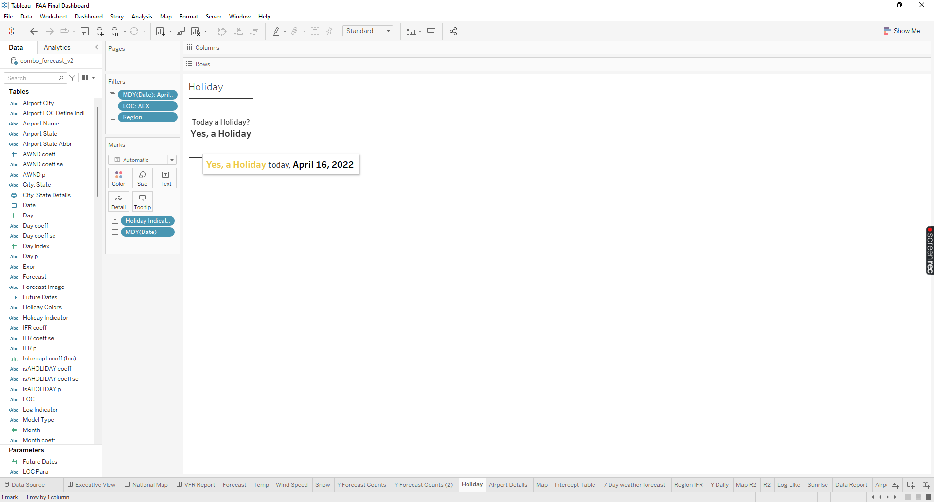Holiday KPI card provides information in regards to whether or not the date you select is a Holiday or not. The tooltip also relays the same information using color and bolding along with the Date.

Figure 8 Holiday KPI card

#### Variables Used

Variables used to create the text is the Holiday Indicator and for the filter Date modified in the MDY format, LOC and Region. The tooltip uses Holiday Indicator and Date.

#### Created Calculated Fields

The only Calculated field is the Holiday Indicator. Leveraging the Is AHoliday[1] variable, the calculated field uses a ElseIF statement to convert the binary values in the Is AHoliday to text responses such as Yes and No. Below is the formula used to create the Holiday Indicator:

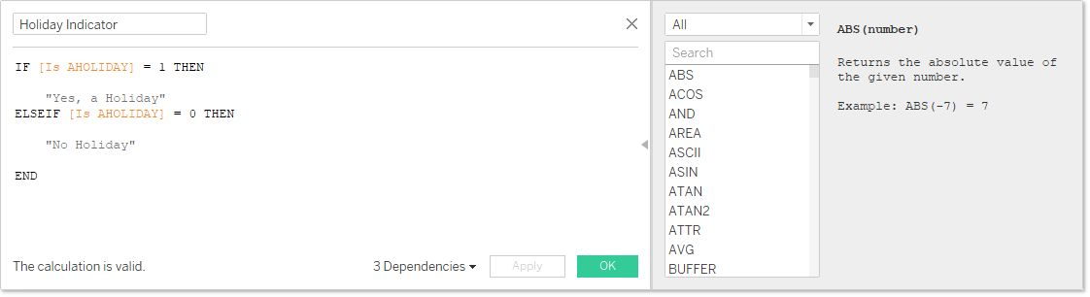

Figure 9 Holiday Indicator formula.

### Weather Forecast KPI

Today’s Forecast KPI card provides information in regards to weather forecast and the probability of precipitation with a arrow indicating where its positive or negative probability. The tooltip also relays the same information using color and bolding along with the LOC variable.

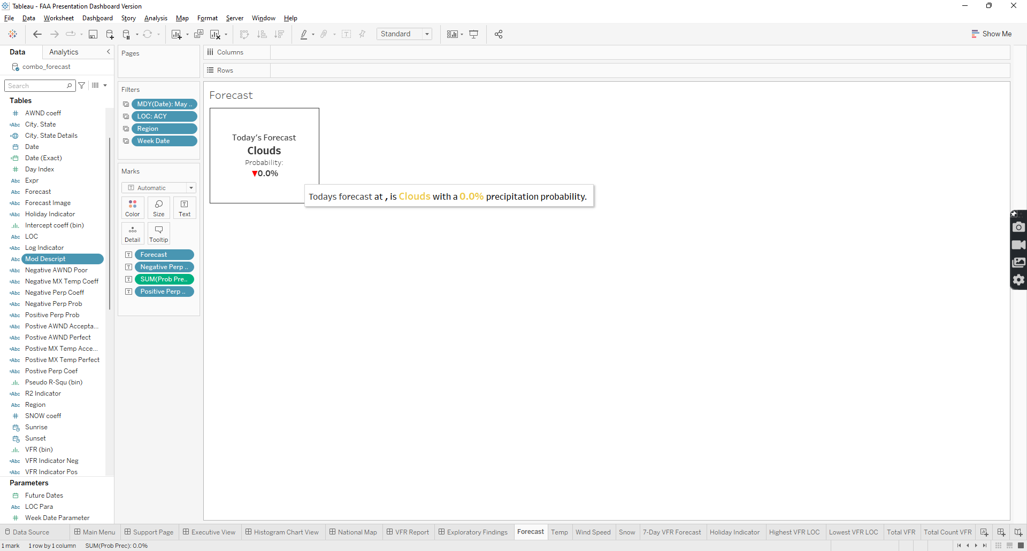

Figure 10 Weather Forecast KPI Card

#### Variables Used

Variables used to create the text are the following: Forecast, Prob Prec, Positive Perp Prob, and Negative Perp Prob. Card is filtered by Date, LOC and Region and tool tip uses LOC, Forecast, and Prob Prec. Next section will clarify the meaning behind each variable and their formulas.

#### Calculated Fields

The calculated fields consist of the following: Positive Perp Prob, and Negative Perp Prob. Table 3 displays the associated alias of the following fields and their purposes. Positive and Negative Perp Prob consist of the Else/IF statement.

Table 3 Calculated Fields in Weather forecast KPI

|  |  |  |  |
| --- | --- | --- | --- |
| **Variable** | **Alias** | **Purpose** | **Formula** |
| Negative Perp Prob | Negative Precipitation Probability | Indicate when precipitation probability is below 50 percent threshold | If [Prob Prec] < .50 then "▼"  END |
| Positive Perp Prob | Positive Precipitation Probability | Indicate when precipitation probability is above 50 percent threshold | If [Prob Prec] > .50 then "▲"  END |

### Max Temperature

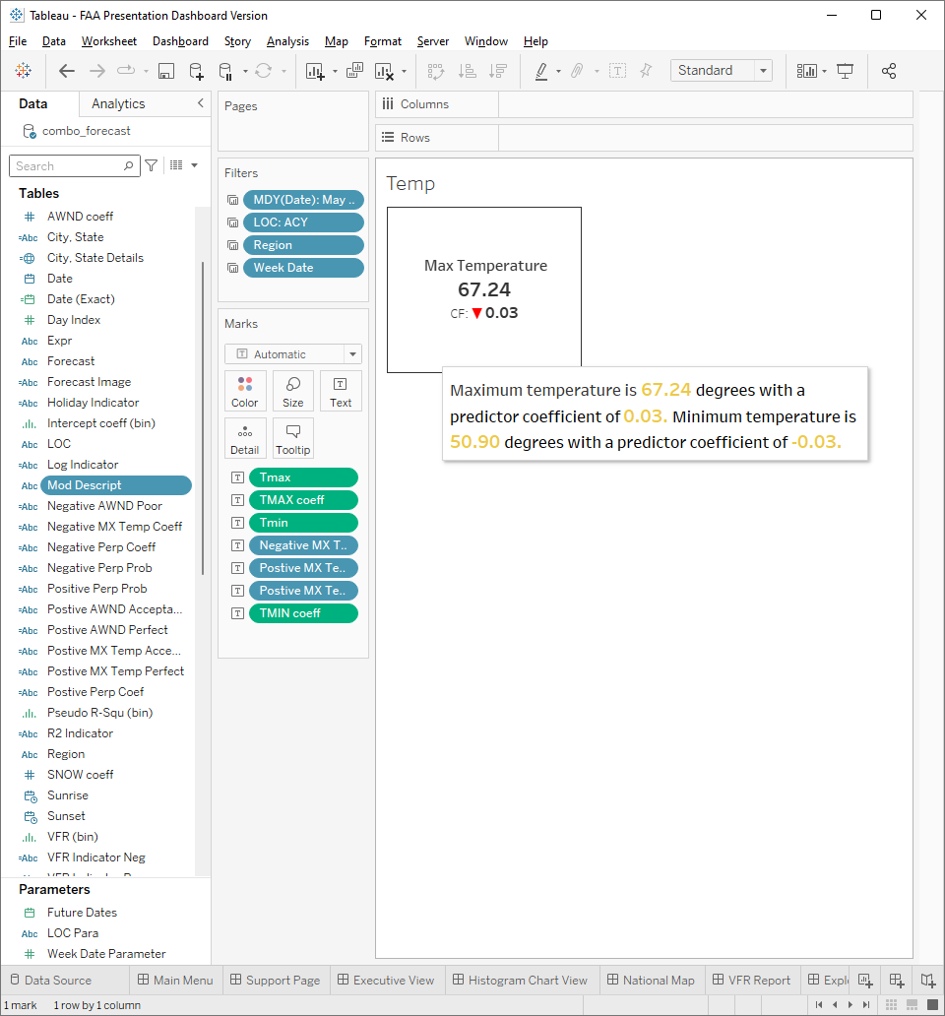Max Temperature KPI card provides information in regards to Maximum Temperature currently along with the predictor coefficient. The tooltip also relays the same information using color and bolding along with the minimum temperature and predictor coefficient.

Figure 11 Max Temp KPI card

#### Variables Used

Variables used to create the text are the Tmax and TMAX coeff variables and the tooltip uses Tmin, TMIN coeff, Negative MX Temp Coeff, Positive MX Temp Acceptable and Positive MX Temp Perfect.

#### Created Calculated Fields

The only Calculated fields are the Negative MX Temp Coeff, Positive MX Temp Acceptable and Positive MX Temp Perfect. Below is the table that provides the formula used to create the calculated fields:

Table 4 Max Temp KPi Variables

|  |  |  |
| --- | --- | --- |
| **Variable** | **Purpose** | **Formula** |
| Negative MX Temp Coeff | Indicate when coefficient is below .50 percent threshold | If [TMAX coeff] < .50 then "▼"  END |
| Positive MX Temp Acceptable | Indicate when coefficient is greater than .60 but less than .79 percent threshold | If [TMAX coeff] >= .60 AND [TMAX coeff] <= .79 then "ᐊ"  END |
| Positive MX Temp Perfect | Indicate when coefficient is greater than .80 percent threshold | If [TMAX coeff] > .80 then "▲"  END |

### Wind Speed

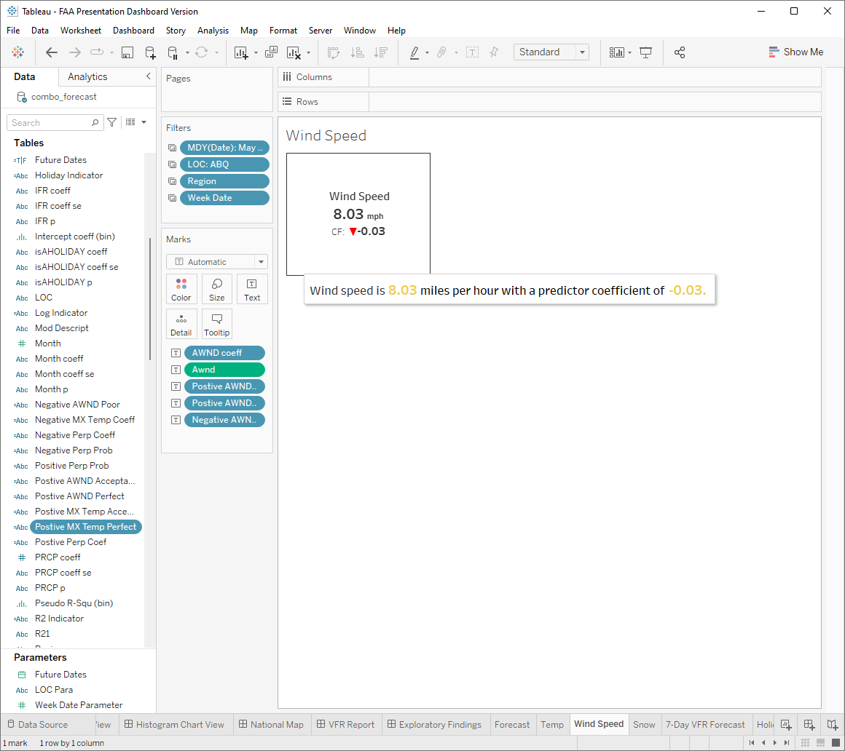Wind speed KPI card provides information in regards to wind speed currently along with the predictor coefficient. The tooltip also relays the same information using color and bolding.

Figure 12 Wind Speed KPI card

#### Variables Used

Variables used to create the text are the AWND coeff, Awnd and the tooltip uses Positive AWND Acceptable, Positive AWND Perfect, Negative AWND Poor in addition to the variables used in the text.

#### Created Calculated Fields

The only Created Calculated field are the Positive AWND Acceptable, Positive AWND Perfect, Negative AWND Poor. Below is the table that provides the formula used to create the calculated fields:

Table 5 Wind Speed KPI Variables

|  |  |  |
| --- | --- | --- |
| **Variable** | **Purpose** | **Formula** |
| Negative AWND Poor | Indicate when coefficient is below .50 percent threshold | If [AWND coeff] < .50 then "▼"  END |
| Positive AWND Acceptable | Indicate when coefficient is greater than .60 but less than .79 percent threshold | If [AWND coeff] >= .60 AND [AWND coeff] <= .79 then "ᐊ"  END |
| Positive AWND Perfect | Indicate when coefficient is greater than .80 percent threshold | If [AWND coeff] > .80 then "▲"  END |

### Model Type KPI

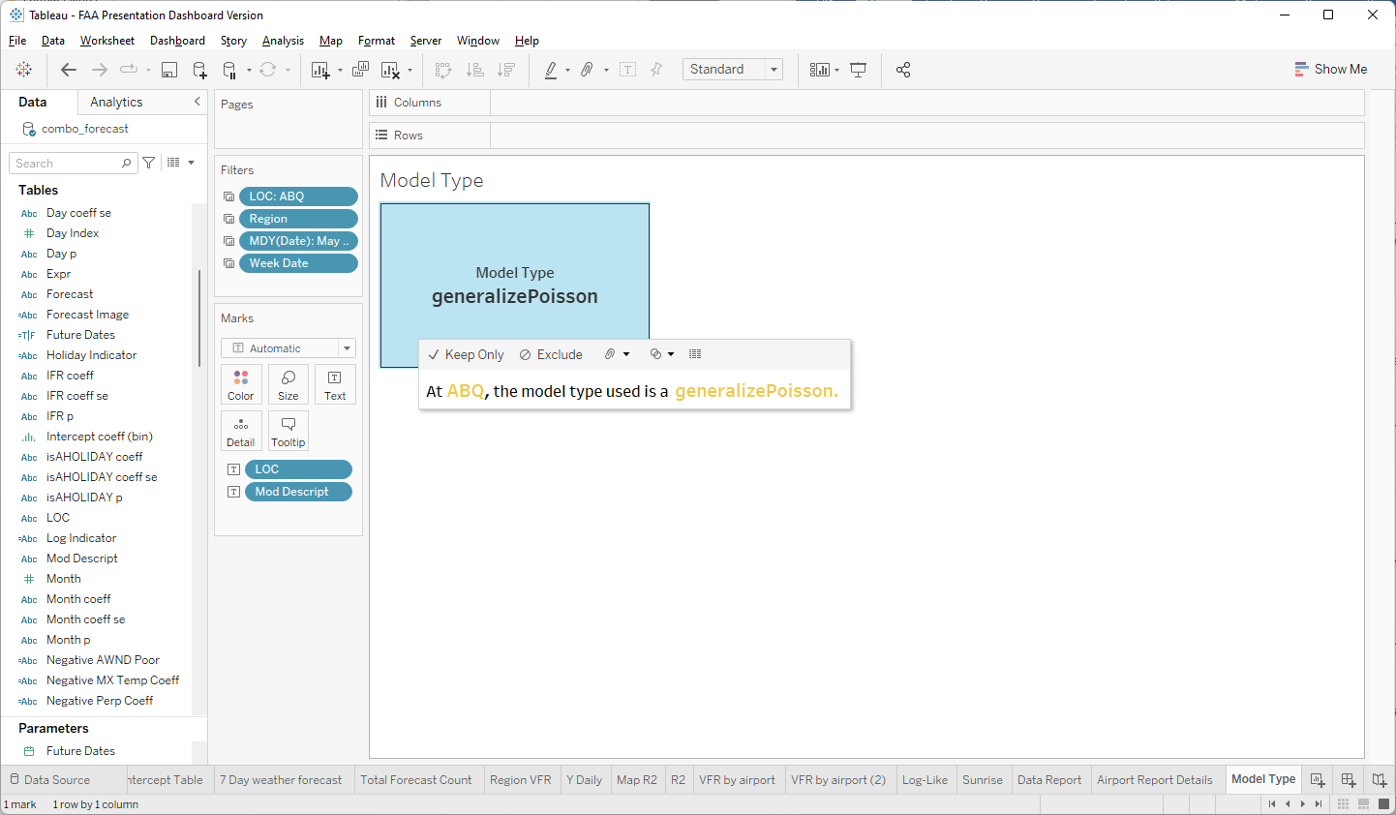 Model Type KPI provides information regarding what model was used for the selected airport.

Figure 13 Model Type KPI card

#### Variables Used

Variables used to create the card are the following: LOC and Mod Descript and the same information is relayed in the tooltip.

### Model Expression

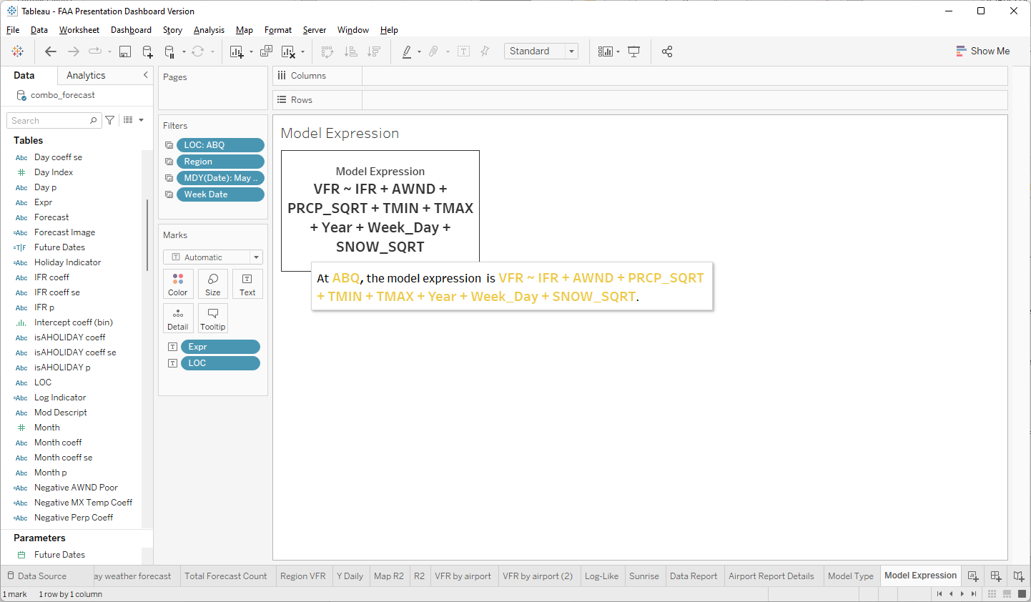 Model Expression KPI provides information regarding what the models expression is for the selected airport.

Figure 14 Model Expression KPI card

#### Variables Used

Variables used to create the card are the following: LOC and Expr and the same information is relayed in the tooltip.

## Tables

Within the Executive Summary, there are tables that provide in depth information pertaining to statistical analysis, time, and weather details. Tables tooltips allows for more information to be provided also explain further to what is already displayed. The following sections will focus on tables developed in the Executive summary.

### 7 – Day Weather Forecast

The table shows weather and climate information over a 7 day period that can be further drilled down by the week number. The table displays Date, Weekday, Temperature, Weather forecast name and image, and Week number.

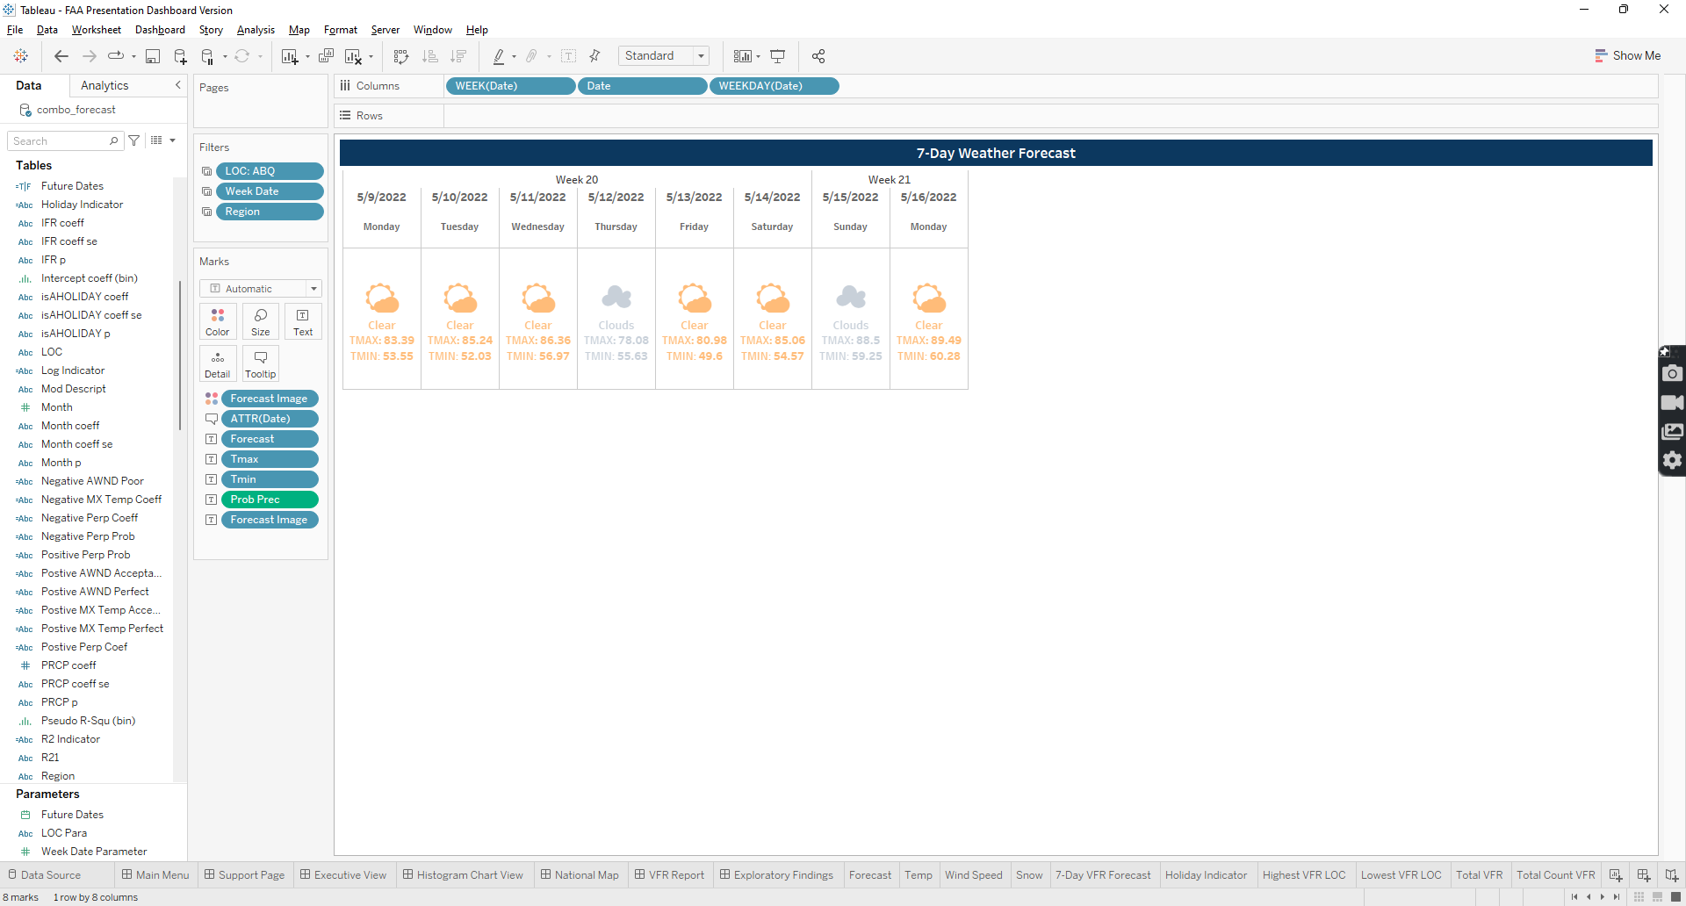

Figure 15 Predicted weather forecast table

#### Variables Used

Variables used to create the text are the Date, WEEK(Date), WEEKDAY(Date), Weather forecast, Tmax, Tmin, and Forecast Image. The tooltip contains in addition to the previous variables mentioned, probability of precipitation.

#### Created Calculated Fields

The only created Calculated field was the Forecast image where, following an Else/IF statement formula, forecast variable will define specific Forecast values and then indicated values will display an image that is associated with the value stated. Below is the following formula:

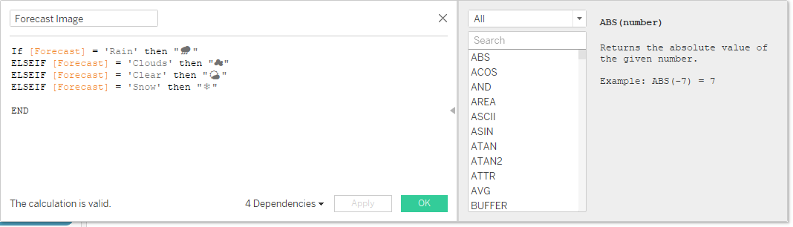

Figure 16 Forecast Image Calculate Field formula

### Sunrise and Sunset Table

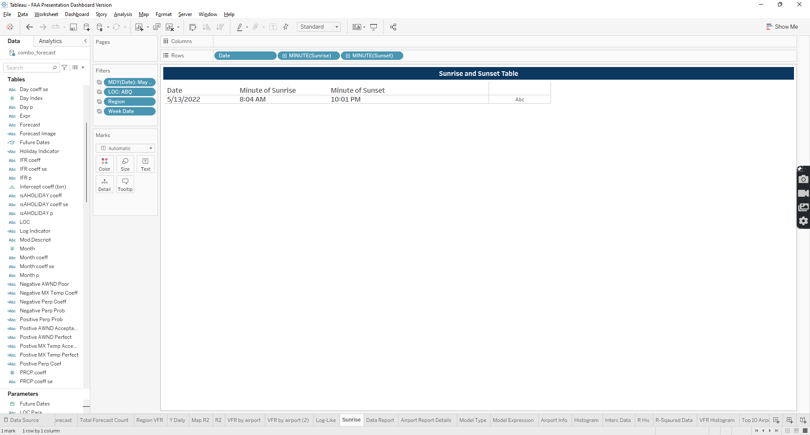 The table shows information pertaining to sunrise and sunset times along with the date.

Figure 17 Sunrise and Sunset Table

#### Variables Used

Variables used to create the table are the following: Date, MINUTE(Sunrise), MINUTE(Sunset).

### Daily Intercept and Log Table

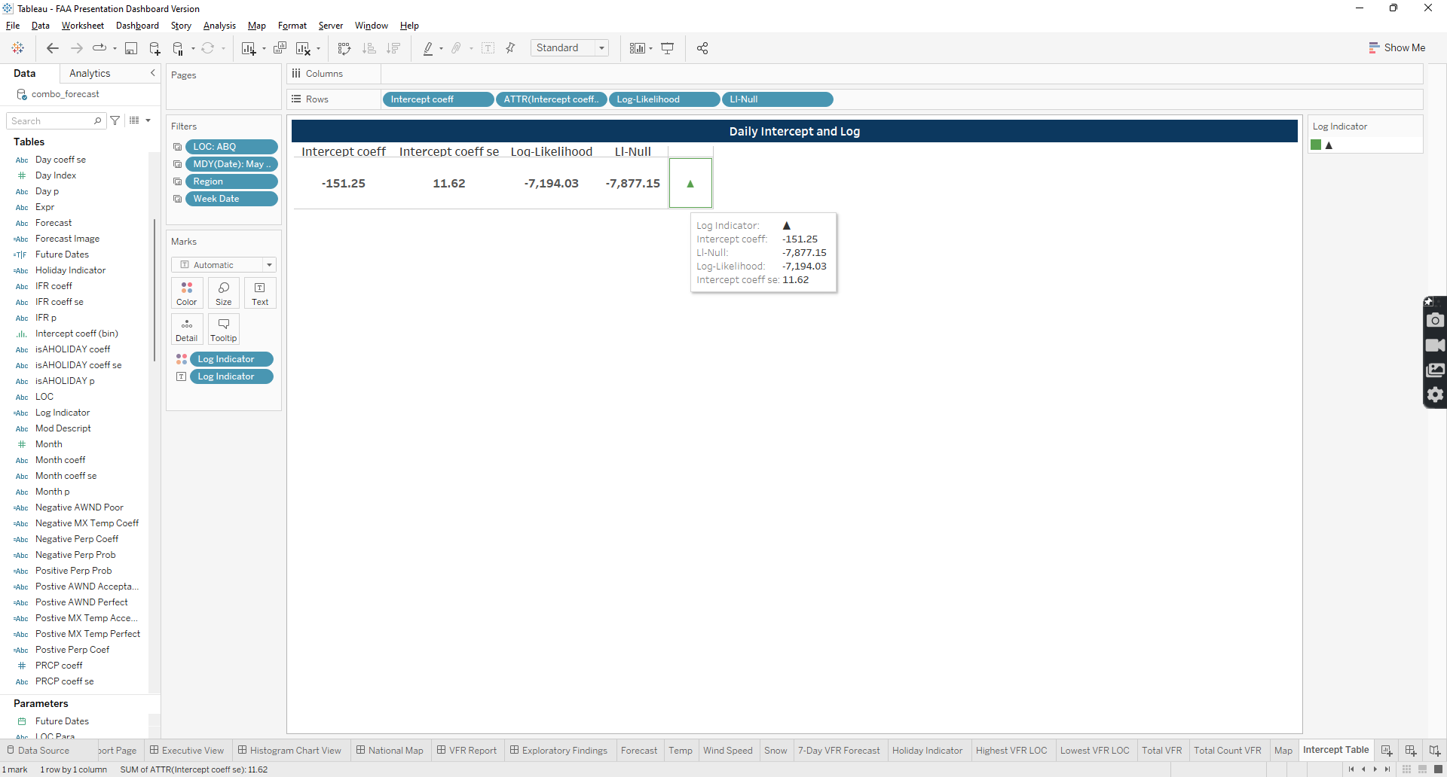 The table shows information pertaining to statistical analysis data such as intercept, intercept coefficient, intercept coefficient se, log-likelihood, Li-Null and a Log indicator.

Figure 18 Daily Intercept and Log Table

#### Variables Used

Figure 12 Daily Intercept and Log Table variables, filters and text display

Variables used to create the table are the following: Intercept Coeff, Intercept Coeff Se, Log-Likelihood, Li-Null, Log Indicator and the same information is relayed in the tooltip.

#### Created Calculated Fields

The only created Calculated field is the Log Indicator which uses Else/IF statements to compare the Log-Likelihood and Li-Null variables to each other and provide a indicating arrow whether or not Log-Likehood is greater than or less than Li-Null. Below is the formula:

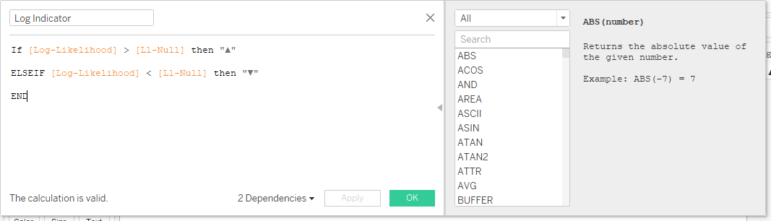

Figure 19 Log Indicator Calculate Field formula

## Charts

Within the Executive Summary, there are line graphs and charts that provide period ranged data, grouped by category, standalone charts and other views on VFR with certain factors applied to them.

### 7 – Day Predicted Forecast

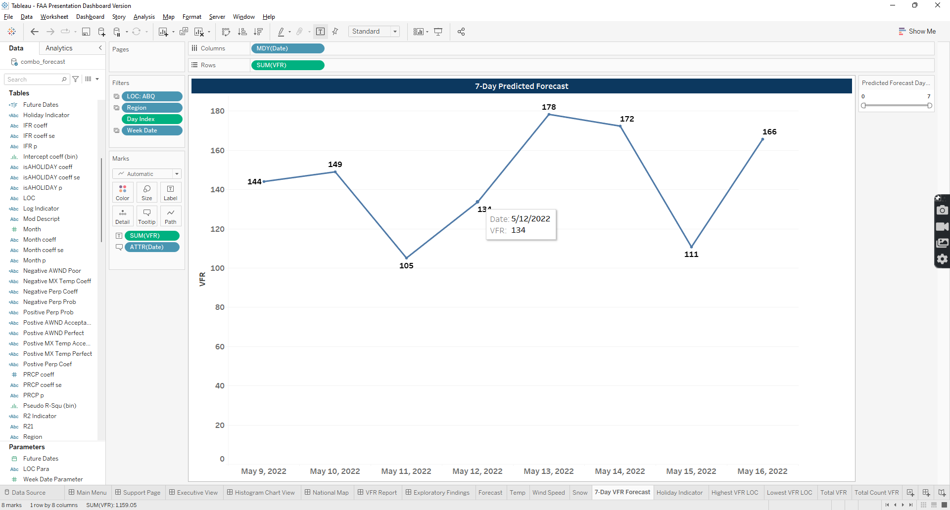Chart provides total VFR values over a 7-day period that can be further drilled downed using the Day index variable as a filter. Tool tip will relay the same information along with the date.

Figure 20 7-day predicted forecast chart

#### Variables Used

Variables used to create the text is the VFR and the tooltip uses VFR and Date. The Day Index is used as a slide filter.

### Pseudo R-Squared By Airport

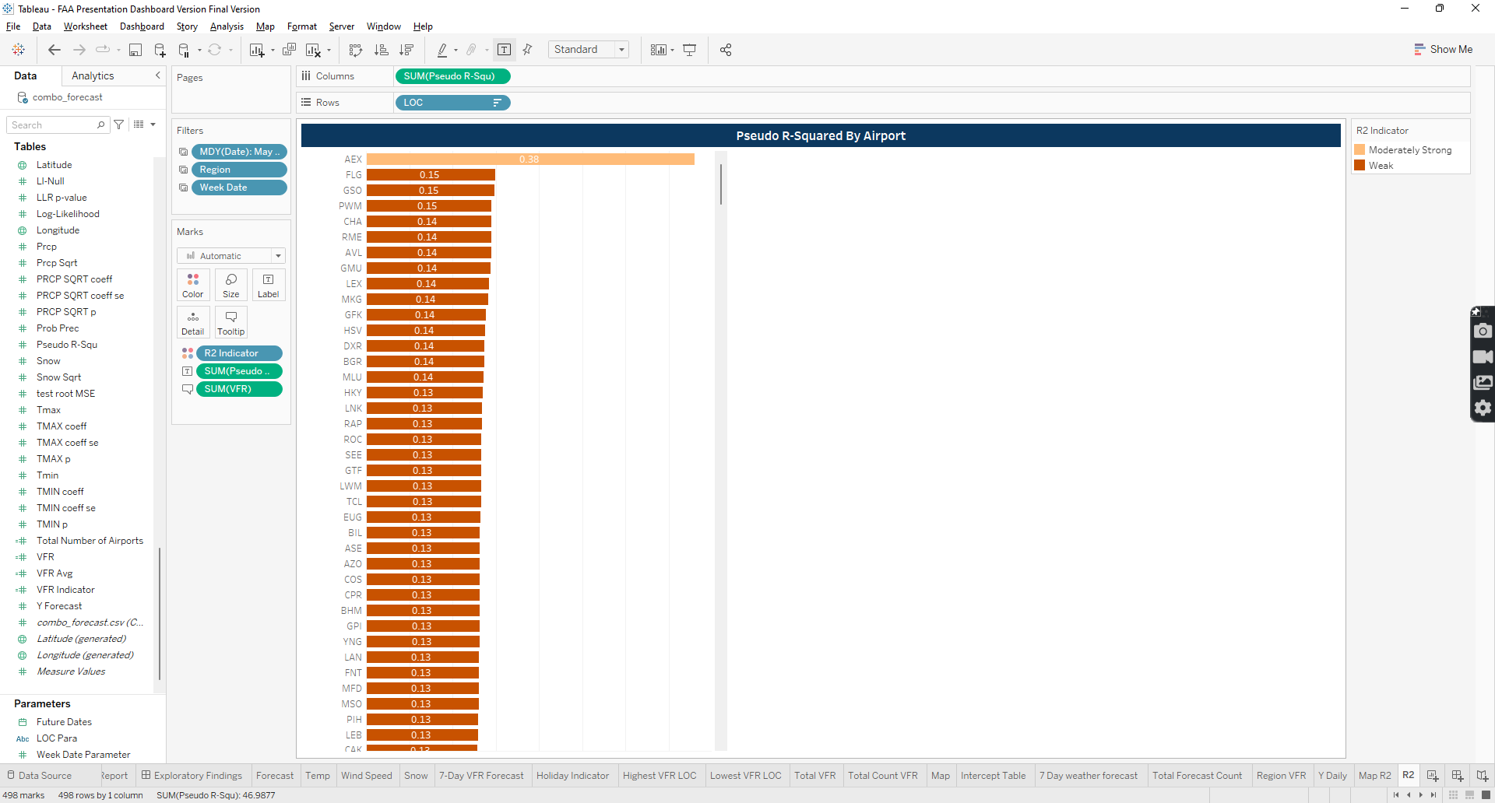The chart provides information in regards to LOC by Pseudo R-Squared along with a R2 indicator and VFR value.

Figure 21 Pseudo R Squared Bar Chart by LOC

#### Variables Used

Variables used to create the bar chart are the following: LOC, SUM(Pseudo R-Squ), R2 Indicator and SUM(VFR) and the same information is relayed in the tooltip.

#### Created Calculated Fields

The only created Calculated field is the R2 Indicator which uses Else/IF statements to compare the Pseudo R-Squ to different thresholds. Below is the formula:

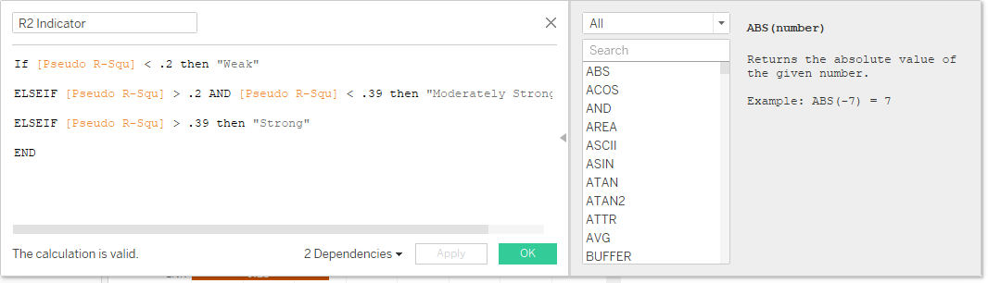

Figure 22 R2 Indicator Calculate Field formula

### Current VFR Forecast

The Current VFR Forecast bar chart provides information regarding total VFR value, the average VFR and a VFR indicator.

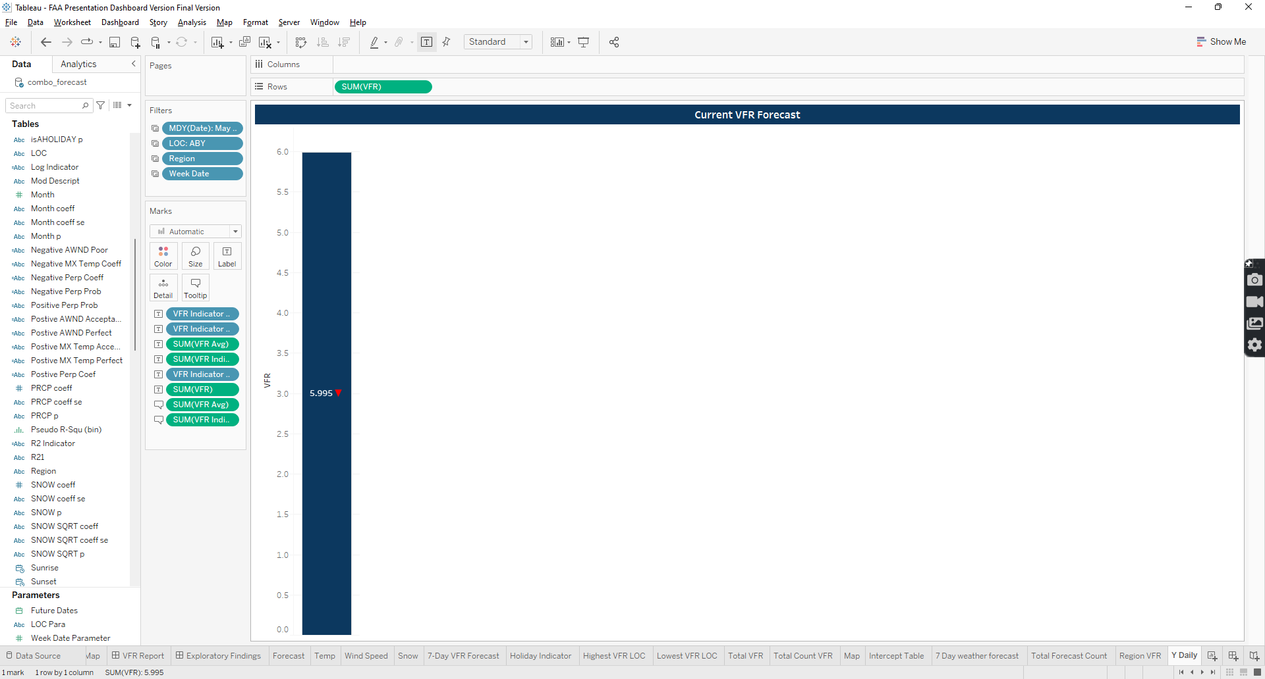

Figure 23 Current VFR Forecast Bar Chart

#### Variables Used

Variables used to create the bar chart are the following: SUM(VFR), VFR Indicator Neg, VFR Indicator Pos, VFR Indicator, and VFR Avg and the same information is relayed in the tooltip.

#### Created Calculated Fields

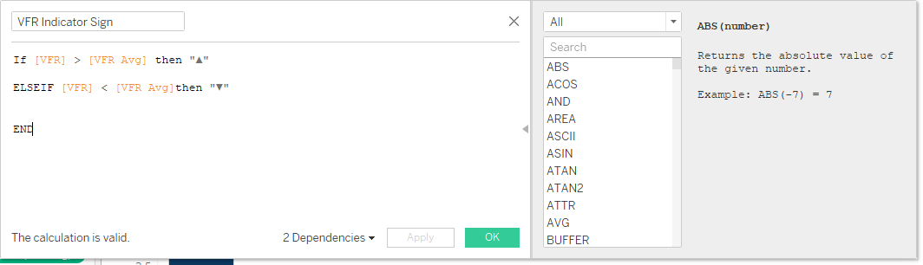The only created Calculated field are the VFR Avg, VFR Indicator Neg, VFR Indicator Pos, VFR Indicator sign, which uses Else/IF statements to compare the VFR Value to the VFR Avg. Below is the formula:

Figure 24 VFR Indicator Calculate Field formula

### Average Pseudo R-Squared and Total VFR By Region

The Average Pseudo R-Squared and Total VFR By Region bar chart, as stated in the name, provides information regarding total VFR value, the Average VFR and Average Pseudo R-Squared by region.

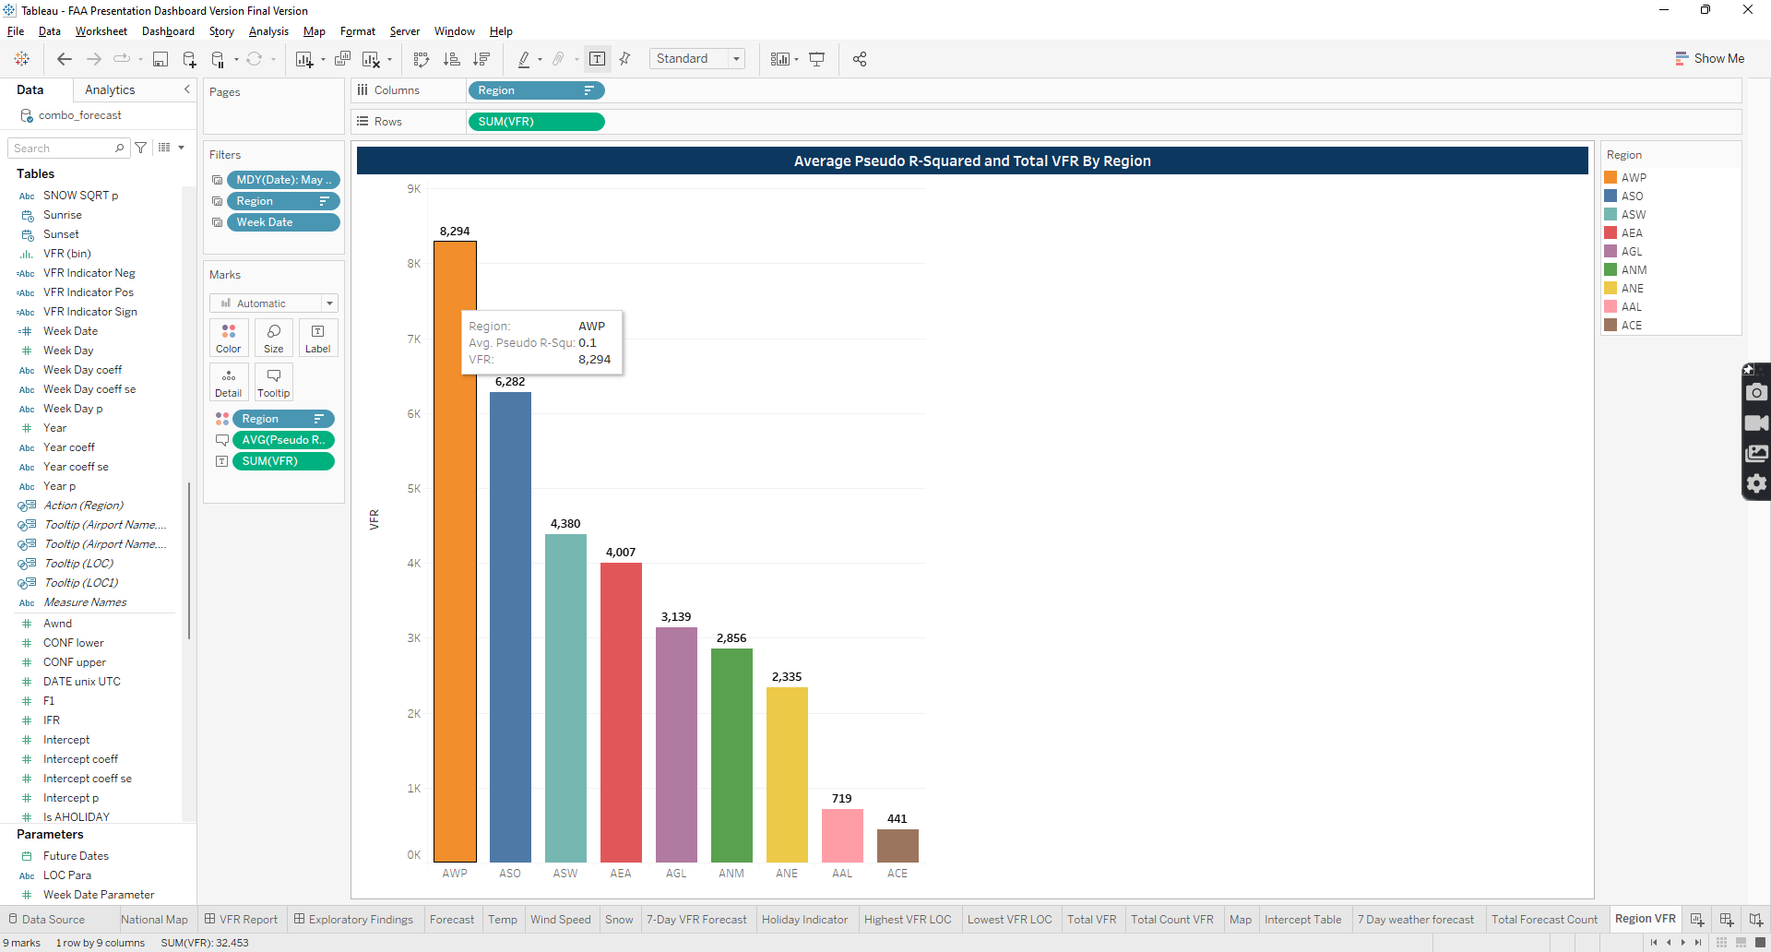

Figure 25 Average Pseudo R-Squared and Total VFR By Region Bar Chart

#### Variables Used

Variables used to create the bar chart are the following: Region, SUM(VFR) and Avg(Pseudo R-Squared) and the same information is relayed in the tooltip.

# Histogram Chart View

Histogram Chart view is an extension of two charts found on the Executive Summary view that have been expanded to full screen. There are no filters on the page and both have buttons that Show/Hide the charts to allow for the screen to be expanded. The next sections will focus on the charts and the associated tables.

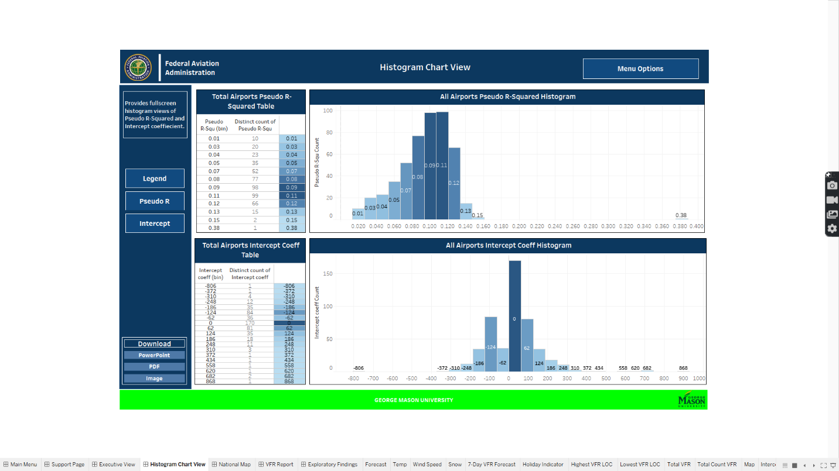

Figure 26 Histogram Chart View

## Charts

There are two histogram charts that were created that focused on Pseudo R-square and Intercept coefficient of VFR values. The following sections will focus on the calculated fields used in addition to information that maybe observed in the tooltip.

### All Airports Pseudo R-Squared Histogram

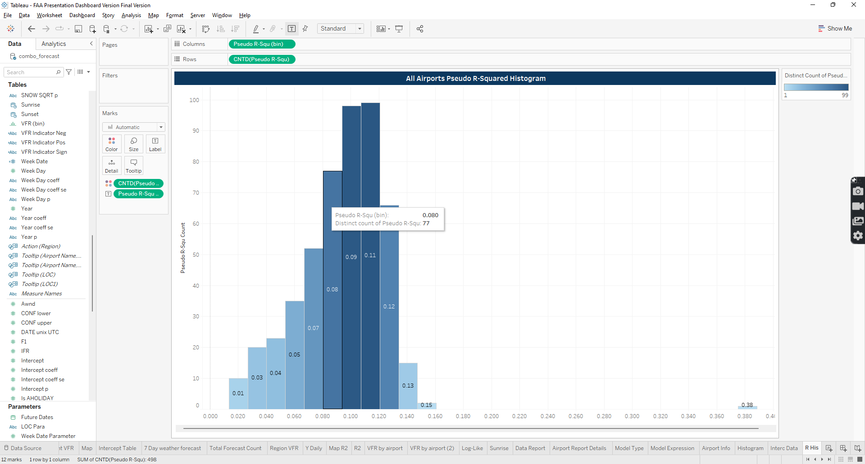The histogram provides information that pertains to the frequency of Pseudo R-Squared and their distinct count within the dataset across all airports.

Figure 27 All Airports Pseudo R-Squared Histogram

#### Variables Used

Variables used to create histogram are the following: Pseudo R-Squared (bin) and CNTD(Pseudo R-Squared) and the same information is relayed in the tooltip.

### All Airports Intercept Histogram

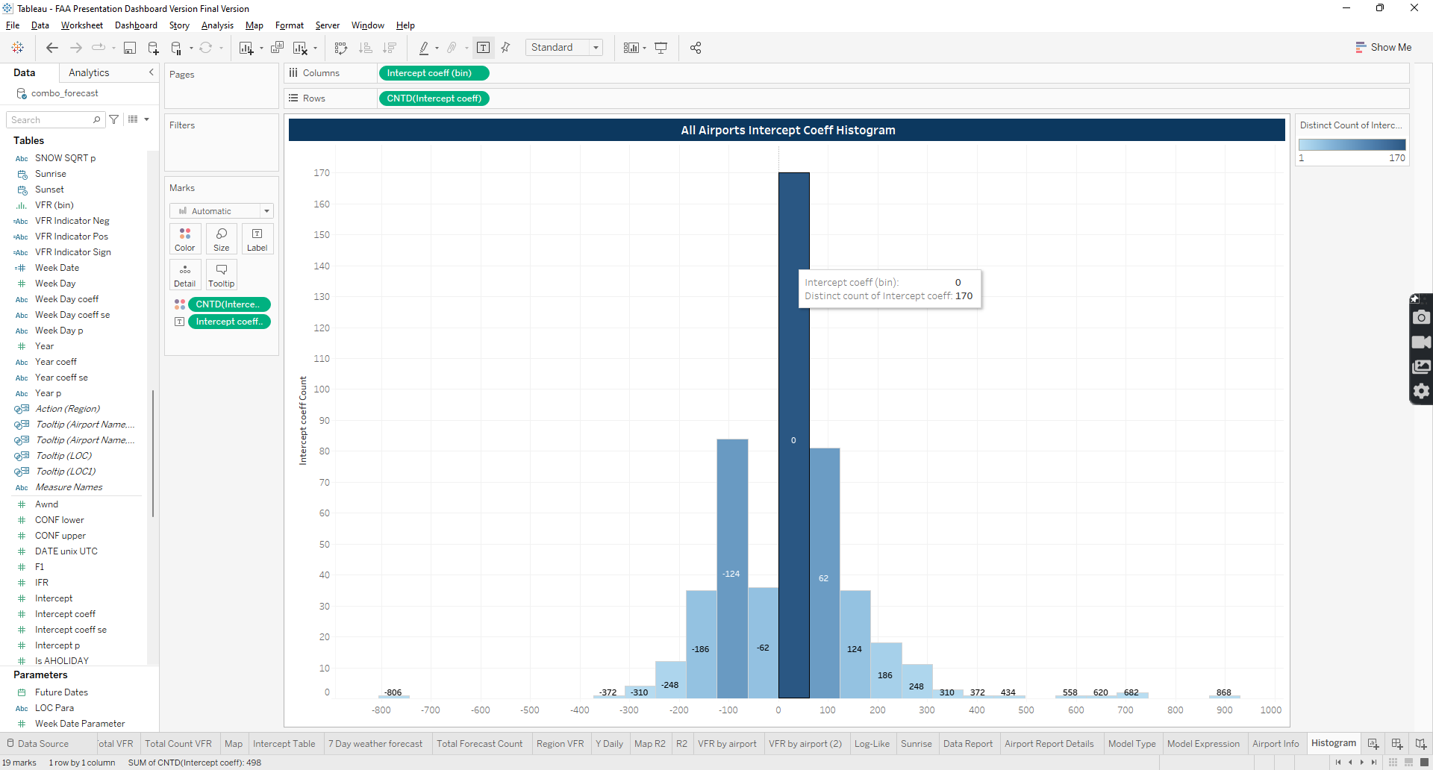The histogram provides information that pertains to the frequency of Intercept Coeff and their distinct count within the dataset across all airports.

Figure 28 All Airports Intercept Coeff Histogram

#### Variables Used

Variables used to create histogram are the following: Intercept Coeff (bin) and CNTD(Intercept Coeff) and the same information is relayed in the tooltip.

## Table

There are two tables associated with the histograms that provide the distinct count and bin for each histogram.

### Total Airports Pseudo R-Squared and Intercept Coefficient Tables

The table relays the same information found in the histogram and also uses the same variables.

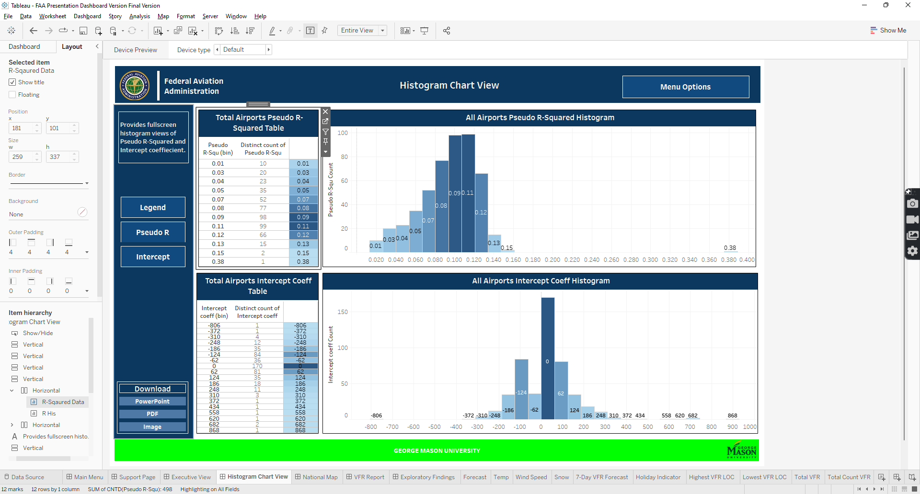

Figure 29 Total Airports Intercept Coeff Table



Figure 30 Total Airports Pseudo R-Squared Table

# National Map View

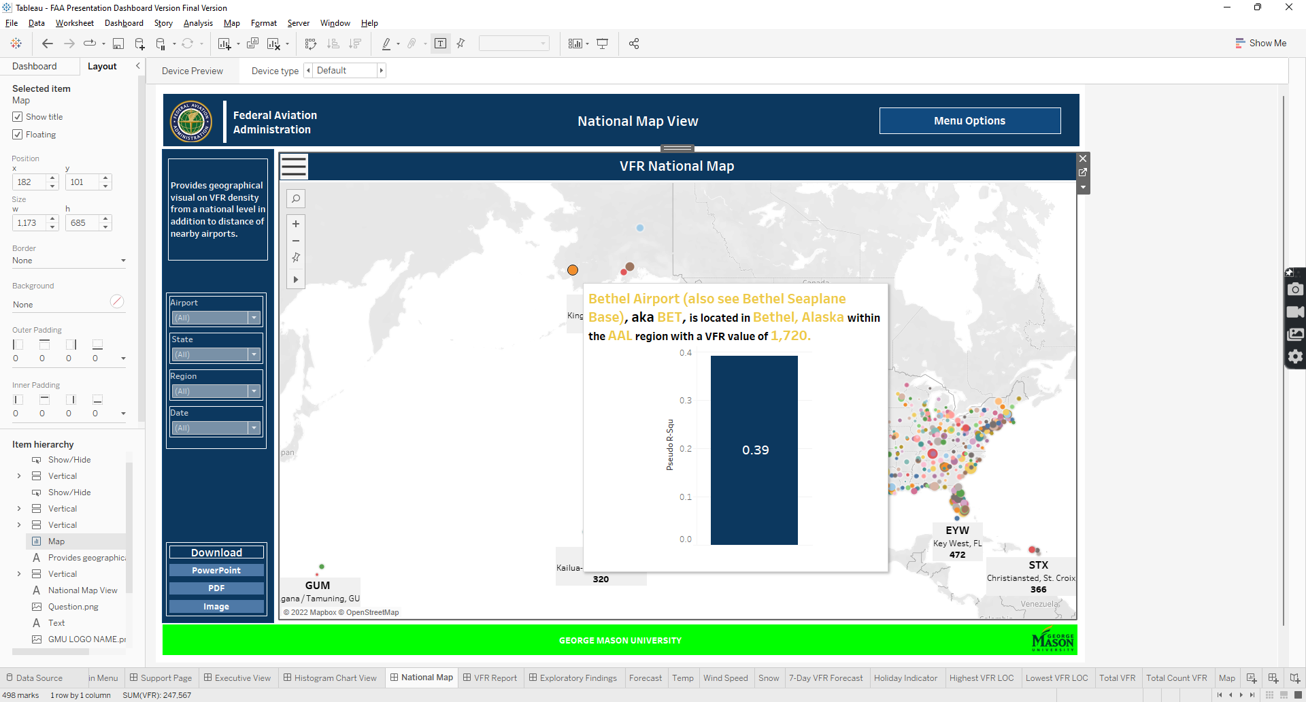There are several calculated fields that are leveraged from the Executive summary view for the National Map. In this section, we will go through the applied filters and formulas created. In addition, we will also discuss additional features that were implemented for functionality.

Figure 31 National Map View

Figure 32 VFR Details Content

## Filters

There are 4 main filters applied on the National Map sheet and also apply to the other pages in the dashboard that share the filter: Date, Airport Name, Region and State. The Date is formatted in the MDY format. The state is a calculated field created and can be review in section Airport Details KPI card.

Figure 33 National Map filters

## Variables Used

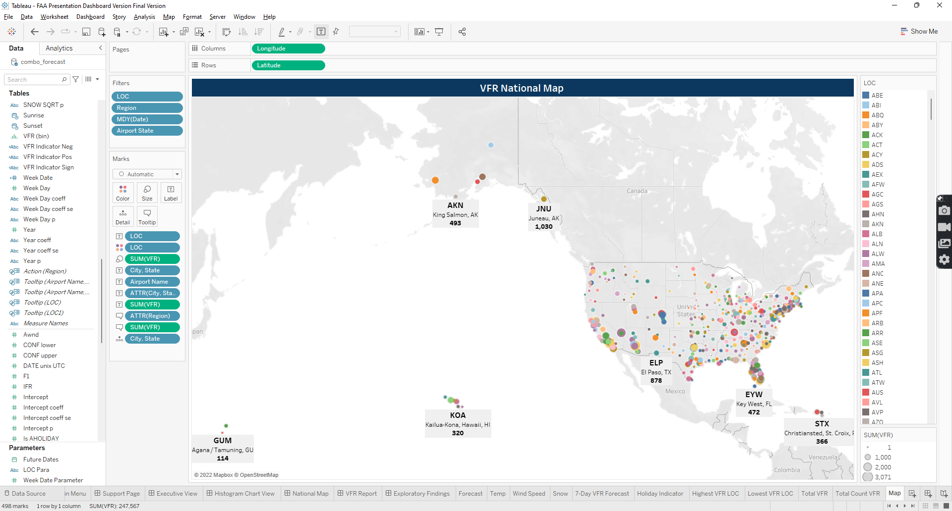Variables used to create the map are the following: Longitude, Latitude, LOC, SUM(VFR), City, State, Airport Name, and Region. Many of the variable are used to generate the map, color code, label and provide details upon filtering.

Figure 34 National Map Variables

## Calculated Fields

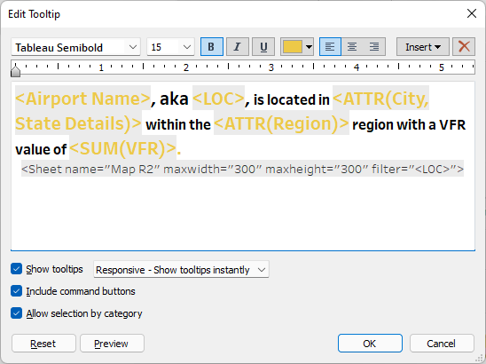There are several calculated fields in the map that pertain to location, specifically, City, State and Airport Name. Both calculations can be found in the Airport Details Calculated Fields section. In additional, there is an embedded bar chart in the tool tip that is displayed upon hovering over airports. Tool tip references the chart to be embedded in the tool tip.

Figure 35 National Map Tool Tip

### Map R2 Bar Chart

#### A chart was created specifically to be used in the National Map sheet. The chart is composed of SUM(Pseudo R-Squ) variable.

Figure 36 Map R2 Bar Chart

# VFR Report

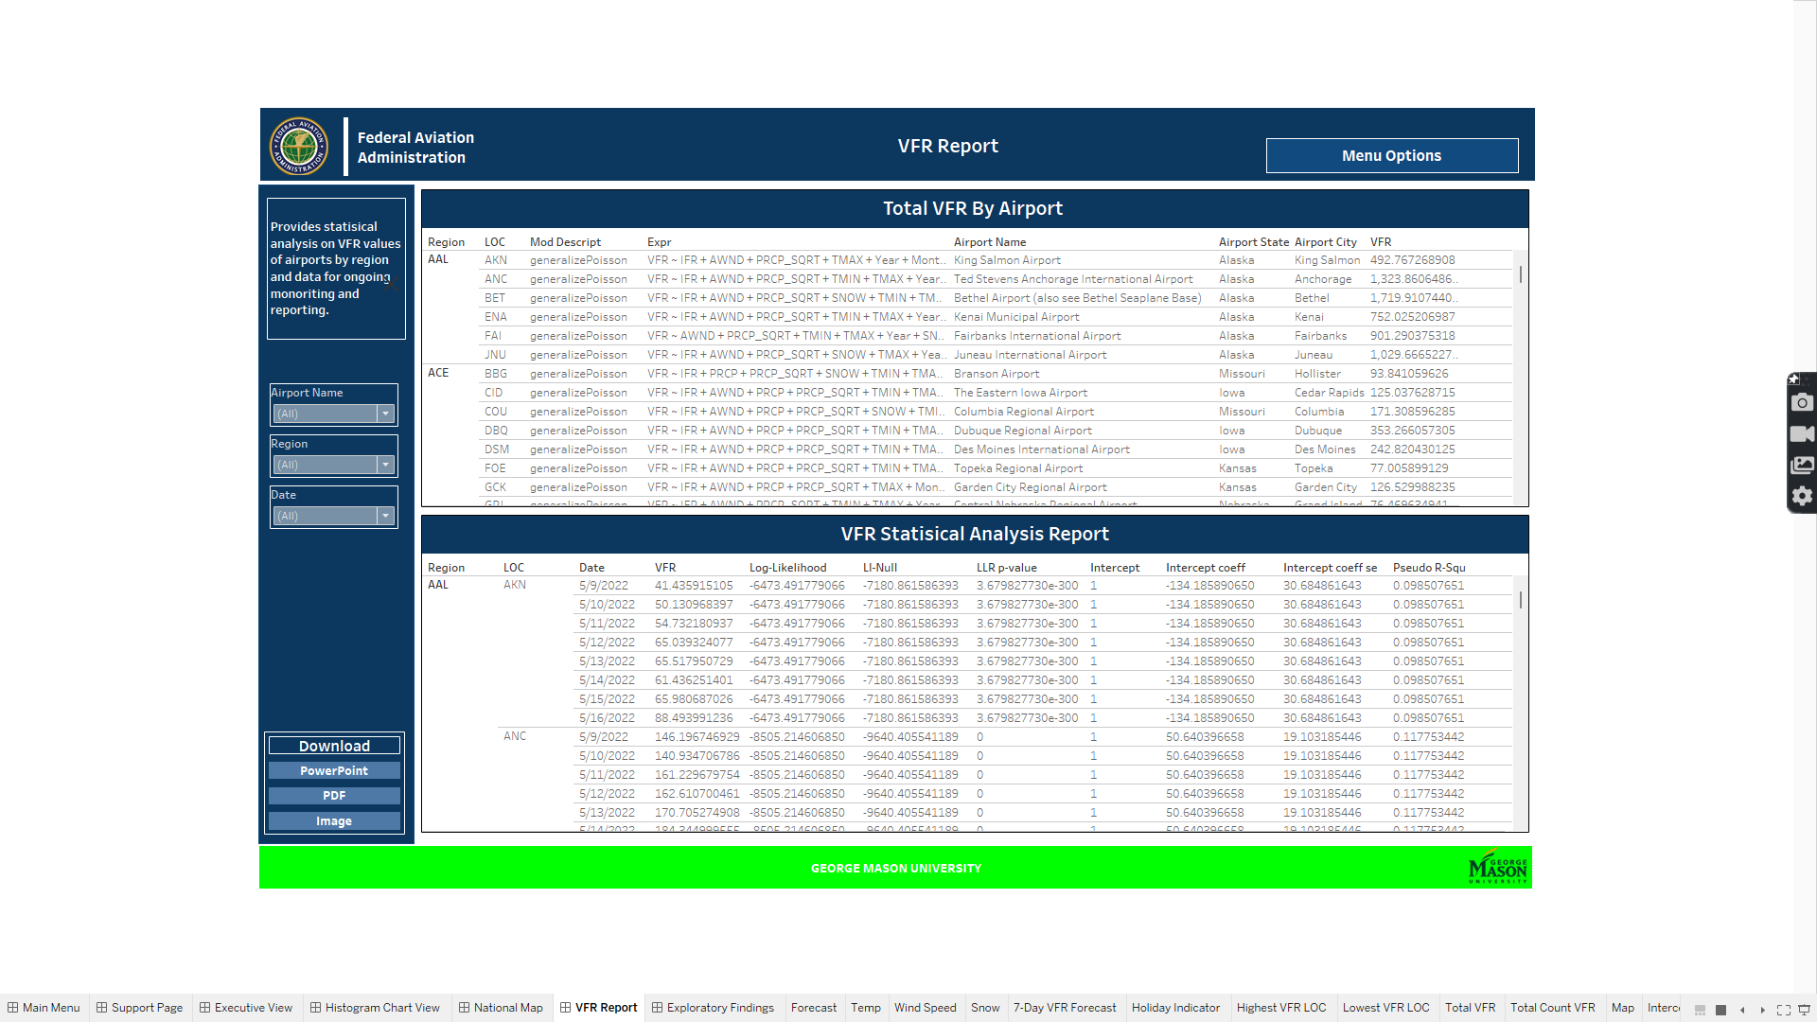This section we will go through 2 tables that provide details in regards to airport information and statistical analysis.

Figure 37 VFR Report

## Filters

There are 3 main filters: Date, Region and LOC. Each can filter the page and change the values to show different grouping and dates associated with the stats and VFR total values.

Figure 38 VFR Report Filters

## Tables

The tables that will be discussed contain many variables from the Airport Details KPI so please refer to that section in regards to the calculated fields mentioned in the next section.

### Total VFR By Airport

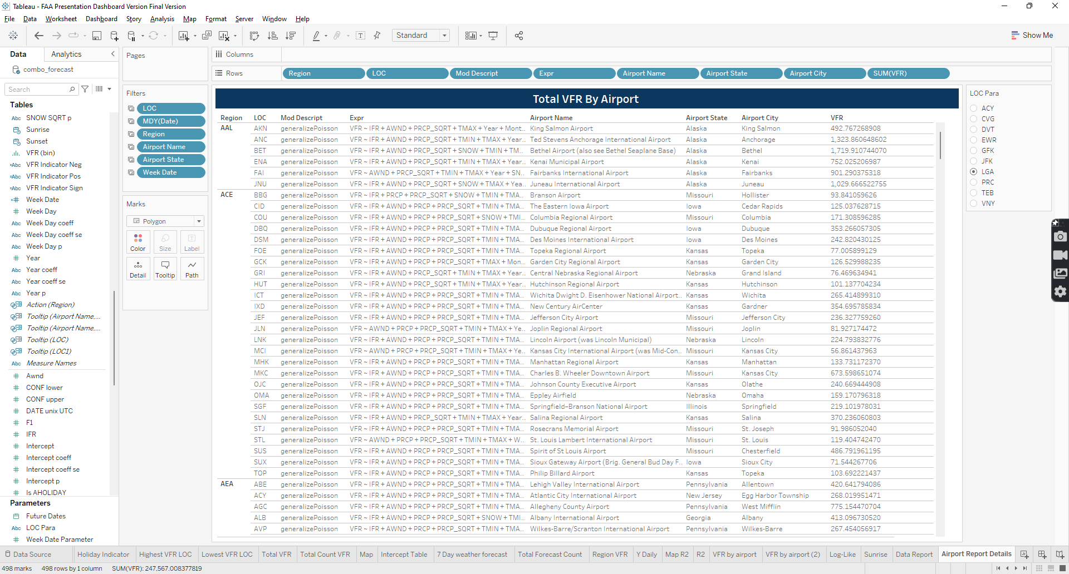The table provides information in regards to model type, expression, airport location, region, full name of the airport and total VFR.

Figure 39 Total VFR By Airport Variables

#### Variables Used

Variables used are the following: Region, LOC, Mod Descript, Expr, Airport Name, Airport State, Airport City and SUM(VFR).

#### Calculated Fields

The following are calculated fields: Airport Name, State and city and the formula for each can be found the Airport Details KPI section.

### VFR Statistical Analysis Report

The table provides information in regards to the statistical analysis performed on the model in refence to measuring VFR.

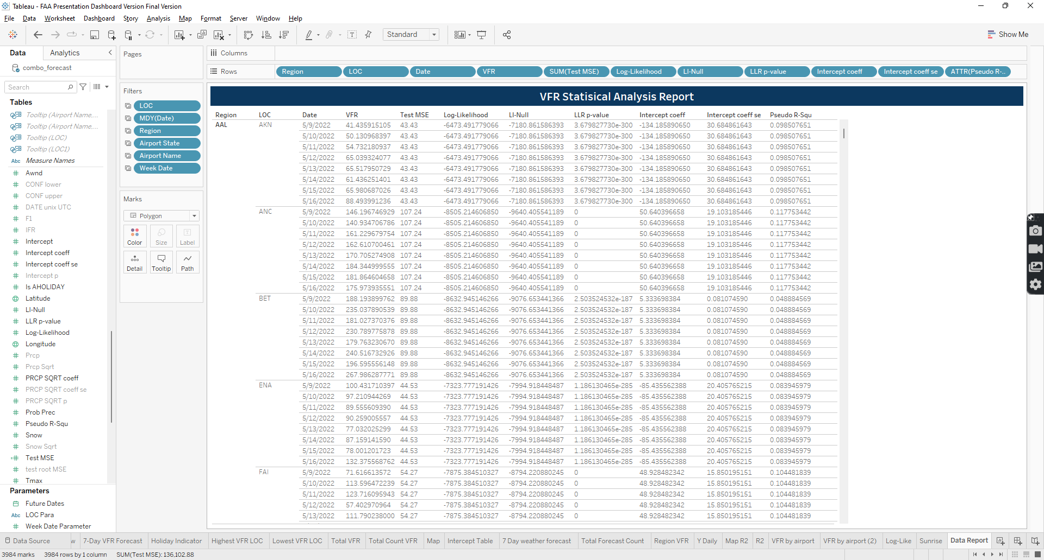

Figure 40 VFR Stat Analysis Report Variables

#### Variables Used

Variables used are the following: Region, LOC, Date, VFR, Test MSE, Log-Likelihood, Ll-Null, LLR p-Value, and Intercept coeff.

#### Calculated Fields

The following are the calculated fields: Airport Name, State and city, and the formula for each can be found the Airport Details KPI section.

# Exploratory Findings

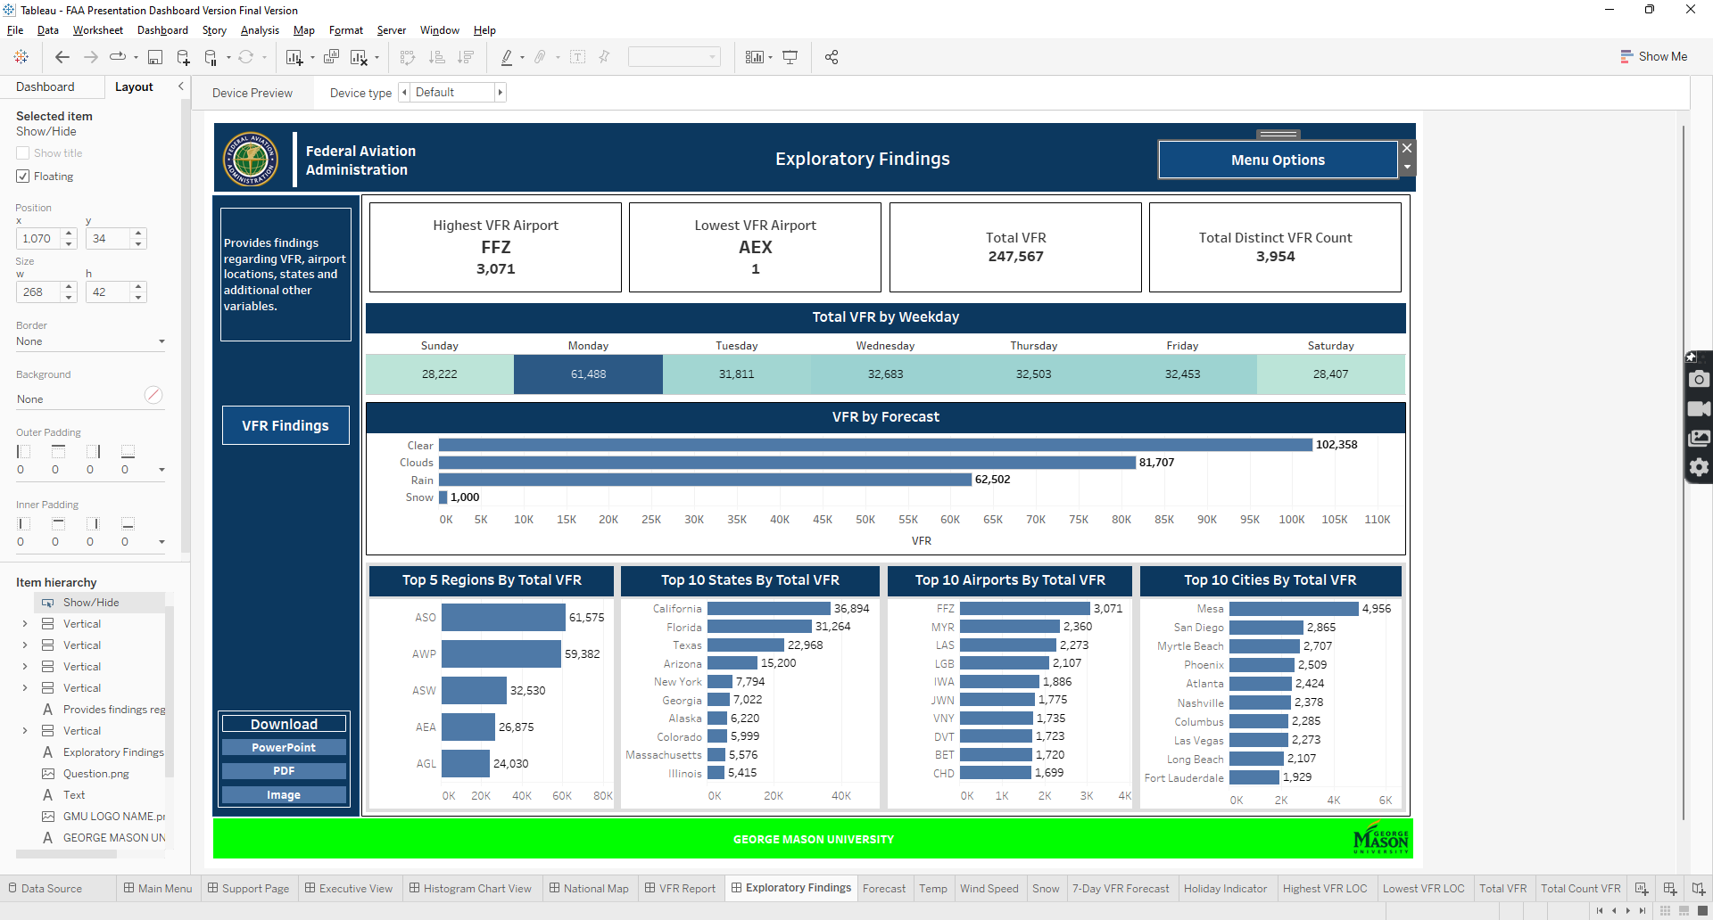Exploratory findings page focuses on exploring the data in regards to VFR and finding insight from a big picture stand point. This page has several KPIs and charts that provide insight in specific areas. This section will explore each chart type and provide information regarding variables and calculated fields.

Figure 41 Exploratory Findings Page

## KPI

There are 4 KPi cards created that provide an overall total in regards to VFR. Next section will focus on each of the KPI’s.

### Highest VFR Airport

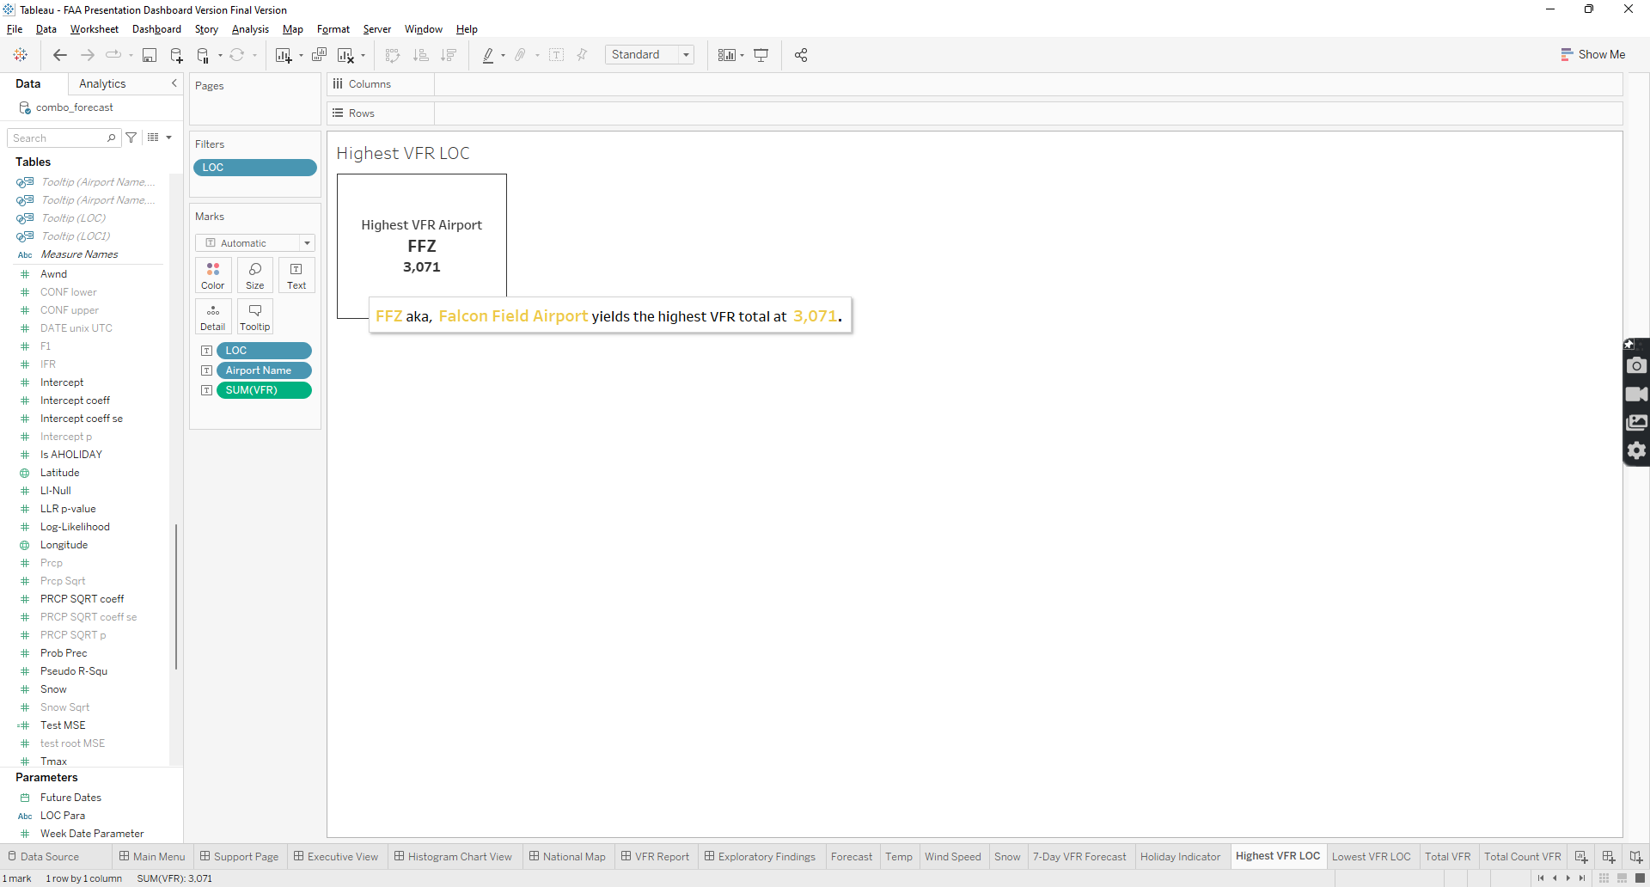The KPI provides information on the number one airport with the highest total VFR. The variables composed in the card are LOC, Airport Name, a calculated filed that can be refer to in Airport Details Calculated Fields, and SUM (VFR). The card is also filtered by LOC with following condition in Figure 43.

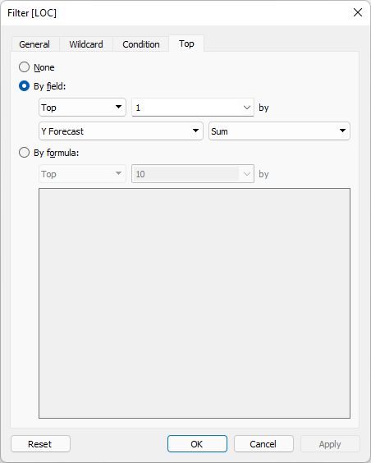

Figure 42 Highest VFR Airport filter Condition

Figure 43 Highest VFR Airport KPI Variable

### Lowest VFR Airport

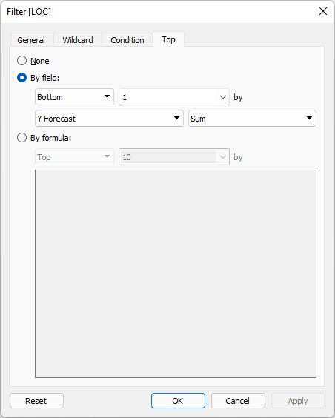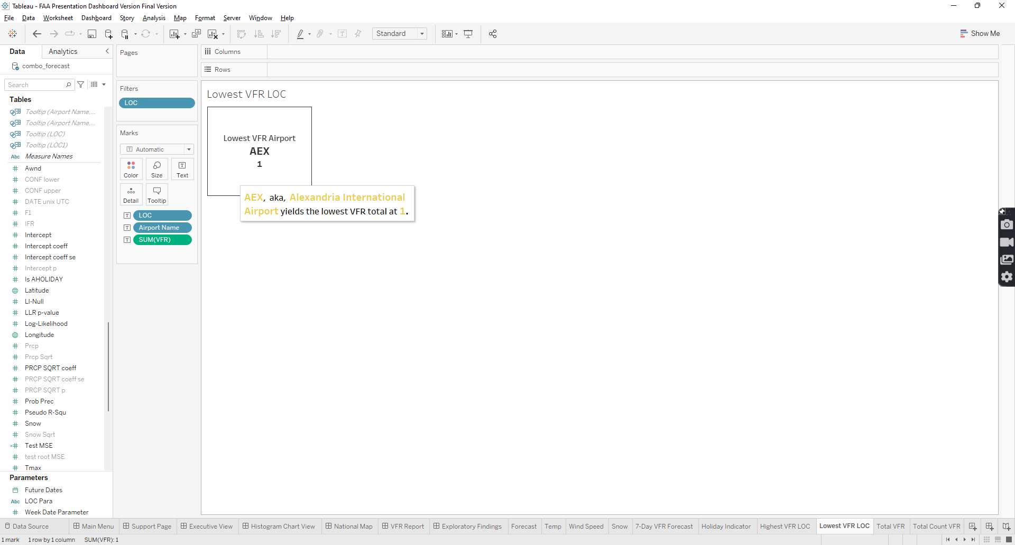The KPI provides information on the number airport with the lowest total VFR. The variables composed in the card are LOC, Airport Name, a calculated filed that can be refer to in Airport Details Calculated Fields, and SUM (VFR). The card is also filtered by LOC with following condition in Figure 45.

Figure 44 Lowest VFR Airport

Figure 45 Lowest VFR Airport Filter Condition

### Total VFR

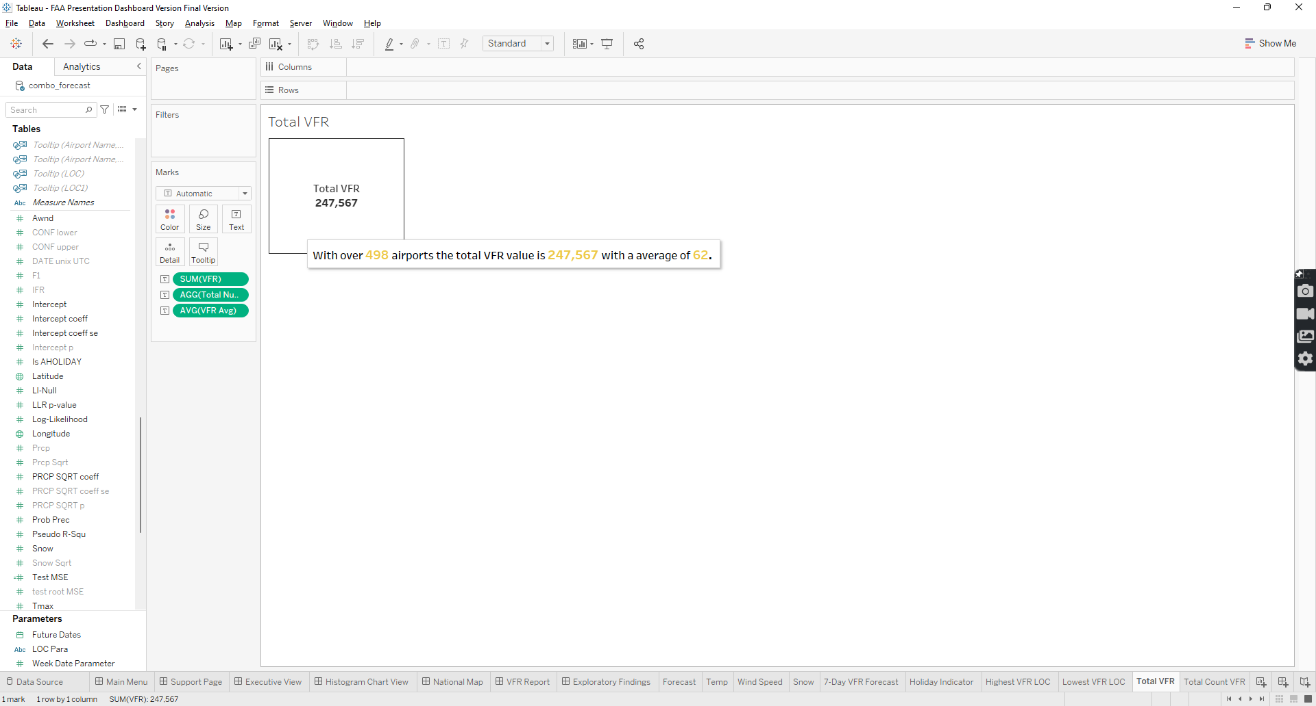The KPI provides information on the overall total of VFR. The variables composed in the card are SUM(VFR), Total Number of Airports, calculated field which is distinct counts LOC variable, and VFR Avg.

Figure 46 Total VFR KPI Variable

### Total Distinct VFR Count

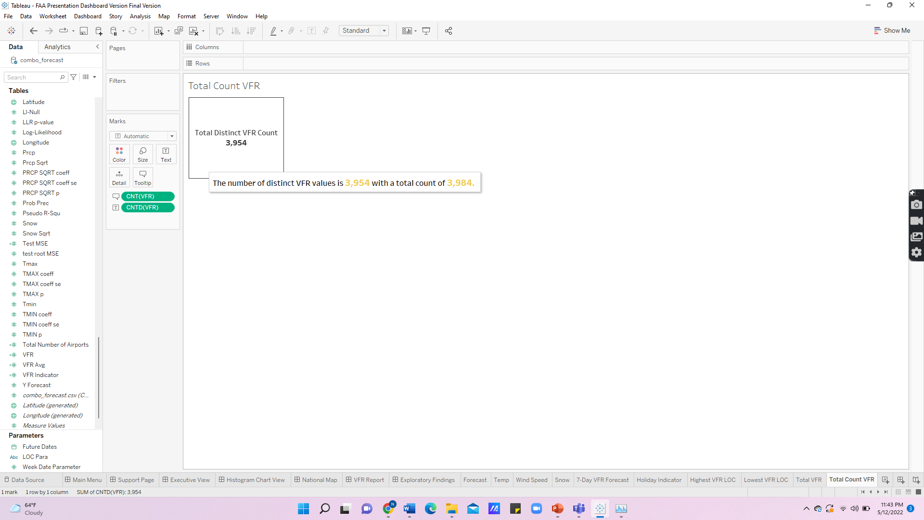The KPI provides information on the distinct count of VFR and total count of VFR values. The variables composed in the card are CNT(VFR) and CNTD(VFR).

Figure 47 Total Distinct VFR Count Variables

## Table

There is one table that provides information in regards to total VFR by Week Day. The following section will provide further details in regards to it.

### Total VFR by Weekday

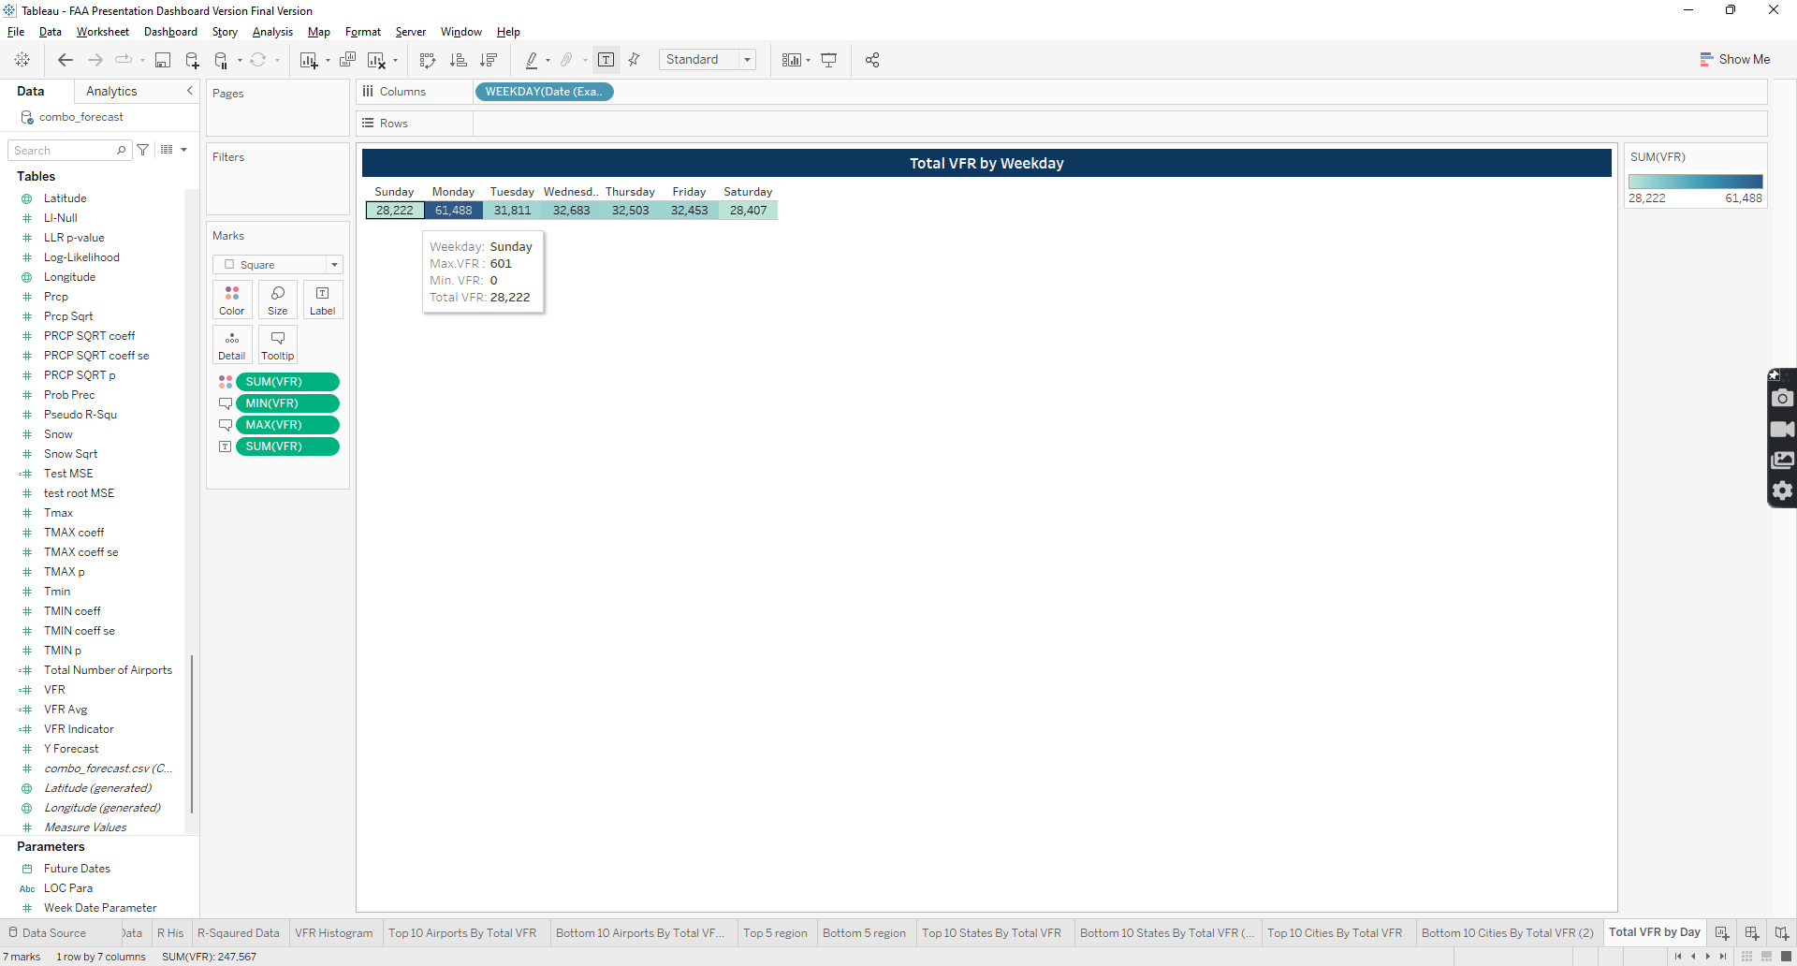The table provides information on the total VFR by weekday in addition to displaying the minimum total and maximum total VFR as well. The variables used are the following: WEEKDAY(DATE(EXACT)), SUM(VFR), MIN(VFR), and MAX(VFR).

Figure 48 Total VFR by Weekday variables

## Charts

There are several charts that are bar charts and histogram. Many are grouped by categories or bins. The next section will go through them and provide information in regards to variables and applied filters.

### VFR By Forecast

The bar chart provides information on total VFR by weather forecast. There are only 4 kinds of forecast and the following variables are the ones composing the chart: SUM(VFR), Forecast, Forecast Image, calculated field please refer to 7-Day weather forecast table for formula, and 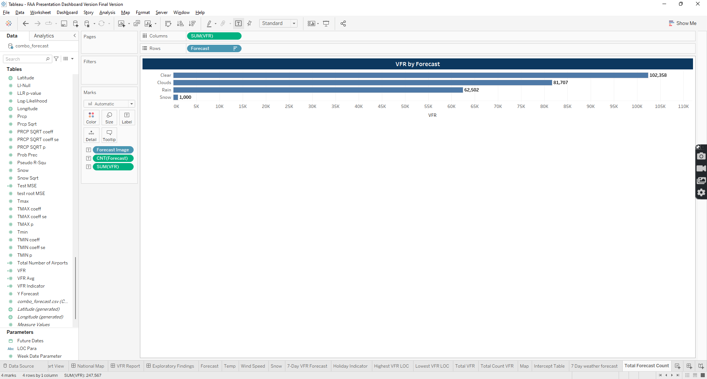CNT(Forecast).

Figure 49 VFR by Forecast chart variables

### Top 5 Regions by Total VFR

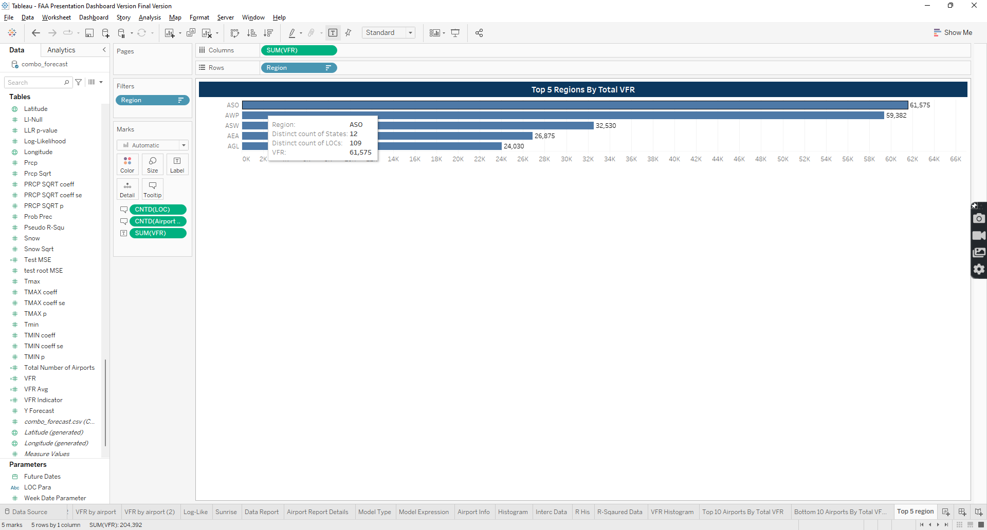The bar chart showcases the top 5 regions with the highest total VFR. The variables compose for the chart are the following: SUM(VFR), Region, condition to filter the top 5 by VFR total, and within the tooltip display the distinct count of LOC, CNTD (LOC), distinct count of states, and CNTD (Airport States).

Figure 50 Top 5 Region Chart variables

### Bottom 5 Regions by Total VFR

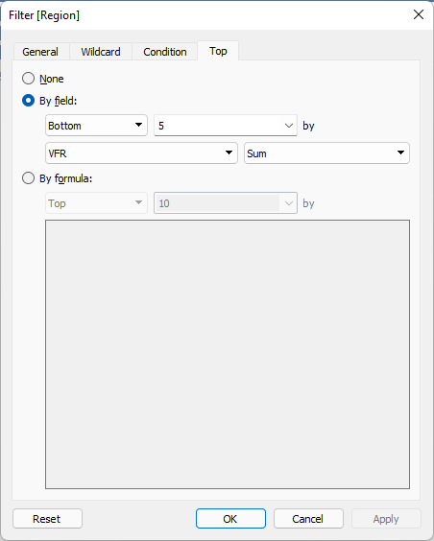Similar to Top 5 Region chart, the chart shows the top 5 region with the lowest total VFR. The variables composed are the same as the Top 5 Region except the filter condition is filtered to bottom instead of top.

Figure 51 Bottom 5 filter condition

### Top 10 Airports by Total VFR

Similar to Top 5 Region chart, Top 10 Airports bar chart provides information on top 10 airports with the highest VFR total. SUM(VFR) and LOC, filtering to Top 10 LOC by total VFR, make up the chart.

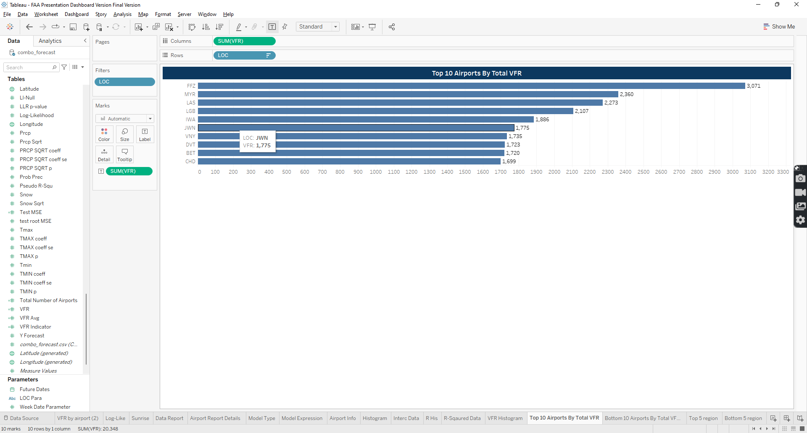

Figure 52 Top Airport Chart variables

### Bottom 10 Airports by Total VFR

Similar to Top 10 Airport chart, bottom 10 Airports bar chart provides information on top 10 airports with the lowest VFR total. SUM(VFR) and LOC, filtering to bottom 10 LOC by total VFR, make up the chart.

### Top 10 State by Total VFR

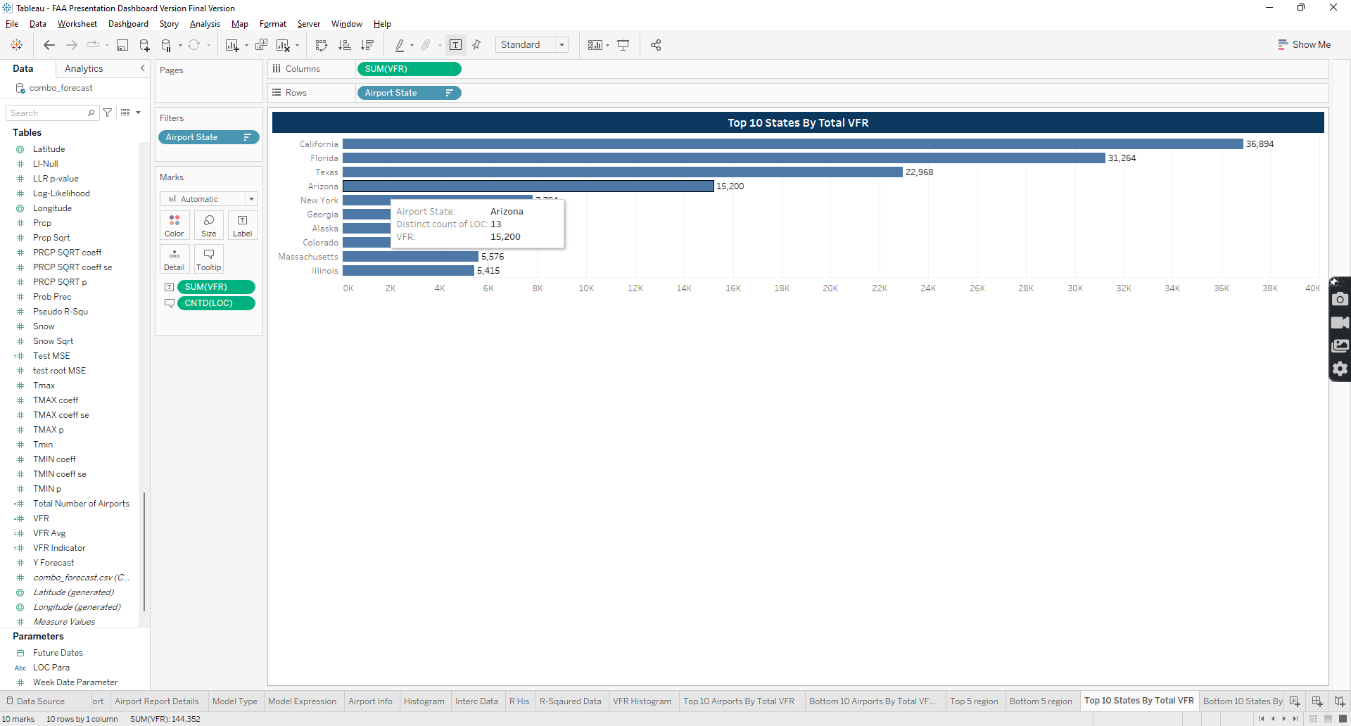Similar to previous top 10 charts, this displays top 10 states with highest VFR total. The SUM(VFR), Airport State, condition by top 10 by SUM(VFR), and distinct count of LOC, CNTD(LOC) make up this chart.

Figure 53 Top 10 state chart variables

### Bottom 10 State by Total VFR

Similar to previous bottom 10 charts, this displays bottom 10 states with lowest VFR total. The SUM(VFR), Airport State, condition by bottom 10 by SUM(VFR), and distinct count of LOC, CNTD(LOC) make up this chart.

### Top 10 Cities by Total VFR

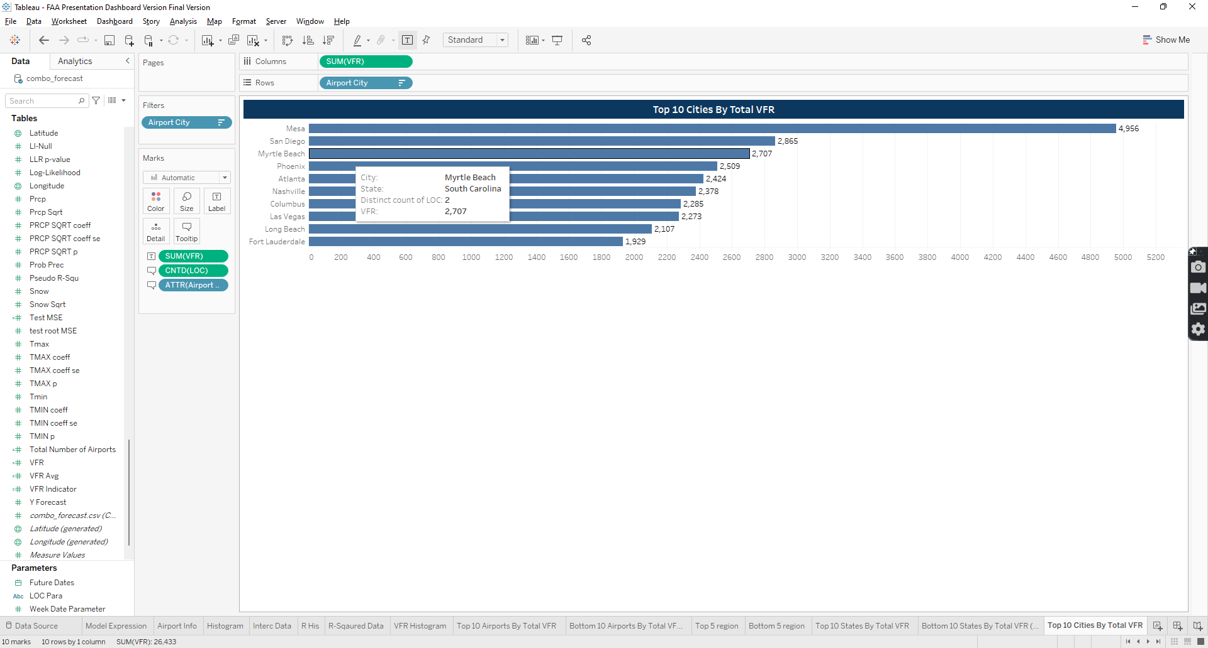Similar to previous top 10 charts, this displays top 10 cities with highest VFR total. The SUM(VFR), Airport City, condition by top 10 by SUM(VFR), Airport State, and distinct count of LOC, CNTD(LOC) make up this chart.

Figure 54 Top 10 Cities chart variables

### Bottom 10 Cities by Total VFR

Similar to previous bottom 10 charts, this displays bottom 10 cities with lowest VFR total. The SUM(VFR), Airport City, condition by bottom 10 by SUM(VFR), Airport State, and distinct count of LOC, CNTD(LOC) make up this chart.

### VFR By LOC Chart

The chart displays LOC by total VFR values. The variables that make up the chart are the following: SUM(VFR), LOC, sorted by highest VFR to lowest, SUM VFR Indicator, calculated fields that compare the VFR to VFR average, and VFR Avg.

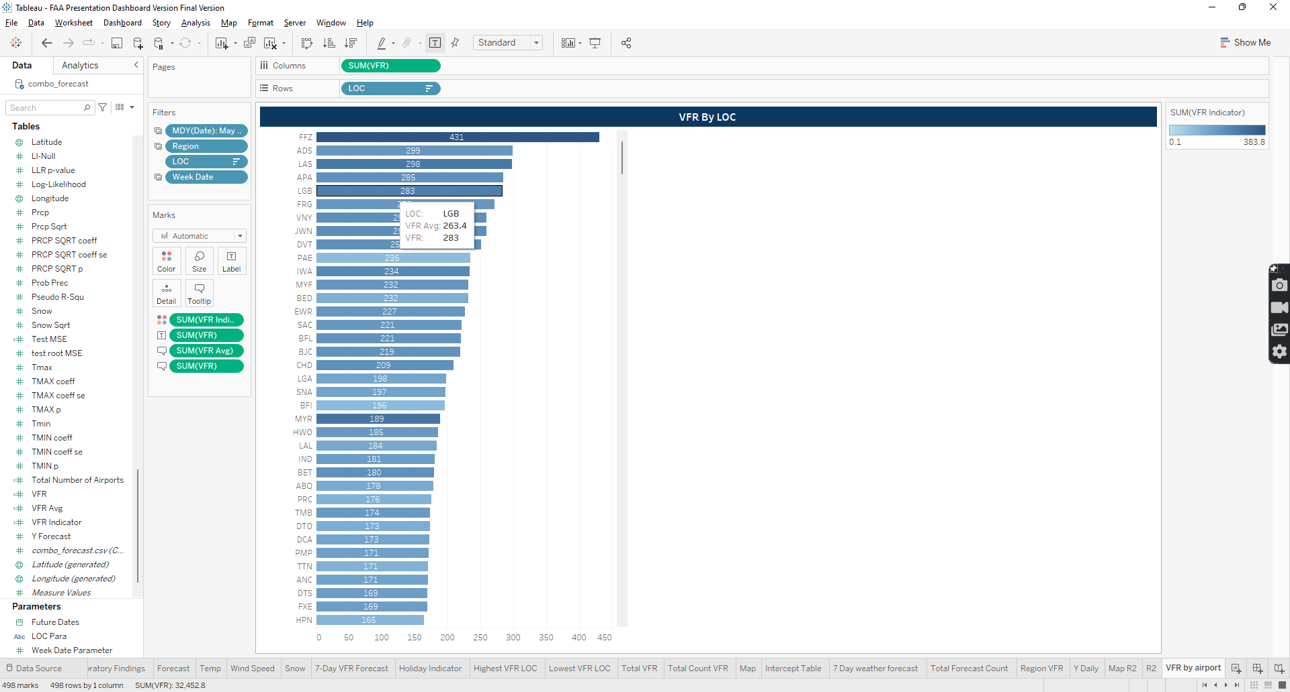

Figure 55 VFR by LOC variables

### VFR Histogram

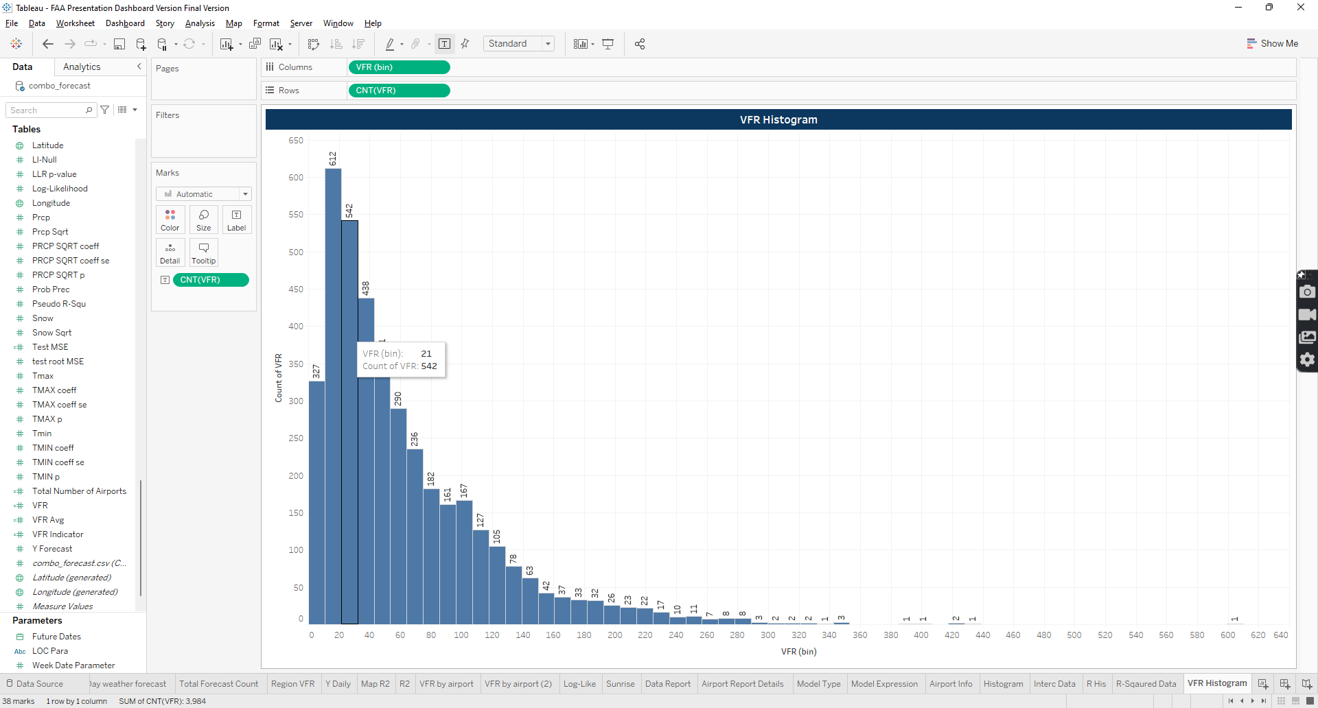The chart displays VFR values frequency in a histogram format. The following variables are used: VFR(bin) and CNT(VFR)

Figure 56 VFR Histogram variables

# Tables of Figures and Tables

Following section provides you list of tables and figures referenced in this document.

## Table of Tables

Table 1 Airport KPI Variables Usage. 10

Table 2 Airport Location formula. 10

Table 3 Calculated Fields in Weather forecast KPI 50

Table 4 Max Temp KPi Variables 51

Table 5 Wind Speed KPI Varaibles 52

## Table of Figures

Figure 1 Main Menu Page 6

Figure 2 Support Page View 7

Figure 3 Executive Summary View page 8

Figure 4 VFR Details Content 8

Figure 5 7-Day Filter Button 9

Figure 6 Executive View Filter 9

Figure 7 Airport Details KPI card 10

Figure 8 Holiday KPI card 49

Figure 9 Holiday Indicator formula. 49

Figure 10 Weather Forecast KPI Card 50

Figure 11 Max Temp KPI card 51

Figure 12 Wind Speed KPI card 52

Figure 13 Model Type KPI card 53

Figure 14 Model Expression KPI card 53

Figure 15 Predicted weather forecast table 54

Figure 16 Forecast Image Calculate Field formula 55

Figure 17 Sunrise and Sunset Table 55

Figure 18 Daily Intercept and Log Table 56

Figure 19 Log Indicator Calculate Field formula 56

Figure 20 7-day predicted forecast chart 57

Figure 21 Pseudo R Squared Bar Chart by LOC 58

Figure 22 R2 Indicator Calculate Field formula 58

Figure 23 Current VFR Forecast Bar Chart 59

Figure 24 VFR Indicator Calculate Field formula 60

Figure 25 Average Pseudo R-Squared and Total VFR By Region Bar Chart 60

Figure 26 Histogram Chart View 61

Figure 27 All Airports Pseudo R-Squared Histogram 62

Figure 28 All Airports Intercept Coeff Histogram 62

Figure 29 Total Airports Intercept Coeff Table 63

Figure 30 Total Airports Pseudo R-Squared Table 63

Figure 31 National Map View 64

Figure 32 VFR Details Content 64

Figure 33 National Map filters 64

Figure 34 National Map Variables 65

Figure 35 National Map Tool Tip 65

Figure 36 Map R2 Bar Chart 66

Figure 37 VFR Report 67

Figure 38 VFR Report Filters 67

Figure 39 Total VFR By Airport Variables 68

Figure 40 VFR Stat Analysis Report Variables 68

Figure 41 Exploratory Findings Page 69

Figure 42 Highest VFR Airport filter Condition 70

Figure 43 Highest VFR Airport KPI Variable 70

Figure 44 Lowest VFR Airport 70

Figure 45 Lowest VFR Airport Filter Condition 70

Figure 46 Total VFR KPI Variable 71

Figure 47 Total Distinct VFR Count Variables 71

Figure 48 Total VFR by Weekday variables 72

1. Binary variable that indicates if there’s a holiday using 0 or 1 values.